MicroBlaze-V-Zephyr-Kria-OpenAMP
Creating VIVADO Design and Generating the SDT

Creating VIVADO Design

- VIVADO Block design
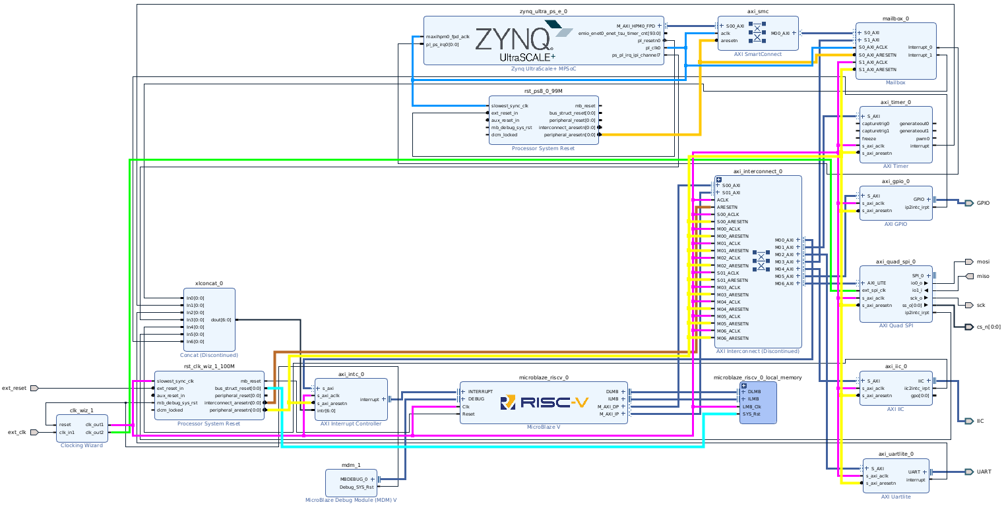
- Microblaze IP Block Automation option
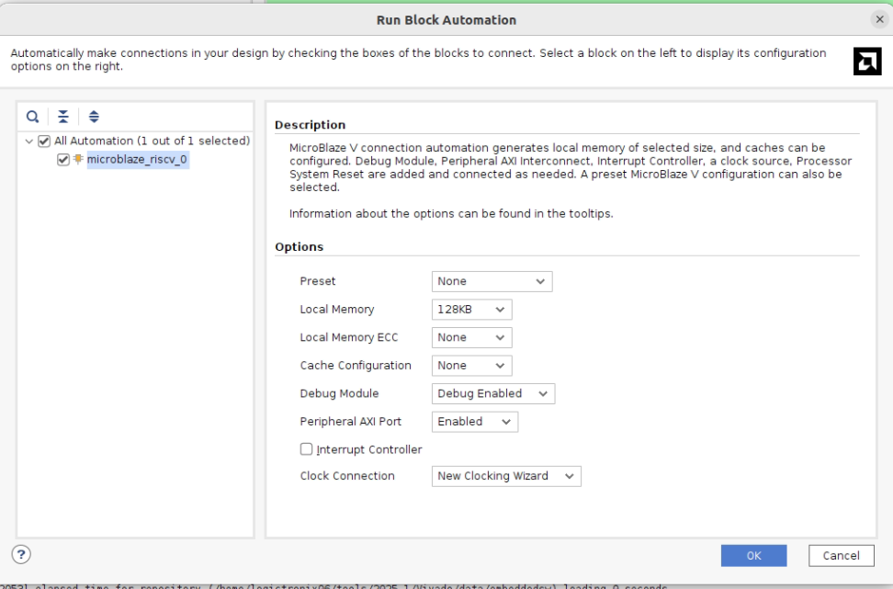

Microblaze IP Config:
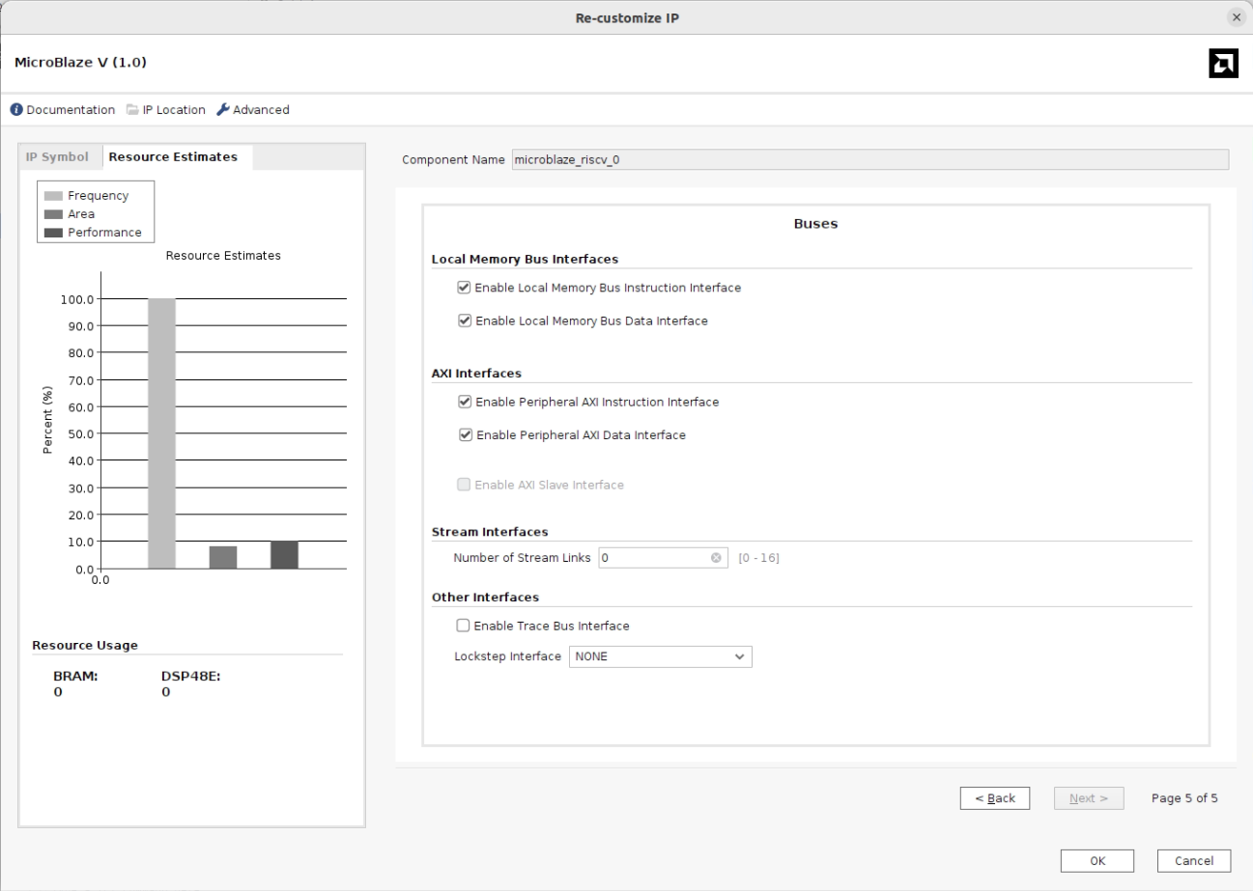

Microblaze V minimal block design with local memory and AXI interface ports enabled:
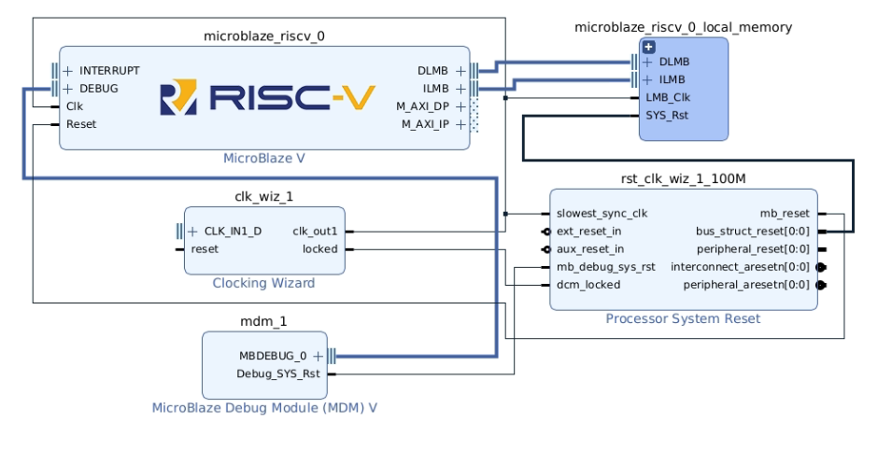
- VIVADO Address Editor
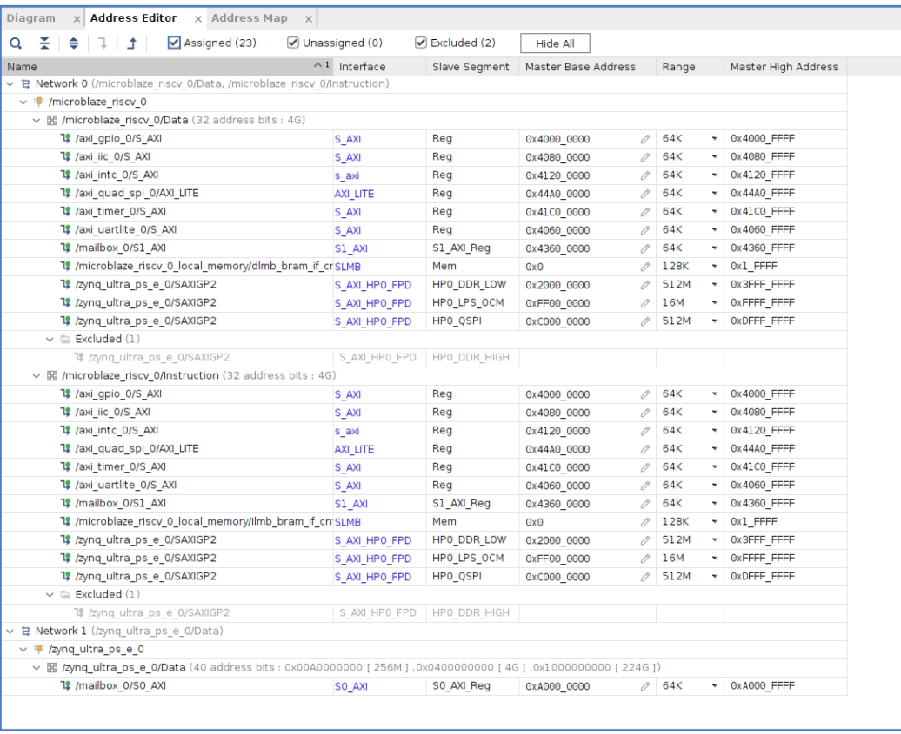

- Constraint
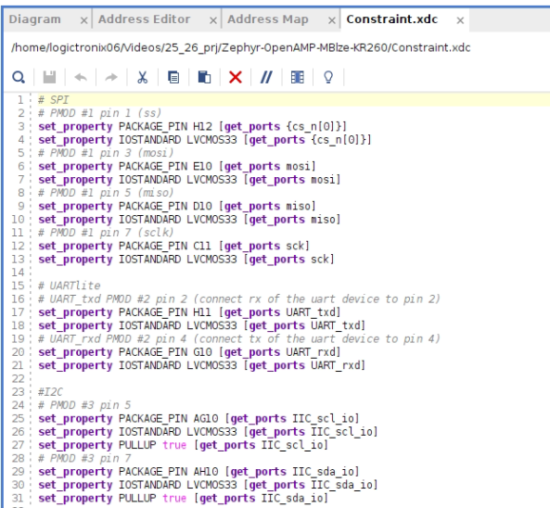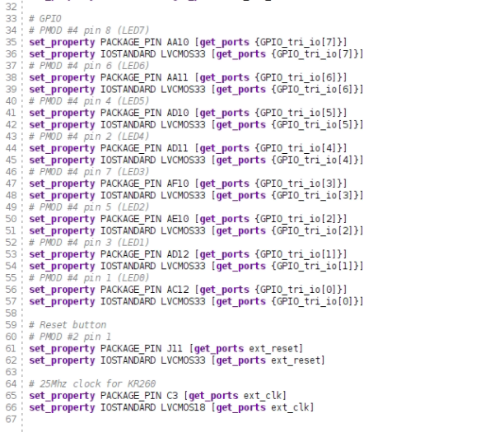

Creating the SDT- device tree
One can run following command to generate the device tree-
eval sdtgen set_dt_param -dir zephyr -xsa zephyr_wrapper.xsa ; sdtgen generate_sdt

Below is the command run and generated device tree files from SDT Generator.
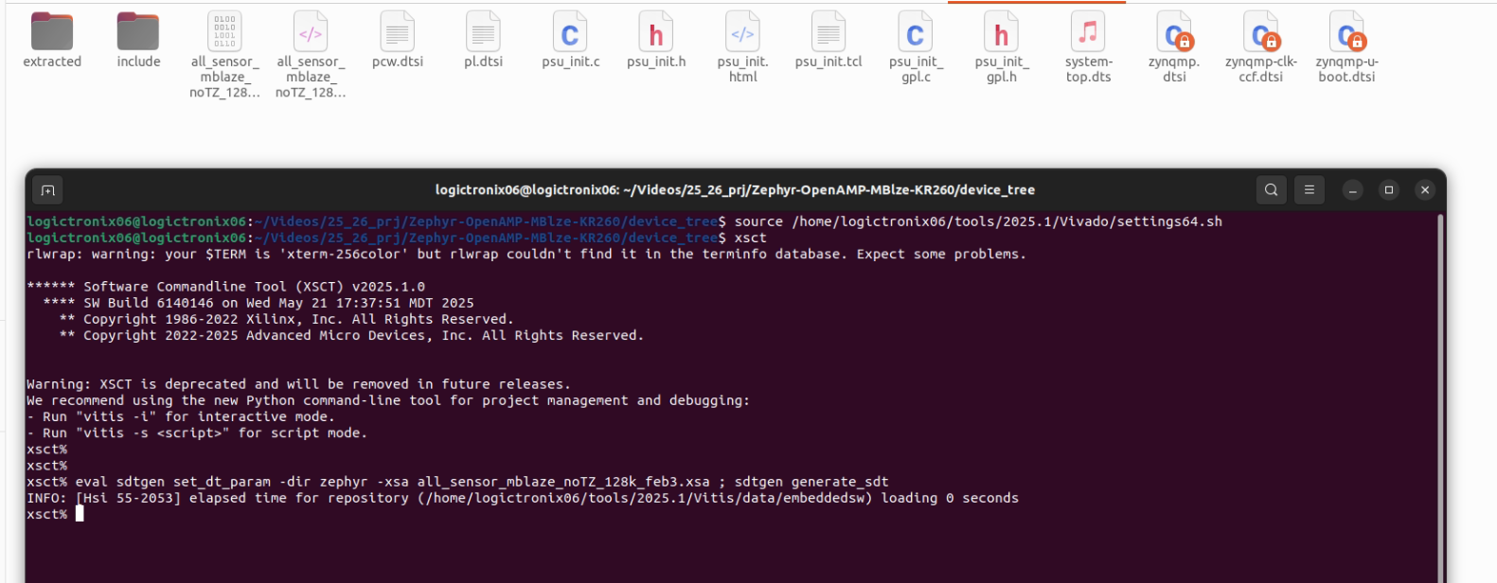

Revision History
S.N | Revision Number | Revision Details | Author
1. | v1.0 | Initial Revision | Krishna Gaihre and Sanam Shakya

