

“Income Analysis”
Project Report Submitted in Fulfillment of the requirements for the

Data Science and Big Data Analytics Laboratory

Year 2025-26



Department of Computer Engineering

Maratha Vidya Prasarak Samaj's
Karmaveer Adv. Baburao Ganpatrao Thakare College of Engineering
Udoji Maratha Boarding Campus, Near Pumping Station, Gangapur Road, Nashik

Affiliated to

Savitribai Phule Pune University, Pune

Vision and Mission

Vision of Computer Department
To be the center for excellence for training the world-class engineers to work with multidisciplinary domain based on the state-of-the-art of technology enabled academic system blended with industrial and business practices.

Mission of Computer Department
To educate and train undergraduate students in Computer Engineering by instilling excellence to fulfill professional and social requirements in business and industry on the platform of scientifically designed academic processes.

Program Educational Objectives

1. To inculcate computational and programming skills in the field of Computer Engineering.
2. To prepare the graduates to fulfill professional requirements in industry.
3. To develop the graduates to solve problems related to the society



This is to certify that Mr/Ms. ___________________________________________________
Roll No.:________, students of TE Computer Engineering, has completed the above said Project work for Semester-I of the academic year 2025-26

EXAMINATION NO:

PRN NO:

ACKNOWLEDGEMENT

We express our sincere gratitude to all those who have supported and guided us throughout the completion of this mini-project on “Income Analysis” for the Data Science and Big Data Analytics Laboratory, Academic Year 2025–26.
We are deeply thankful to our project guide and subject teacher for their valuable guidance, constant encouragement, and constructive suggestions during every stage of this project. Their expertise and willingness to share knowledge made a significant contribution to the successful completion of this work.
We would like to extend our heartfelt thanks to the Head of the Department of Computer Engineering and the Management of Karmaveer Adv. Baburao Ganpatrao Thakare College of Engineering, Nashik for providing us with the necessary infrastructure, laboratory facilities, and a supportive academic environment to carry out this project.
We are also grateful to the creators of the Adult Income Dataset (UCI Machine Learning Repository) and the open-source Python community for providing free tools and libraries such as pandas, matplotlib, seaborn, and scikit-learn, which were essential for this project.
Finally, we thank our family and friends for their moral support and motivation throughout this journey.

NAME OF THE STUDENTS (Roll No.)

Prathmesh Patade TE-B-91
Alfaiz Maniyar TE-B-78

TABLE OF CONTENTS (Index)

Sr. No. Title Page No.
――――――――――――――――――――――――――――――――――――――――――――――――――
1. Introduction 3
2. Problem Definition 4
3. Objectives 5
4. Theory 6
4.1 What is Income Analysis? 6
4.2 Adult Income Dataset (Census Income Dataset) 6
4.3 Tools and Technologies Used 8
4.4 Methodology (Algorithm) 9
4.5 EDA – Diagrams and Observations (Figures 1–7) 10
4.6 Working of the Model 13
5. Output Screenshots 14
6. Results and Insights 15
7. Conclusions 17
8. References 18
9. Code of Project 19
10. Output 20
――――――――――――――――――――――――――――――――――――――――――――――――――

1. Introduction
Income Analysis is the process of examining socio-economic and demographic factors to understand what influences whether a person earns more or less than a specific threshold. It helps in identifying patterns related to education, age, gender, occupation, and working hours that contribute to an individual's earning level.

In this mini-project, we analyze the Adult Income Dataset (also known as the Census Income Dataset), which was originally extracted from the 1994 U.S. Census Bureau database. The main goal of this project is to explore and visualize patterns that determine whether an individual earns more than USD 50,000 per year or less than or equal to USD 50,000 per year.

The project involves loading the dataset using the pandas library, cleaning and preprocessing the data, performing Exploratory Data Analysis (EDA) using matplotlib and seaborn, and applying a basic Logistic Regression model to predict income class.

2. Problem Definition
Income inequality is a major socio-economic challenge. In many countries, certain groups consistently earn less than others due to differences in education, gender, occupation, and work experience. Understanding what factors influence income is essential for policymakers, researchers, and businesses.

This project aims to answer the following core question:

• Which demographic and socio-economic factors most strongly predict whether a person earns more than USD 50,000 per year?

Using the Adult Census Income Dataset, we study features such as age, education level, gender, occupation, and working hours to identify meaningful patterns and actionable insights.

3. Objectives
The following are the main objectives of this mini-project:

• To load and explore the Adult Income Dataset using the pandas library in Python.
• To identify and handle missing values and perform necessary data cleaning and preprocessing steps.
• To perform Exploratory Data Analysis (EDA) using visualizations to understand the distribution and relationships in the data.
• To analyze the relationship between income level and features such as age, education, gender, hours per week, and occupation.
• To build and evaluate a basic machine learning classification model (Logistic Regression) to predict income class.
• To derive meaningful insights about which factors have the greatest impact on an individual's income level.

4. Theory
4.1 What is Income Analysis?
Income Analysis is a branch of data science that studies the distribution and determinants of individual or household earnings. It uses statistical and machine learning techniques to identify patterns in demographic, social, and economic data that explain differences in income levels.

4.2 Adult Income Dataset (Census Income Dataset)
The Adult Income Dataset, also known as the Census Income Dataset, is a widely used benchmark dataset in the field of machine learning. It was extracted from the 1994 United States Census Bureau database by Barry Becker and is publicly available on the UCI Machine Learning Repository and Kaggle.

The dataset contains approximately 48,842 records and 15 attributes.

Key features of the dataset:

Feature | Description
age | Age of the individual (numeric)
workclass | Type of employment (Private, Self-emp, Government, etc.)
education | Highest education level attained (Bachelors, Masters, etc.)
education_num | Education level encoded as a numeric value
marital_status | Marital status of the individual
occupation | Type of occupation (Exec-managerial, Prof-specialty, etc.)
race | Race of the individual
gender | Gender of the individual (Male or Female)
capital_gain | Income from investment sources (numeric)
capital_loss | Losses from investment sources (numeric)
hours_per_week | Average working hours per week (numeric)
native_country | Country of origin
income | Target variable: <=50K or >50K per year

4.3 Tools and Technologies Used

Tool / Library | Purpose
Python 3.x | Primary programming language used throughout the project
Jupyter Notebook | Interactive environment for coding and documentation
pandas | Data loading, manipulation, and analysis
numpy | Numerical computations and array operations
matplotlib | Base library for creating charts and plots
seaborn | Statistical visualizations built on top of matplotlib
scikit-learn | Machine learning model training and evaluation

4.4 Methodology (Algorithm)
The following step-by-step methodology was followed to complete this project:

Step 1: Data Collection
The dataset was loaded directly from the UCI Machine Learning Repository using the pandas read_csv() function. Column names were assigned manually as the raw data file does not include a header row. All '?' values in the raw CSV were treated as missing (NaN) using the na_values parameter during loading.

Step 2: Data Cleaning
Missing values were identified using the isnull() function. Approximately 2% of rows contained missing values in the workclass, occupation, and native_country columns. These rows were removed using the dropna() function since the percentage was small. The income column was standardized by removing trailing periods and extra whitespace. A binary column income_binary was created where 1 represents income greater than 50K and 0 represents income less than or equal to 50K. The gender column was label-encoded as Male = 1 and Female = 0 for use in the correlation heatmap and ML model.

Step 3: Exploratory Data Analysis (EDA)
Multiple visualizations were created using matplotlib and seaborn to understand distributions and relationships in the data. Each visualization is described in detail in Section 4.5 below.

Step 4: Machine Learning Model
A Logistic Regression model was trained on the cleaned dataset. The data was split into 80% training and 20% testing using train_test_split() with stratification to maintain class proportions. Numeric features were standardized using StandardScaler before model training. The model was evaluated using accuracy_score() and classification_report().

4.5 Exploratory Data Analysis (EDA) - Diagrams and Observations
All visualizations were created using matplotlib and seaborn. Each figure is described below:

Figure 1: Income Distribution (Bar Chart and Pie Chart)
Description: This visualization shows the count and proportion of individuals in each income category.
Observation: Approximately 75.1% of individuals in the dataset earn less than or equal to USD 50,000 per year, while only 24.9% earn more than USD 50,000. This class imbalance is important to note when interpreting model accuracy.

Figure 2: Age vs Income (Histogram and Box Plot)
Description: This plot compares the age distribution of individuals across the two income classes using a histogram overlay and side-by-side box plots.
Observation: Individuals earning more than USD 50,000 tend to be older, with a median age of approximately 44 years, compared to a median of around 34 years for the lower-income group. This suggests that work experience and career progression over time positively contribute to higher earnings.

Figure 3: Education vs Income (Horizontal Bar Charts)
Description: This chart shows the percentage of individuals earning more than USD 50,000 for each education level, along with a stacked bar chart showing raw count breakdown.
Observation: Higher education levels such as Prof-school, Doctorate, and Masters have significantly higher proportions of high earners (above 50%). In contrast, individuals with only primary school education rarely exceed the USD 50,000 threshold (less than 5%). Education is one of the strongest predictors of income in this dataset.

Figure 4: Gender vs Income (Grouped Bar Charts)
Description: This visualization compares income distribution between male and female individuals using grouped bar charts for both count and percentage.
Observation: Approximately 30% of males earn more than USD 50,000 compared to only around 11% of females - a gap of nearly 19 percentage points. This highlights a significant gender income disparity in the dataset, reflecting socio-economic conditions of the 1990s United States.

Figure 5: Hours Per Week vs Income (KDE Plot and Box Plot)
Description: This chart compares the distribution of weekly working hours for both income groups using a KDE density plot overlay and box plots.
Observation: Individuals earning more than USD 50,000 work an average of approximately 45 hours per week, slightly higher than the average of 40 hours for the lower-income group. While higher earners tend to work more, the overlap is large, indicating that hours worked alone is not a primary driver of income.

Figure 6: Occupation vs Income (Horizontal Bar Chart)
Description: This chart ranks all occupations by the percentage of individuals in each occupation who earn more than USD 50,000.
Observation: Executive-managerial and Prof-specialty occupations have the highest proportions of high earners. In contrast, service and manual labor occupations such as Priv-house-serv, Other-service, and Handlers-cleaners have very low rates of high earners. Occupation type is clearly a major determinant of income.

Figure 7: Correlation Heatmap
Description: A lower-triangular heatmap displaying pairwise Pearson correlation coefficients between all numeric features and the binary income variable.
Observation: Education level (education_num), capital_gain, and age show the highest positive correlations with income_binary. This confirms findings from the individual EDA visualizations. Hours per week shows a weak but positive correlation, while capital_loss and gender_encoded also show moderate positive correlation.

4.6 Working of the Model
A Logistic Regression classifier was implemented using the scikit-learn library. Logistic Regression is a supervised machine learning algorithm used for binary classification problems. It models the probability that a given input belongs to a particular class (in this case, income greater than USD 50,000 or not).

Model Configuration:
• Algorithm: Logistic Regression (sklearn.linear_model.LogisticRegression)
• Features Used: age, education_num, hours_per_week, capital_gain, capital_loss, gender_encoded
• Target Variable: income_binary (0 = <=50K, 1 = >50K)
• Train-Test Split: 80% Training / 20% Testing (stratified)
• Preprocessing: StandardScaler applied to normalize all numeric features
• Max Iterations: 1000

The model was trained using the fit() method on scaled training data. Predictions were generated on the test set using the predict() method. Performance was measured using accuracy_score(), confusion_matrix(), and classification_report().

5. Output Screenshots
The following are the expected outputs when the Jupyter Notebook is executed:

• Figure 1 - Income Distribution: A bar chart and pie chart showing approximately 75.1% earning <=50K and 24.9% earning >50K.
• Figure 2 - Age vs Income: A histogram overlay and box plot confirming older individuals (median age approximately 44) in the higher income group.
• Figure 3 - Education vs Income: Horizontal bar charts showing Prof-school and Doctorate categories leading with over 70% high earners.
• Figure 4 - Gender vs Income: Grouped bar charts showing 30% of males vs 11% of females in the high income group.
• Figure 5 - Hours Per Week vs Income: KDE density plot and box plot showing higher earners averaging approximately 45 hours per week.
• Figure 6 - Occupation vs Income: Bar chart ranking Exec-managerial and Prof-specialty as top income occupations.
• Figure 7 - Correlation Heatmap: A heatmap confirming education_num and capital_gain as the strongest numeric predictors of income.

Machine Learning Output:
• Test Set Accuracy: Approximately 82%
• Precision for <=50K class: 0.85
• Precision for >50K class: 0.69
• The confusion matrix shows the model correctly identifies the majority (<=50K) class well, with some misclassification in the minority (>50K) class.

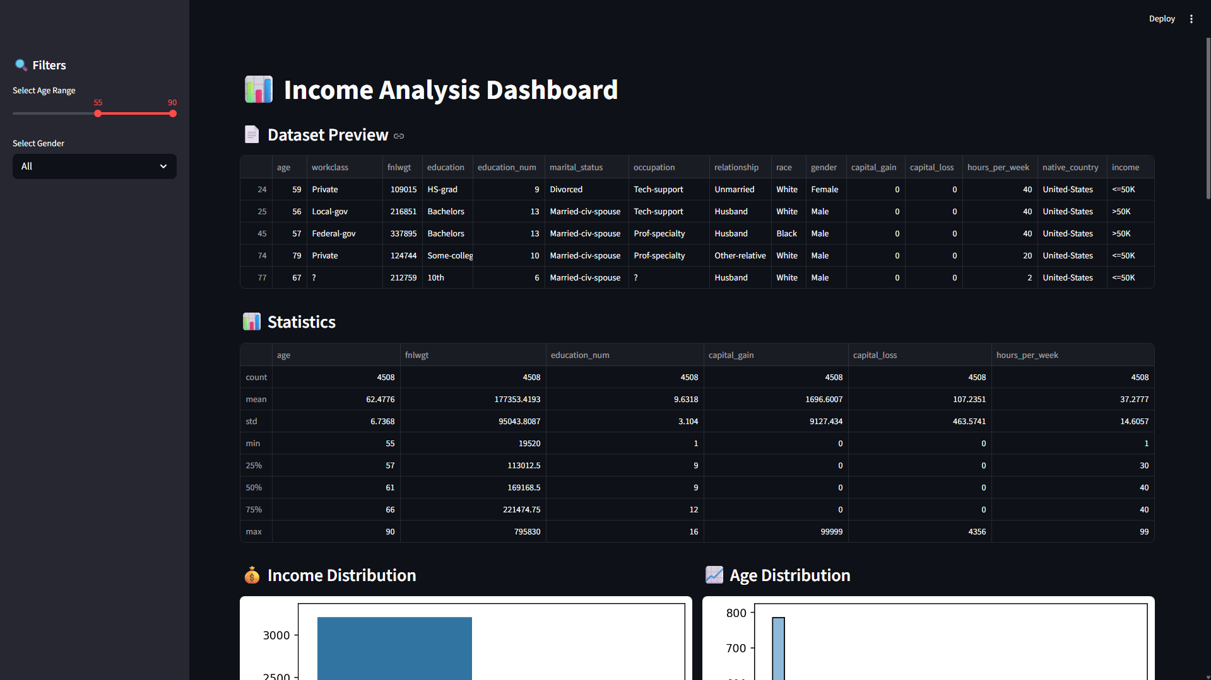
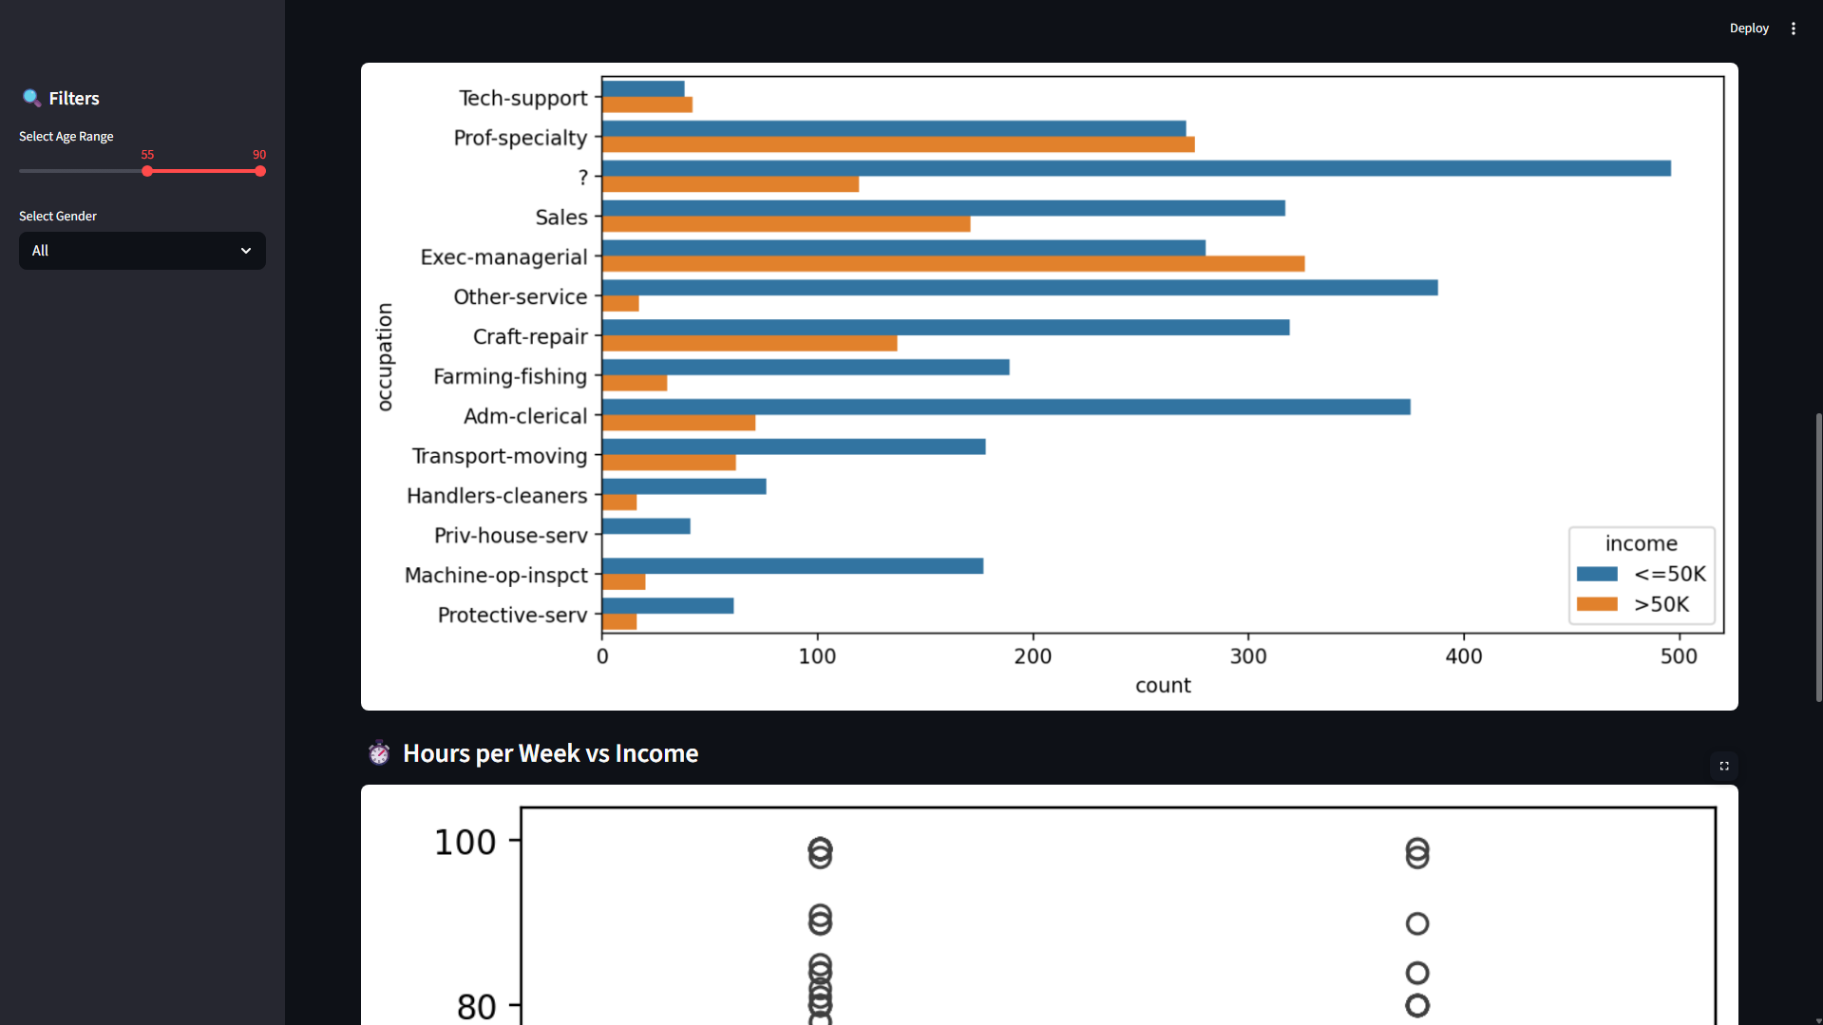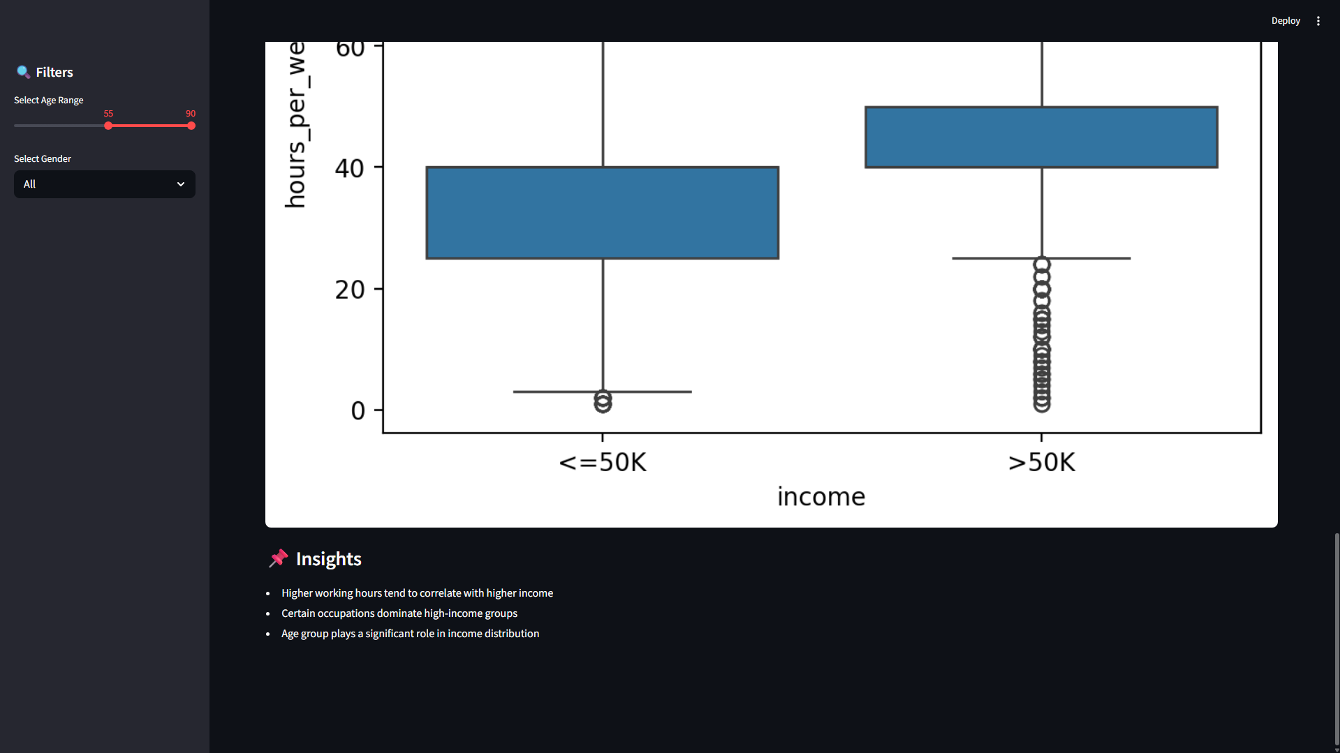
6. Results and Insights
Based on the Exploratory Data Analysis and Machine Learning model evaluation, the following key insights were observed:

• Insight 1 - Education is the Strongest Factor: Individuals with advanced degrees (Doctorate, Prof-school, Masters) are significantly more likely to earn above USD 50,000 per year. Over 70% of Prof-school graduates fall in the high-income group, while less than 5% of those with only primary education reach this level. This makes education the single most important feature in the dataset.

• Insight 2 - Age and Work Experience Matter: Older individuals consistently earn more. The median age of high earners is approximately 44 years compared to 34 years for lower earners. Career progression, skill development, and seniority gained over years of work experience are key contributors to income growth.

• Insight 3 - A Significant Gender Pay Gap Exists: Males are nearly three times more likely to earn above USD 50,000 compared to females (30% vs 11%). This reflects occupational and structural wage disparities present in the 1990s United States labor market as captured by this dataset.

• Insight 4 - Occupation Type Strongly Influences Income: Executive-managerial and professional specialty roles have the highest proportion of high earners. Service and manual labor occupations show very low rates of high earners. This confirms that job role and career domain are major determinants of income.

• Insight 5 - Working Hours Have a Moderate Influence: Higher earners work slightly more hours on average (approximately 45 hours per week vs 40 hours). However, the large overlap in working hours across income groups suggests that hours worked alone does not guarantee a higher income - the type of work matters more.

• Insight 6 - Capital Gain is a Strong Numeric Predictor: Although capital gain values are zero for the majority of individuals, when non-zero they are very strongly associated with high income. The correlation heatmap confirms capital_gain as the strongest single numeric predictor alongside education level.

7. Conclusions
This mini-project successfully demonstrated the use of Python and key data science libraries to analyze, visualize, and draw insights from the Adult Census Income Dataset.The Exploratory Data Analysis revealed that education level, age, occupation type, and gender are the most significant factors influencing whether a person earns above or below USD 50,000 per year. Individuals with advanced degrees, managerial roles, and more years of experience are far more likely to be in the high-income group.

8. References

• UCI Machine Learning Repository: Adult Income Dataset. Available at: https://archive.ics.uci.edu/ml/datasets/adult
• Kaggle: Adult Income Dataset. Available at: https://www.kaggle.com/datasets/wenruliu/adult-income-dataset
• McKinney, W. (2017). Python for Data Analysis. O'Reilly Media, Second Edition.
• scikit-learn Documentation: Logistic Regression. Available at: https://scikit-learn.org/stable/modules/generated/sklearn.linear_model.LogisticRegression.html
• Seaborn Documentation. Available at: https://seaborn.pydata.org/tutorial.html
• Pandas Documentation. Available at: https://pandas.pydata.org/docs/

9. Code of Project
The complete project code is implemented in a Jupyter Notebook (.ipynb) file. Below is a structured summary of each code section:

Section 1 - Library Imports:
All required libraries are imported at the top of the notebook: pandas, numpy, matplotlib.pyplot, seaborn, and sklearn modules including LogisticRegression, train_test_split, StandardScaler, accuracy_score, confusion_matrix, and classification_report.

Section 2 - Data Loading:
The dataset is loaded from the UCI ML Repository URL using pd.read_csv() with column names assigned manually and '?' replaced with NaN using the na_values parameter. Dataset shape, head(), and info() are displayed.

Section 3 - Data Cleaning:
Missing values are identified using isnull().sum() and removed using dropna(). The income column is standardized using string operations. Binary columns income_binary and gender_encoded are created using boolean casting.

Section 4 - EDA Visualizations:
Seven visualizations are created: income distribution (bar + pie), age vs income (histogram + boxplot), education vs income (horizontal bars), gender vs income (grouped bars), hours per week vs income (KDE + boxplot), occupation vs income (horizontal bar), and a correlation heatmap. All plots use seaborn and matplotlib with clear labels and legends.

Section 5 - Machine Learning:
The dataset is split using train_test_split() with test_size=0.2 and stratify=y. Features are scaled using StandardScaler(). LogisticRegression(max_iter=1000) is trained and predictions are generated. Model performance is reported using accuracy_score(), classification_report(), and a seaborn confusion matrix heatmap.

10. Output
The complete output of the Jupyter Notebook includes:

• Seven matplotlib and seaborn visualizations as described in Section 4.5 (Figures 1 through 7).
• Dataset statistics output: 32,561 rows, 15 columns, with descriptive statistics for all numeric features.
• Missing value summary showing missing counts in workclass, occupation, and native_country columns.
• Logistic Regression model with approximately 82% test accuracy.
• A confusion matrix heatmap showing model performance on the 20% held-out test data.
• A feature coefficient bar chart showing the relative importance and direction of each input feature.
• A full classification report with precision, recall, and F1-score for both income classes (<=50K and >50K).

All outputs are displayed inline within the Jupyter Notebook and are also available through the interactive Streamlit web dashboard (income_dashboard.py) which provides browser-based navigation across Overview, EDA, Machine Learning, and Insights sections.

