Regimens
Inventory Management System for Outstretched Arm Enterprise
Entity-Relationship Diagram — Week 3, Deliverable 2
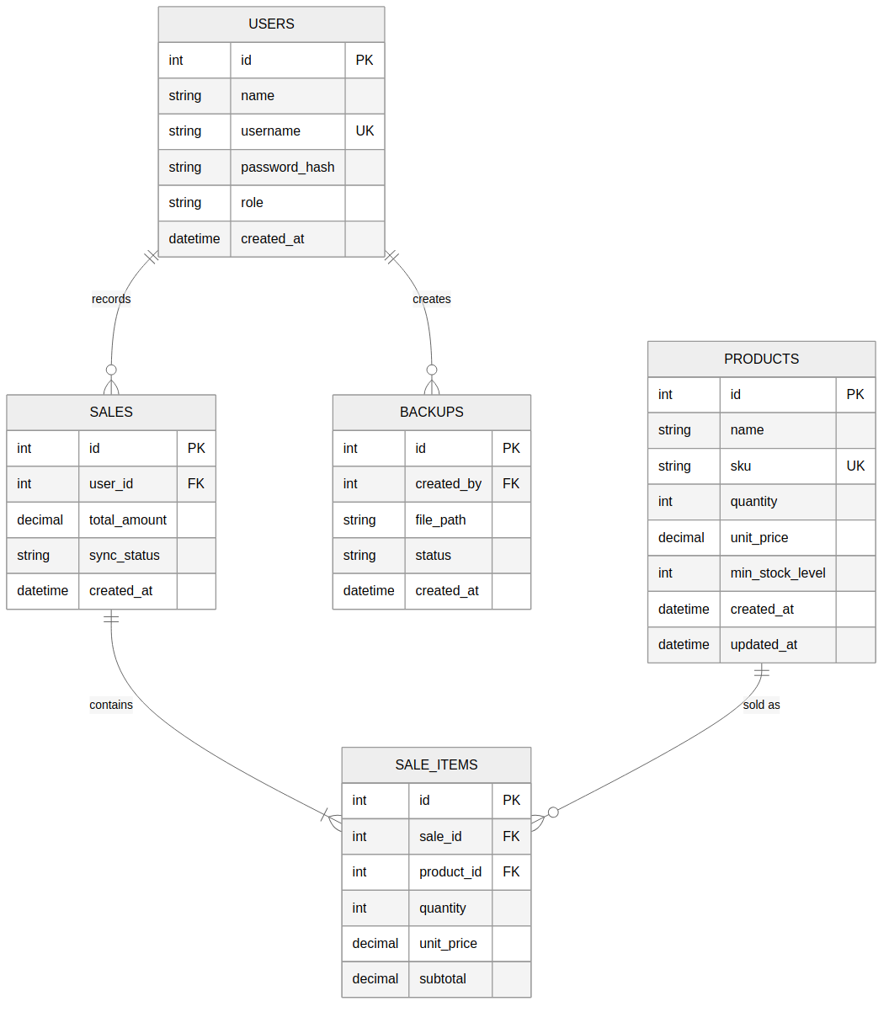

Relationships
A user (owner or assistant) records many sales, and a user may also create many backups. Each sale contains one or more sale items; each sale item references exactly one product. A product can appear in many sale items across many sales. This gives five entities and four relationships, exceeding the Week 3 minimum of four entities.

Entity Reference
users
Column | Type | Notes
id | INTEGER, PK | Auto-incrementing primary key
name | VARCHAR | Full name of the user
username | VARCHAR, UNIQUE | Login identifier
password_hash | VARCHAR | Bcrypt-hashed password, never stored in plain text
role | VARCHAR (owner | assistant) | Drives role-based access control
created_at | TIMESTAMP | Account creation time
products
Column | Type | Notes
id | INTEGER, PK | Auto-incrementing primary key
name | VARCHAR | Product name shown in search and inventory list
sku | VARCHAR, UNIQUE | Optional internal stock-keeping code
quantity | INTEGER | Current stock on hand; decremented automatically on sale
unit_price | DECIMAL | Selling price used to calculate sale totals
min_stock_level | INTEGER | Threshold used to trigger low-stock alerts
created_at / updated_at | TIMESTAMP | Audit fields
sales
Column | Type | Notes
id | INTEGER, PK | Auto-incrementing primary key
user_id | INTEGER, FK → users.id | Who recorded the sale
total_amount | DECIMAL | Sum of all sale_items subtotals
sync_status | VARCHAR (synced | pending) | Set to pending when created offline; updated once synced
created_at | TIMESTAMP | When the sale was recorded
sale_items
Column | Type | Notes
id | INTEGER, PK | Auto-incrementing primary key
sale_id | INTEGER, FK → sales.id | Parent sale
product_id | INTEGER, FK → products.id | Product sold
quantity | INTEGER | Units sold in this line item
unit_price | DECIMAL | Price at time of sale (kept even if the product price later changes)
subtotal | DECIMAL | quantity × unit_price
backups
Column | Type | Notes
id | INTEGER, PK | Auto-incrementing primary key
created_by | INTEGER, FK → users.id | Who triggered the backup
file_path | VARCHAR | Location of the stored backup file
status | VARCHAR (completed | failed) | Result of the backup operation
created_at | TIMESTAMP | When the backup was created

