Regimens
Inventory Management System for Outstretched Arm Enterprise
Developed by Team StoreSync — COE 454 Software Engineering
Team Collaboration & Task Breakdown

1. Purpose
This document ties together the ADRs, ERD, and API Schema into a single reference so every team member knows exactly what to build, in what order, and how their piece connects to everyone else's. The goal is that Database, Backend, Frontend, and UI/UX work all converge on the same contract without needing to renegotiate it mid-build.

2. How the Documents Connect
The build order follows the dependency chain below: the ADRs set the ground rules, the Database team turns the ERD into real tables, the Backend lead builds the API against those tables, and Frontend/UI/UX build the app against that API. Documentation stays in sync with all of it.
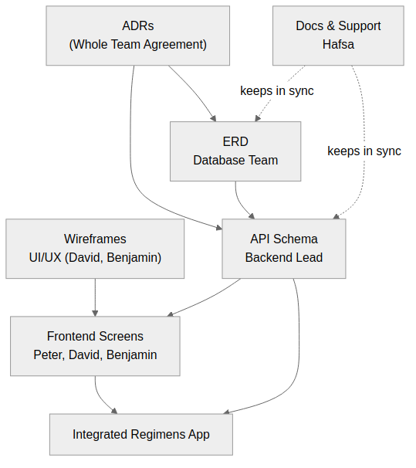

3. Roles & Document Ownership
Name | Charter Role | Owns / Primary Document
Ntim Francis Gyan | Database management & maintenance | ERD_Regimens.docx
Ampaabeng Raymond Kyeremeh | Database management & maintenance | ERD_Regimens.docx
Peter Appiah | Frontend dev | API_Schema_Regimens.docx (consumer)
David Kwame Castel | UI/UX & Frontend dev | UIUX_Design_Guide_Week2.docx → API_Schema_Regimens.docx
Nuamah Asamoaa Hafsa | Documentation & assisting backend | All documents — keeps them in sync
Ayapong Albert Yeboah (Logical) | Backend lead & potential AI work | Architecture_Decision_Records.docx, API_Schema_Regimens.docx
Benjamin Azumah | UI/UX & Frontend dev | UIUX_Design_Guide_Week2.docx → API_Schema_Regimens.docx

4. What Each Person Does

4.1 Database Team — Francis & Raymond
Task | Reference
Stand up a local PostgreSQL instance and a shared dev/staging database | ADR-001
Write migration scripts for all five tables: users, products, sales, sale_items, backups | ERD_Regimens.docx
Apply the exact column names, types, and constraints (PK/FK/UNIQUE) shown in the ERD field reference — the backend code will assume these names | ERD_Regimens.docx
Seed a small set of sample products and a test owner/assistant user for development | —
Flag the whole team before renaming or removing a column — it breaks the API contract | Section 6, this doc

4.2 Backend Lead — Albert (you)
Task | Reference
Scaffold the Express app: folder structure, DB connection, error handling | ADR-002
Implement every endpoint listed in the API Schema, grouped in this order: Auth → Products → Sales → Reports → Backup → Sync | API_Schema_Regimens.docx
Implement JWT issuing/validation and the owner/assistant role check | ADR-004
Implement the offline sync endpoint with last-write-wins conflict handling | ADR-005
Own the API contract: if an endpoint needs to change shape, update API_Schema_Regimens.docx first and notify Frontend before shipping the change | Section 6, this doc

4.3 Documentation & Backend Support — Hafsa
Task | Reference
Keep API_Schema_Regimens.docx, ERD_Regimens.docx, and the ADRs updated whenever a decision changes | All documents
Assist the backend lead on Reports and Backup endpoints, and on request validation | API Schema – Reports, Backup
Write and maintain the repository README with local setup instructions | Week 3, Deliverable 5
Take notes at weekly meetings and record any decisions that should become a new or revised ADR | Team Charter – Decision Making Process

4.4 Frontend — Peter
Task | Reference
Scaffold the React app: routing, state management, and the local offline store (e.g. Dexie/IndexedDB) | ADR-005
Build the Login screen and wire it to /auth/login | API Schema – Auth
Build the New Sale / Cart flow and wire it to /products search and POST /sales | API Schema – Products, Sales
Implement the offline queue: hold writes locally when there's no connection, replay via /sync on reconnect | ADR-005, API Schema – Sync

4.5 UI/UX & Frontend — David
Task | Reference
Finish the low-fidelity wireframes for the “Record a Sale” flow (5 screens) | UIUX_Design_Guide_Week2.docx
Translate the Dashboard and New Sale wireframes into React components | UIUX Guide → API Schema – Products, Sales
Make sure every screen matches the field names returned by the API (e.g. quantity, unit_price) rather than inventing new ones | API_Schema_Regimens.docx

4.6 UI/UX & Frontend — Benjamin
Task | Reference
Sketch the stretch-goal “Add a New Product” flow if time allows | UIUX_Design_Guide_Week2.docx
Build the low-stock alert banner on the Dashboard | API Schema – Products, User Story 7
Build the sale-confirmation screen, including a visible “pending sync” state when a sale was recorded offline | ADR-005, API Schema – Sales

5. Suggested GitHub Issues (Week 3, Deliverable 4)
Load these onto the GitHub project board as issues, one per row, assigned as suggested. This also satisfies the Week 3 requirement for a screenshot of the board with all user stories loaded as issues — each issue below references the user story or ADR it comes from.
# | Issue Title | Suggested Assignee | Reference
1 | Set up PostgreSQL instance and run initial schema migration | Database (Francis, Raymond) | ERD_Regimens.docx
2 | Create products table + constraints | Database | ERD_Regimens.docx
3 | Create users, sales, sale_items, backups tables + FKs | Database | ERD_Regimens.docx
4 | Scaffold Express app (routes, controllers, db connection) | Backend (Albert) | ADR-002
5 | Implement POST /auth/login + JWT issuing | Backend (Albert) | ADR-004, API Schema
6 | Implement /products CRUD endpoints | Backend (Albert, Hafsa) | API Schema – Products
7 | Implement POST /sales with stock decrement transaction | Backend (Albert) | API Schema – Sales, User Story 4
8 | Implement /reports/sales endpoint | Backend (Albert, Hafsa) | API Schema – Reports, User Story 8
9 | Implement /backup + /backup/:id/restore | Backend (Albert) | API Schema – Backup, User Story 10
10 | Implement /sync endpoint (last-write-wins) | Backend (Albert) | ADR-005, API Schema – Sync
11 | Finish wireframe sketches for Record-a-Sale flow | UI/UX (David, Benjamin) | UIUX Design Guide
12 | Scaffold React app + routing + local IndexedDB store | Frontend (Peter) | ADR-005
13 | Build Login screen | Frontend (Peter, David) | API Schema – Auth
14 | Build Dashboard / low-stock alert banner | Frontend (Benjamin) | API Schema – Products, User Story 7
15 | Build New Sale + Cart screens | Frontend (David, Peter) | API Schema – Sales, UIUX Guide
16 | Build offline sync indicator on Sale Success screen | Frontend (Benjamin) | ADR-005
17 | Write README with local setup instructions | Documentation (Hafsa) | Week 3 Deliverable 5
18 | Keep API Schema doc updated as endpoints change | Documentation (Hafsa) | All docs

6. Rules to Avoid Integration Conflicts
- Nobody changes a table name/column, an API endpoint's shape, or a core architecture decision without raising it in the Saturday meeting or the WhatsApp group first — per the Team Charter's decision-making process.
- The API Schema document is the single source of truth for what the backend returns. If frontend needs a field that isn't there, that's a documented change request, not a silent assumption.
- Database changes land first, then backend code that depends on them, then frontend code that calls the backend — in that order, to avoid building against a moving target.
- Any teammate blocked by another team's unfinished piece should say so early (per the Team Charter's “notify the team early” rule) rather than guessing at the missing contract.

