***ST no: 10262244***

***Name: Ntshuxeko***

***Part 1 of POE***

***Table of Content***

Page1: Cover page

Page2: table of contents

Page3: Website choice and description

Page4: Website pages

Page5:Refernce list

***Description of Business***

‘The KKK’ short for kingdom of kota kings is a small kota business that sells the best kotas that the town of Nkowa Nkowa has to offer. To promote their business, I'll be making an online website so their social reach can be increased and make them recognized to the broader population. The website will be a pictorial representation of their products that they are selling alongside the ingredients so customers may know what to expect when they find an interest in the business. The website will also contain contact numbers for the people who operate the business so that they can make phone call orders with the operators because it could get problematic if costumers were to travel to the place and find long ridiculous lines and must wait for their orders to be taken and their food taking time to be given. The website will also have a gallery to display the kotas sold and how the place looks like so that newcomers don’t get lost when going to the place to buy. The Kkk kotas are made with love as the chefs like taking their time preparing the delicious food for customers and this is their uniqueness. Their operating hours will also be displayed in the ‘about us’ page for customers to view and know when to go because it could be a pain if someone gone to the store and found out that it's not open. Although it’s a kota business, their store is in Collab with a cake baking company and which makes cakes and muffins, on the menu customers can choose to buy a delicious kota and have a delicious mouth washing desert of cupcakes or even if they want to order cakes, they can add kotas on their side for family times in birthdays

Part 2

In my part 2 I've made improvements to my web pages by using an external CSS styling sheet to make web pages look more decorative and appealing

1.The navigation bar: the first improvement was the navigation bar whereby I had to make it look more attractive when a user is interacting with the webpage. When the user is trying to navigate throw the webpages, as they hover on the navigations there is a hovering event whereby a line increases its value and decreases when no longer hovering on the navigation. I chose the line to be yellow to resemble the logo of the business

2.The menu page: In the menu page I added an image gallery features so that instead of the images and description being separated they should be on one box so user can see the image of the food and its descriptions such as name, price and what the food comes with in one place

3.Contact us page: by learning about website layouts, I was able to use one of its tricks by letting the contact us page be separated into 3 different sections which is the header, left side of the page and right side of the page right below the header. Within the right side contains the address and location of the business and a google map to make things easier for viewers, instead of having to search the location, they already have it waiting on the contact us page

4. The footer: using CSS I was able to make the footer stick to the bottom of the webpage regardless of scrolling

5. Font and margins: ive set a default font across the whole web pages to make them look more bald for the eyes and set the margins of the page to 0 so the whole content covers the whole page

Part 3

Improvements to part 2: to improve my part 2 I had to go to my CSS page and start coding my website to support smaller screens such as mobile phones since most websites are accessed by mobile phones

Functionality:

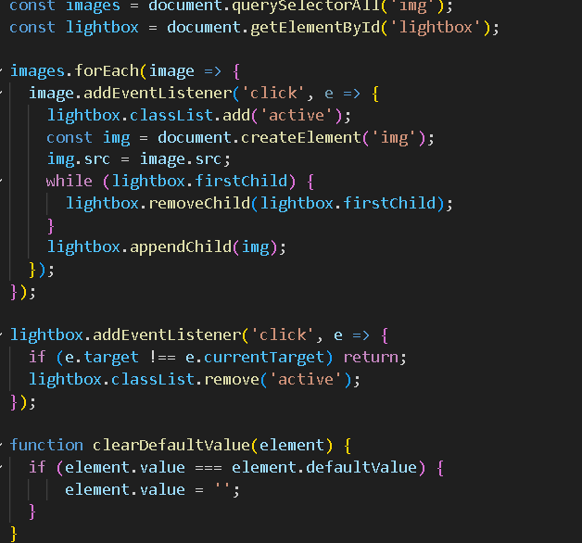

Carefully following steps from a YouTube video, I was able to successfully implement a light box for my website's gallery allowing viewers to click on one of the mages they would like to see on the gallery, and it would pop up bigger for better viewing.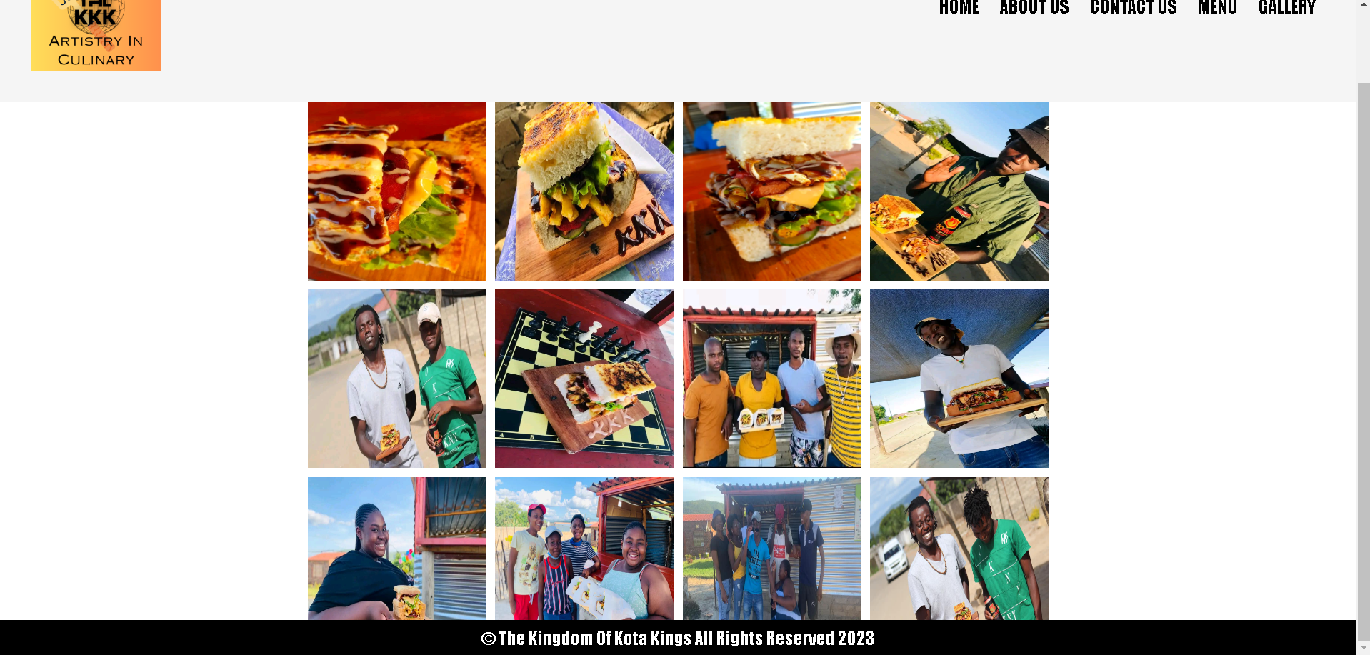

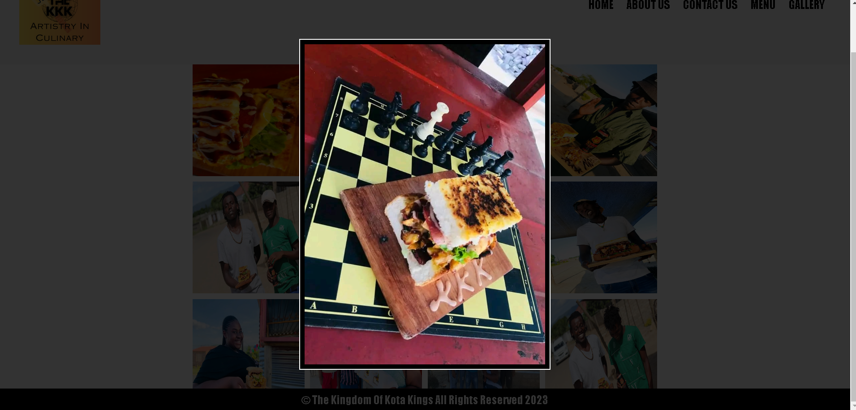

All a viewer needs to do is click on the desired picture and a lightbox effect would take place.

SEO:

* Meta description for each page: for my webpage to be more SEO-valid, I had to add a meta description of every page on the head element. These descriptions can help improve the click-through rate from search engine results pages and provide users with a clear idea of your website's content.
* Mobile Responsiveness: I had to ensure that my website is mobile-responsive because Google favors mobile-friendly websites in its search results.

***Website pages***

1.Home page

* Contains information on what The KKK business is about
* Has a navigation bar that takes to other websites
* Will have A background image of the logo embedded with their slogan

2.About us

* Has information on what drives the owners to start this business
* Has working hours for customers to know when they open and what time
* Contains delivery contact and fees during loadshedding

3.Contact us

* Contains location of the business
* Contains their contacts
* Contains their facebook page

4.Menu

* This page has the menu of the business that has product pictures, ingredients and prices

5.Products and services

* This page has pictures to display satisfied customers and well displayed products incase customers would be curious to see the businesses progress or legitimacy

***Reference list***

1. <https://www.canva.com/design/DAFuEyn8Sz0/SV3yUHaNpJv95aPrK2z3QA/edit>

* Website I used to create the KKK logo with slogan which will be displayed in the background

2. this link is for the KKK official facebook page where I qouted some of their texts along with the images used used to show their content <https://www.facebook.com/groups/2416495721977350>

* “Health Is Wealth, For Health is Life And Life Is Wealth❤✌🏿🙌🏿 The mission is to provide Classic Health Junk🥪🥙❤ A Dignified Kasi Meal at an Affordable Price🥪🥙❤”
* “All the way from Limpopo in the deep tropics of Tzaneen in Nkowa-Nkowa. A kingdom of Young hustlers striving to succeed through the Streets.<br>
* Where it all Started as a Thought to sell Kotas, a year Later we're still kicking serving the people of Nkowa-Nkowa Its not what we envisioned yet it came with better lessons. Quit, Start, and Grow, so far we're still on a right track. Food and Friends, Life And Love, The Bond that bind us Together We hope that we serve you well as kings serve their Kingdoms It's KKK Till Forever”
* “Love is the first ingridient we put in our food with every bite you can taste the passion, dedication and pure intentions we give into making the most perfect kota you have tasted”

3. <https://ionic.io/ionicons> is an icon making website

* is the website I used to create the Facebook icon that takes u to their page when clicked on it
* The contact icons were added using this website

4. <https://youtu.be/sGQSz22U8VM>

[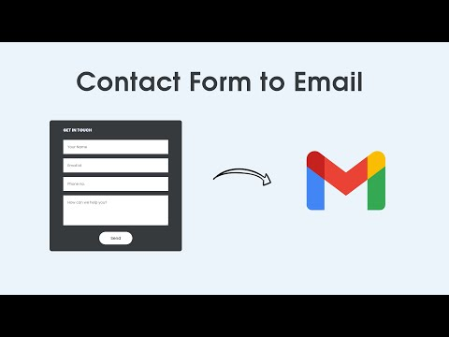](https://youtu.be/sGQSz22U8VM)

<https://youtu.be/uKVVSwXdLr0?t=218>

[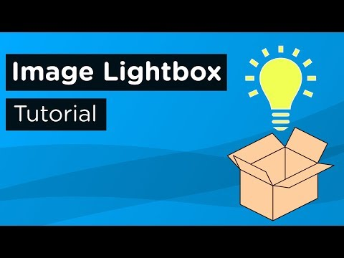](https://youtu.be/uKVVSwXdLr0?t=218)