We are now ready to build our scene in Unity. First, we need a fresh new Unity project with an installed version of iCanScript. For the purpose of this tutorial, the project will be named "Houpi Youpi" (I don't know how to call it! So please bear with me...).

Open Unity and select the `File->New Project...` menu item as shown in the image below:

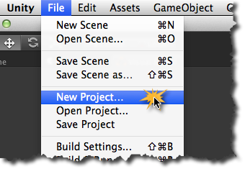
[<$figure=unity-new-project>. Create a new Unity project.]

Next you will be asked for a project name and prompted to install standard Unity packages. Enter _"HoupiYoupi"_ as the project name. None of the Unity packages will be required for this tutorial. So don't select any and close the dialog box by clicking the `Create Project` button.

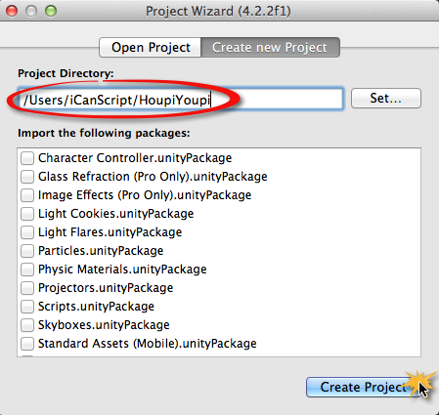
[<$figure=create-houpi-youpi>. Create _Houpi Youpi_ Project.]

You now have a bare project in which to import iCanScript. Please follow the instructions in the [installation] section to download the latest version of iCanScript if you haven't already done so. Use the `Assets->Import Package->Custom Package...` menu item to import iCanScript into your project. Once you complete the import, your project panel in Unity should look as follows:

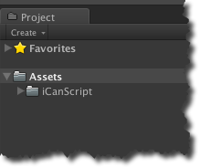
[<$figure=iCanScript-empty-project>. Unity project with the iCanScript package.]

<$page-break>

