iCanScript installs menu items to open its five (5) editors & panels in Unity's top-level _Window_ menu.

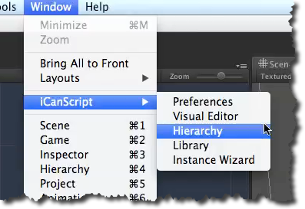
[<$figure=menu-window>. iCanscript Window menu extension.]

