{\Scrv_annot \color={\R=0.000000\G=0.000000\B=0.000000} \text=<$begin{tipbox}><$latex(\color{red})><$html(<span style="color:red">)>

Please note that the installation of iCanScript from the Unity Asset Store is currently not discussed. It will be added in future releases of this document.

<$html(</span>)><$end{tipbox}>
\end_Scrv_annot}
 iCanScript is a downloadable plugin for the Unity 3D game engine. It comes in the form of a Unity package that must be installed for each project.

The initial download of iCanScript is available from the project [website](http://www.icanscript.com). User registration is required to obtain the latest version of the iCanScript software via email. An overview of the registration, download and installation procedure is available in the following video:

[](http://youtu.be/LJIqMaUNoAU)

Follow these steps to install iCanScript for the first time:

1. Visit the iCanScript web site at [www.icanscript.com](http://www.icanscript.com);
2. Click the download button from the home page;
3. Fill-in the registration form (the email is important);
4. Shortly after, you will receive an email with the latest version of iCanScript in attachment;
5. Open the email and save the iCanScript package;
6. Launch Unity and import the iCanScript package (see Figure <$rfigure=custom-import>);
7. You are now ready to start …

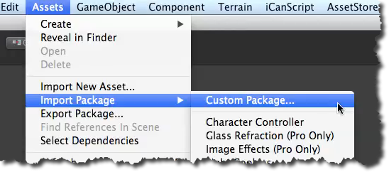
[<$figure=custom-import>. Importing iCanScript into Unity.]

You now have the knowledge to download and install iCanScript in your own project. I propose that you move on to the [quick start tutorial][] where you will build your first visual script.

{\Scrv_annot \color={\R=0.000000\G=0.000000\B=0.000000} \text=<$begin{tipbox}>
 ^^iCanScript User Interface Tips^^

---

> Subsequent software releases can be downloaded using the [upgrade][Upgrading iCanScript] feature of iCanScript.

<$end{tipbox}>
\end_Scrv_annot}

