We are now ready for our final actor: _Mr Cube_. Use the `GameObject->Create Other->Cube` menu item to add _Mr Cube_ to the scene.

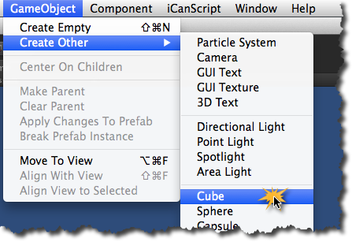
[<$figure=adding-mr-cube>. Adding Mr Cube to the scene.]

Once more, you need to set the initial parameters of the new actor. _Mr Cube_ must be configured as follows:

1. Rename the cube object to _"Mr Cube"_ (sexy!);
2. Relocate _Mr Cube_ outside both trigger zones at position (5,0,0);
3. For _Mr Cube_ to collide with the trigger zones, it must have a _Rigid Body_. Add the _Rigid Body_ to _Mr Cube_ using the `Component->Physics->RigidBody` menu item (see figure <$rfigure=adding-rigid-body>);
4. The _Rigid Body_ component is configured to use gravity by default. Our land of _Emptiness_ is deprived of this _Newtonian_ concept and therefore requires that you remove all gravity behaviour. Select the _Rigid Body_ component of _Mr Cube_ and uncheck the `Use Gravity` checkbox as illustrated in figure <$rfigure=remove-gravity-from-mr-cube>.

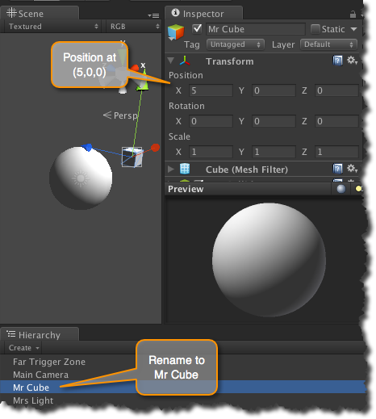
[<$figure=config-mr-cube>. Adjusting Name and Position of Mr Cube.]

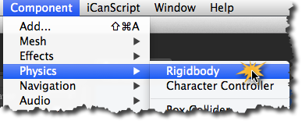
[<$figure=adding-rigid-body>. Adding a Rigid Body to Mr Cube.]

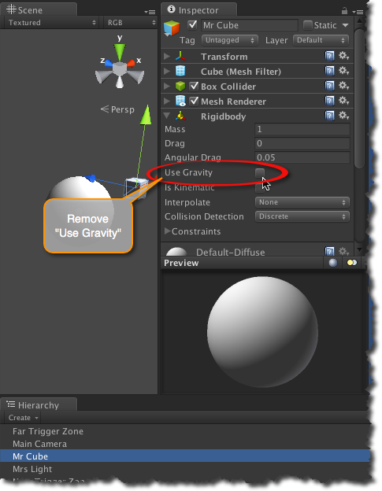
[<$figure=remove-gravity-from-mr-cube>. Removing gravity from Mr Cube.]

