All of our actors are now included in the scene. However, we still need to make one last adjustment: hide the trigger zones.

The trigger zones are the _"magic"_ that makes actors change behaviour and everyone knows that _"magic"_ must be invisible. So, let's hide those spheres for no one to see. To hide the trigger zones, you need to disable the _Mesh Renderer_ as depicted in the below figure.

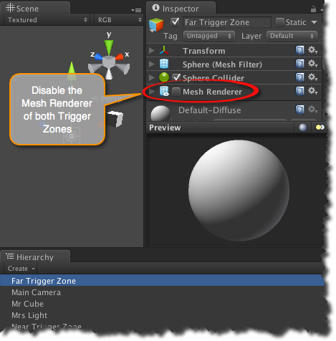
[<$figure=disable-trigger-zones-mesh-renderer>. Disable the Mesh Renderer of both Trigger Zones.]

{\Scrv_annot \color={\R=0.000000\G=0.000000\B=0.000000} \text=<$begin{tipbox}>
 ^^Unity Tips^^

---
**What's a Renderer?**
> The **renderer** is the Unity entity responsible for drawing the scene objects. Each object in a Unity scene includes a renderer component to control its drawing properties. By disabling the **Mesh Renderer**, you are telling Unity to forgo the drawing of the trigger zones hence hiding them from the user. Hiding the trigger zones does not change the behaviour of other components such as collision detection that is dear to us.

<$end{tipbox}>
\end_Scrv_annot}

You are now ready to build your visual scripts!!!
> (finally you must be saying to yourself).

