_Mr Cube_ visual script will evolve to become somewhat involved as you increase its functionality. To avoid complex and overblown graphs, you should consider structuring the visual script from its inception.

The following diagram depicts the high-level design of the visual script you will create for Mr Cube:

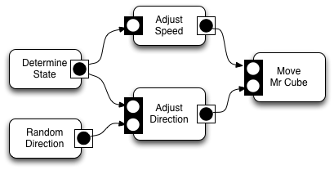
[<$figure=mr-cube-script-overview>. _Mr Cube_ visual script overview.]

It's good practice to segregate and encapsulate functionality into tight bundles and iCanScript has the right _Composite_ node to do so: (drum roll...) the '_**Package**_'.

The _Package_ is iCanScript most flexible node. It can contain complex graphs and expose only those ports that are made public by the visual script designer. To modify a _Package_, it will need to be _**unfolded**_, showing its internal graph. Once you have completed its functionality, you may want to _**fold**_ it so that it displays as a singular node or _**iconize**_ it to reduce visual clutter.

The following diagram shows the controls to fold/unfold and iconize a _Package_ node.

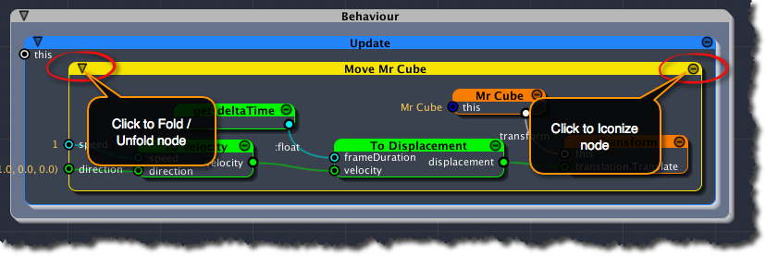
[<$figure=node-display-state-controls>. Node display state controls.]

