The following steps are needed to uninstall iCanScript from your project:

* Remove the _**iCanScript**_ folder;
* Open the _Gizmos_ folder and remove the _**iCanScriptGizmo.png**_ file;
* Remove the optional _**iCanScript_Nodes**_ package;

{\Scrv_annot \color={\R=0.000000\G=0.000000\B=0.000000} \text=<$begin{tipbox}>
 **Note:** Uninstalling the previous version of iCanScript is required when performing an upgrade.

<$end{tipbox}>
\end_Scrv_annot}
!{-2col-

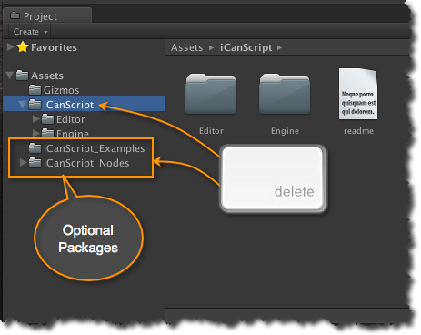
[<$figure=remove-package>. Uninstalling the iCanScript packages.]

!-2col-|

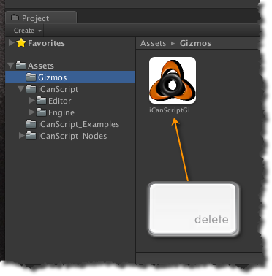
[<$figure=remove-gizmo>. Removing the iCanScript Gizmo.]

!-2col-}

