Improvements to iCanScript are regularly made available as downloadable software updates.

The following steps are needed to verify for and update to the latest version of iCanScript:

1. Verify for an update using the menu item: `Help->iCanScript->Check for Updates…`;
2. If an update is available, a dialog box will guide you to the download page;
3. Download the latest version of iCanScript;
4. Open Unity and uninstall the current version of iCanScript (see [Removing iCanScript]);
5. Import the latest version of iCanScript (see [Installation]);
6. An alert box will be shown if data conversion is required after the upgrade;
- data conversion is performed in memory;
- each visual script data is converted independently;
- converted data is persisted when the scene is saved;
- data rollback is performed if scene is not saved after an upgrade.
7. Save the scene to complete the upgrade.

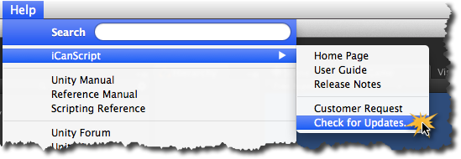
[<$figure=iCanScript-menu-check-for-updates>. Verifying for an update.]

