Before displaying a new frame, Unity sends an _Update_ message to each game object in the scene asking them to prepare for the upcoming frame. This _Update_ message is ideal to trigger the execution of the visual script to move _Mr Cube_. It gives you the chance to recompute _Mr Cube_ position immediately before the scene is displayed.

Your next step is to install the _Update_ message handler node whom will serve as the parent trigger for your visual script. The creation of the _Update_ message handler node is realized as follows:

1- Right click on the _Behaviour_ node to reveal the list of message handlers it supports;
2- Click the `+ Update` menu item to install the message handler node;

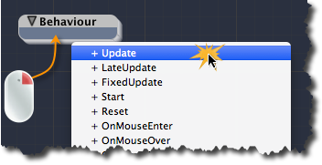
[<$figure=installing-update-message-handler>. Installing the Update message handler.]

A new child node called _Update_ is create inside the _Behaviour_ node. The _Update_ node is blue indicating that it is a message handler. You are now ready to create the visual script to move _Mr Cube_ inside the _Update_ node.

