Your next task is to feed a displacement value to the _Translate_ operation of _Mr Cube_. While this seams easy, it does present a challenge...

**The Challenge:**
The problem is that the displacement is applied for each frame and that the frame rate (# of frames / second) is dependent on the performance of the computer or gaming platform. This means that if the same displacement value is applied, _Mr Cube_ will move lightning fast on high-end gaming computers and turtle slow on entry level portable devices.

**The Solution:**
To maintain constant velocity on all platform regardless of their performance, you need to adjust the magnitude of the displacement according to the frame rate. So how do you do that?

As starters, you need to control the velocity of _Mr Cube_ and derive the displacement from it. The displacement is computed by equation #<$n#equation:calculate_displacement>:

{\Scrv_annot \color={\R=0.000000\G=0.000000\B=0.000000} \text=<$begin{tipbox}>
**Eq. #<$n:equation:calculate_displacement>. Calculation of the displacement for a frame**

displacement= velocity * frame_duration;

<$end{tipbox}>
\end_Scrv_annot}
The result of this equation is that higher the frame rate, smaller are the displacement values added to the movement for each frame. Therefore, the velocity is maintained irrespectively of the computing performance.

From equation <$n:equation:calculate_displacement>, you need to bring in play an operator that multiplies the velocity (a _Vector3_ value) and the frame duration (a _scalar_ value).

Using the search field in the iCanScript library, type the characters _"mul"_ to reveal the available multiply operators. Drag the multiply operation under the _Vector3_ type into the _Move Mr Cube_ package as depicted in figure <$rfigure=adding-velocity-to-displacement-node>.

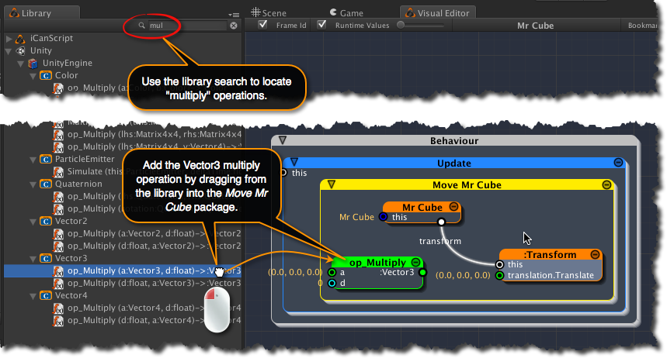
[<$figure=adding-velocity-to-displacement-node>. Adding a function to convert velocity into displacement.]

The _"op\_Multiply"_ node is coloured green indicating that it is a function. Functions are created outside iCanScript and imported into the iCanScript library. In this particular case, the multiply operator is a member function of the _Vector3_ class that is part of the Unity Engine library (the hierarchy in the _Library Tree_ is reminiscence of this structure).

The new node is created with generic names. To improve on the clarity of the visual script, you should rename the node and its ports to reflect the intended functionality.

Follow these steps to rename the _op\_Multiply_ node:

1. Right click on the _"op\_Multiply"_ node to bring up the context menu;
2. Select the _Show in Hierarchy_ menu item;
3. From the hierarchy tree, unfold the node and rename it and its ports as depicted in figure <$rfigure=renaming-to-displacement-node>.

{\Scrv_annot \color={\R=0.000000\G=0.000000\B=0.000000} \text=<$begin{tipbox}>
 ^^iCanScript User Interface Tips^^

---

> You need to double click on the name in the hierarchy tree to edit it.

<$end{tipbox}>
\end_Scrv_annot}

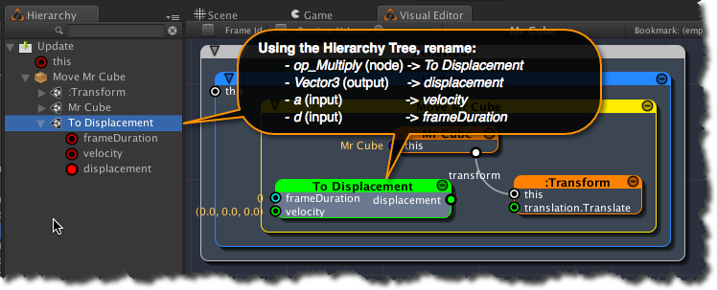
[<$figure=renaming-to-displacement-node>. Renaming the node that converts the velocity to a displacement.]

The next step is to bind the _displacement_ output port of the _To Displacement_ node to the _translation_ input port on the _Transform_ node. This is super simple to accomplish: just drag the _"displacement"_ port onto the _"translation.Translate"_ port and ... Voilà! it's done. Now the computed displacement changes the position of _Mr Cube_ on every frame.

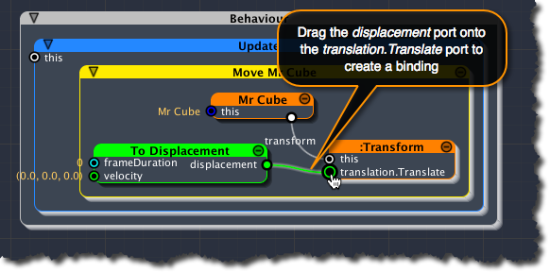
[<$figure=bind-displacement-to-translation>. Bind the computed displacement to Mr Cube transform.]

You are still missing the frame duration value. Unity has us covered with that. The _Time_ type supports several time related functions. The duration of the last executed frame is held in a variable named <u>_deltaTime_</u>.

Start typing _"delta"_ in the search field of the _Library_ panel to expose the _deltaTime_ variable. You should see it under the _Time_ type of the UnityEngine section.

Drag it from the library into the _Move Mr Cube_ package and bind its output (named _:float_) to the _frameDuration_ input of the _To Displacement_ node. The final result should look like figure <$rfigure=adding-delta-time>.

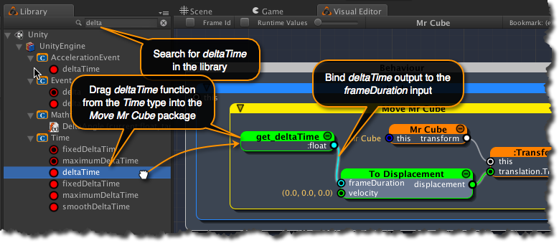
[<$figure=adding-delta-time>. Adding frame duration for displacement computation.]

{\Scrv_annot \color={\R=0.000000\G=0.000000\B=0.000000} \text=<$begin{tipbox}>
 ^^Unity Tips^^

---

**The _CharacterController_ component:**

> Advised users of Unity will have noticed that we have reproduced the functionality to move a game object using relative speed; a functionality that is available in the _CharacterController_ component.

> We have deliberately avoided the _CharacterController_ to focus the learning experience on building visual scripts. The _CharacterController_ offers many features that are beyond the scope of this tutorial. We strongly advise that you take some time to learn about the _CharacterController_ before building large on complex projects with Unity.

<$end{tipbox}>
\end_Scrv_annot}

