The [Tagging your Source Code] and [Importing Public Members] installing mechanism extract existing functionality from the object definition to publish into the iCanScript library. However, they do not provide for defining message handlers for the Unity framework. This is because the Unity messages are dynamically created at runtime and are therefore not visible in the object definitions.

The message handler in iCanScript has the following characteristics:

* it is a parent node (aggregate node);
* it includes child nodes that create the behaviour of the message;
* it has input and output ports that map the received message signature.

The following image depicts a game object behaviour with four (4) message handlers:

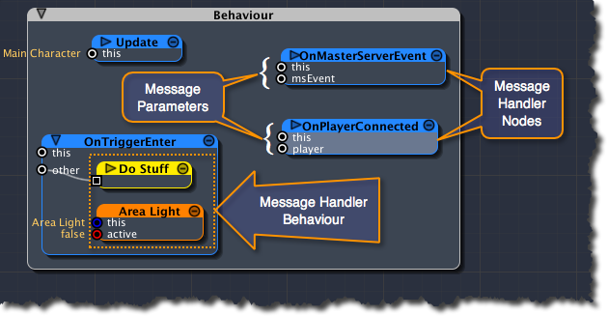

[Figure <$n:figure>. Behaviour Message Handlers Example.]

