Let's start by adding _Ms Light_. Select the _**GameObject->Create Other->Directional Light**_ menu and, _swoosh ... Ms Light_ appears.

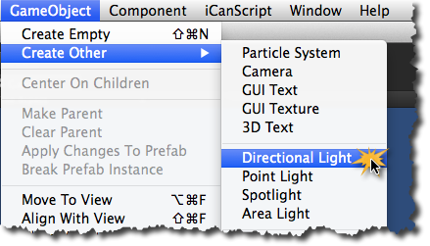
[Figure <$n:figure:adding-mrs-light>. Adding Ms Light to the scene.]

Double click on the _"Directional light"_ label in the hierarchy panel to rename it to _"Ms Light"_. Because _Ms Light_ is a directional light, she lights the scene equally regardless of her position. For consistency shake with our story, I suggest you position her at (0,0,0) as show in Figure <$n#figure:config-mrs-light>.

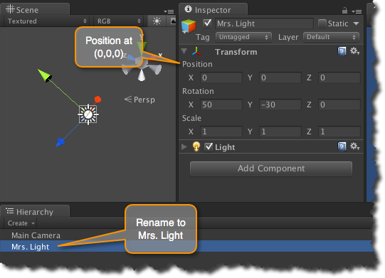
[Figure <$n:figure:config-mrs-light>. Renaming and positioning Ms Light.]

{\Scrv_annot \color={\R=0.000000\G=0.000000\B=0.000000} \text=TIPBOX:
######  Unity Tips

---
**What's a Directional Light?**
> A **directional light** illuminates the scene with uniform intensity regardless of the distance from the light source. It is often used to simulate the sun. Its light direction and color can be configured to create various time-of-day effects and neat extra-terrestrial atmospheres. The default color and direction of the directional light source is adequate for our example.

\end_Scrv_annot}

