iCanScript extends Unity's `Edit` menu with navigation features and the ability to create a Visual script as depicted in the below figure.

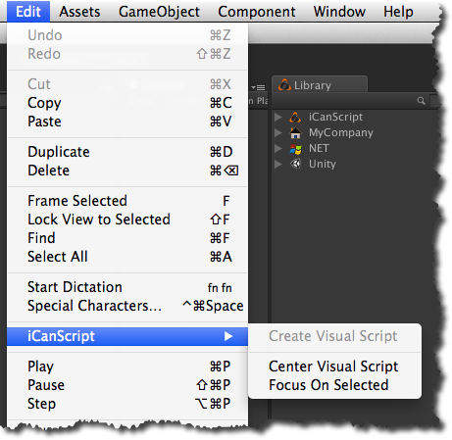
[<$figure=edit-menu>. iCanScript Edit menu extension.]

