It's now time to put beef into your hamburger! The first ingredient you need is _Mr Cube_. He can be brought into the visual script by dragging him from Unity's Hierarchy panel into the _Move Mr Cube_ package (see figure <$rfigure=drag-and-drop-mr-cube>).

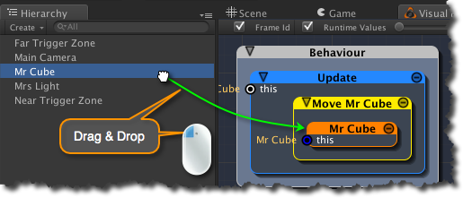
[<$figure=drag-and-drop-mr-cube>. Adding Mr Cube to the _Move Mr Cube_ package.]

The new _Mr Cube_ node is coloured orange indicating that it is an instance of an entity. Factually, _Mr Cube_ is an instance of a _Game Object_: a complex entity that contains several components defining its capabilities.

{\Scrv_annot \color={\R=0.000000\G=0.000000\B=0.000000} \text=<$begin{tipbox}>
 ^^iCanScript User Interface Tips^^

---

**Instance Nodes and the _Instance Wizard_**
iCanScript includes a dedicated editor called the _Instance Wizard_ to manage the variables and operations associated with nodes representing object instances. The _Instance Wizard_ is automatically brought forward when such a node is selected.

Using a simple point-and-click interface, the _Instance Wizard_ can expose or hide the internal variables and operations of the instance. It is divided in three (3) sections:

**Instance (top section):**
> The top section consists of a drop down menu that lists the available functions to create an instance of the proper node type and bind it to the _'this'_ port. Since we have dragged in _Mr Cube_, iCanScript has assumed that the instance should be set to the _Mr Cube_ game object.

**Variables (middle section):**
> The middle section displays all of the variables (fields & properties) of the instance. You may expose those variables as input and/or output ports by modifying the checkbox on the left of the variable name.

**Operations (bottom section):**
> The bottom section gives access to the operations available for the instance as a list of buttons. Clicking on the operation name exposes that operation on the instance node. Clicking again removes the operation.

<$end{tipbox}>
\end_Scrv_annot}

