I bet your fingers are twitching to give your new script a go.

Before you do so, you need to configure initial values for the _speed_ and _direction_ ports. The initial values are configured using the _Inspector_.

Make certain that the _Mr Cube_ game object is selected and open the _Inspector_. You will see that a _visual script component_ is installed on _Mr Cube_. Unfold the _visual script component_ and you will see that it contains two sections:

- a _**Selected Object**_ section and;
- an _**Engine Selected Object**_ section.

You will be using the _Selected Object_ section to configure the _"speed"_ and _"direction"_ ports. Unfold the _Selected Object_ section if it is folded.

With the _Inspector_ open, select the _speed_ port in the visual editor. You will see the details of the port presented in the visual script component. Change the speed value from zero (0) to one (1).

Now select the _direction_ port in the visual editor. The _Inspector_ information will change to match your new selection. Change the _direction_ value from (0,0,0) to (-1,0,0).

You are all done; the initial values are now configured.

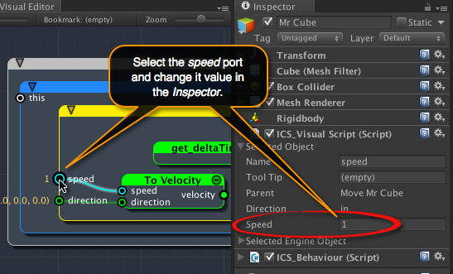
[<$figure=change-speed>. Change speed to 1.]

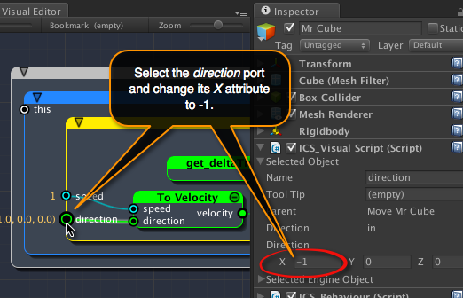
[<$figure=change-direction>. Change direction to (-1,0,0).]

Hit the run button at the top of the Unity editor to give it a whirl (yeh!!!).

iCanScript compiles and runs your script. _Mr Cube_ will start moving towards the centre of the scene (0,0,0) and continues forever in the same direction.

You can configure different values of direction and speed while your script is running. The new values are immediately impacting the behaviour of your script. However, the values configured while the engine is running are temporary and they will revert back to their initial configured values once the Unity game engine is stopped.

{\Scrv_annot \color={\R=0.000000\G=0.000000\B=0.000000} \text=<$begin{tipbox}>
 ^^iCanScript User Interface Tips^^

---

The details of the selected node or port are accessible from the visual script component in the _Inspector_. The visual script component inspector is divided in two sections:

**Selected Object:**
> This section allows to view and configure the attributes of the selected node or port.

**Selected Engine Object:**
> This section displays in-depth information to help debug the visual script. This information will not be used in this tutorial.

<$end{tipbox}>
\end_Scrv_annot}

