Let's create a package to encapsulate the basic movement functionality of _Mr Cube_. This is achieved by:

- Right clicking on the _Update_ node to display the context sensitive menu and;
- Selecting the `+ Package` menu item.

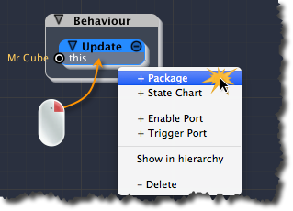
[<$figure=creating-package-in-update>. Creating the _"Move Mr Cube"_ Package.]

iCanScript adds a package node under the _Update_ message handler. By default, the package is yellow and named _":Package"_. A name that better describes the purpose of the package would be better suited. Do let's rename your new package to: _"Move Mr Cube"_.

{\Scrv_annot \color={\R=0.000000\G=0.000000\B=0.000000} \text=<$begin{tipbox}>
 ^^iCanScript User Interface Tips^^

---
**Modifying name of visual elements:**
> Modifying the node or port name is realized either from the _Inspector_ or the iCanScript _Hierarchy Tree_.

> The _Inspector_ grants detail access to the node or port that is selected in the visual script. It is however limited the selected element only and will require re-selecting if more then one element needs to be modified.

> The iCanScript _Hierarchy Tree_ offers a tree-like navigation of the entire visual script. It also allows for changing visual element names. In this tutorial, we will always use the _Hierarchy Tree_ when modifying node and port names.

<$end{tipbox}>
\end_Scrv_annot}

Let's use the _Hierarchy Tree_ to change the name of the package.

From the _Visual Editor_, right click on the _:Package_ and select the `Show in hierarchy` menu item (figure <$rfigure=show-package-in-hierarchy>). This action displays the selected node in the _Hierarchy Tree_.

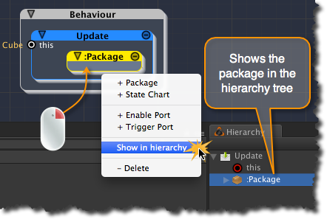
[<$figure=show-package-in-hierarchy>. Show Package node in iCanScript Hierarchy tree.]

Double click on the package name in the _Hierarchy Tree_ to modify it to _"Move Mr Cube"_ (figure <$rfigure=renaming-move-mr-cube-package>).

{\Scrv_annot \color={\R=0.000000\G=0.000000\B=0.000000} \text=<$begin{tipbox}>
 **Note:** The _Visual Editor_ and _Hierarchy Tree_ are two views into the visual script. This means that modifications done in the _Hierarchy Tree_ are reflected in the _Visual Editor_ and vice-versa.

<$end{tipbox}>
\end_Scrv_annot}

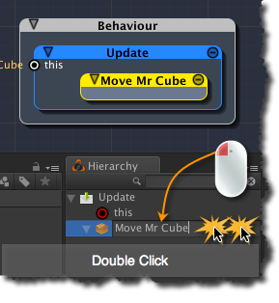
[<$figure=renaming-move-mr-cube-package>. Renaming the package to _Move Mr Cube_.]

