In Unity, a game object and its components form a group of inter-related objects. The game object maintains a list of all of its components and each component keeps a reference back to the game object as depicted in figure <$rfigure=game-object-composition>.

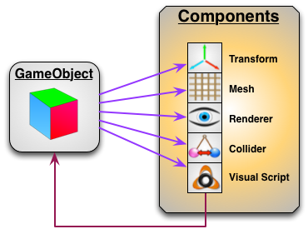
[<$figure=game-object-composition>. Unity _Game Object_ and associated _Components_.]

To gain access to a component of the game object, you first need to extract it as a separate instance node. You can then interact with the component variables and operations using the _Instance Wizard_.

{\Scrv_annot \color={\R=0.000000\G=0.000000\B=0.000000} \text=<$begin{tipbox}>
 ^^Unity Tips^^

---

> The number and type of components that can be attached to a game object is not limited to the listed displayed in figure <$n:figure:game-object-composition>. The Unity library includes a set of standard components and allows for extending the game object functionality with user defined components.

> When you create a visual script on a game object, you are in fact extending that game object by attaching an _iCS_VisualScript_ component to it. iCanScript then uses the iCS_VisualScript component to edit, compile and run you visual script.

<$end{tipbox}>
\end_Scrv_annot}

The component of interest for moving _Mr Cube_ is called the _Transform_. It defines the position, rotation, and scale of the game object. Moving _Mr Cube_ requires that you change its position hence change its _Transform_ component.

Exposing the _Transform_ of _Mr Cube_ requires that:
1- you reveal the port associated with the _Transform_ component and then;
2- extract the transform node to gain access to its variables and operations.

**<$u=STEP #1:> Revealing the _transform_ port:**

Revealing the _transform_ port of _Mr Cube_ is a simple matter of:
- selecting the _Mr Cube_ node to reveal the _Instance Wizard_ (figure <$rfigure=reveal-mr-cube-transform>);
- clicking the checkbox on the left side of the _"transform"_ variable in the _Instance Wizard_ (you may need to scroll to the bottom of the _Variables_ section).

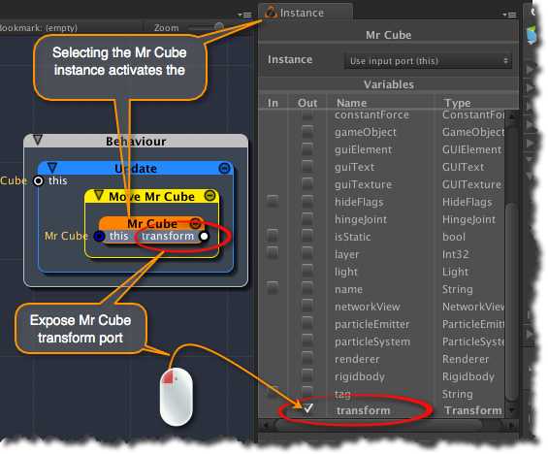
[<$figure=reveal-mr-cube-transform>. Reveal Mr Cube transform port.]

**<$u=STEP #2:> Extracting the _transform_ instance node:**

The next step is to extract the transform node from _Mr Cube_. The good news is that iCanScript includes a feature that automatically creates an instance node when you drag a port into an empty area.

Since the _Move Mr Cube_ package tightly surrounds the _Mr Cube_ node, dragging the port into an empty area inside the _Move Mr Cube_ node may be challenging (Undo can be used if mistakes are made). In the current situation, the easiest way is to drag the _transform_ port up towards the title bar of the _Move Mr Cube_ node and release it their (see figure <$rfigure=extract-mr-cube-transform>).

You can later reposition the new transform node by dragging it from its title bar. Likewise, you can relocate the ports by sliding them on the boundaries of the node.

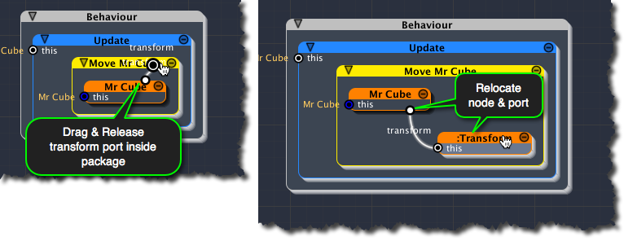
[<$figure=extract-mr-cube-transform>. Extract Mr Cube transform.]

{\Scrv_annot \color={\R=0.000000\G=0.000000\B=0.000000} \text=<$begin{tipbox}>
^^Unity Tips^^

---

**Game Object Transform:**

> Every _Game Object_ in Unity includes a _Transform_ component. The _Transform_ component defines the position, rotation, and scale of the object with respect to its parent. If no parent exists, then the _Transform_ is considered global -- relative to the world coordinates -- as for all actors in our example.

<$end{tipbox}>
\end_Scrv_annot}

