Now that you have access to the _Transform_ instance node, you can select it and browse its variables and operations using the _Instance Wizard_ (figure <$rfigure=add-mr-cube-translation>).

If you browse the _Operations_ section, you will find that the _Transform_ node includes several _Translate(...)_ operations that can be used to move _Mr Cube_. We are interested in the _Translate_ operation that utilizes a _Vector3_ type for the displacement.

To add the _Translate_ operation to your visual script, you will need to depress the `Translate(translation:Vector3)` button of the _Instance Wizard_. Once the operation is added, its button is shown as depressed and the text as bolded. Clicking the button a second time will remove the operation from the visual script. Make certain that the _Translate_ operation is added before moving on.

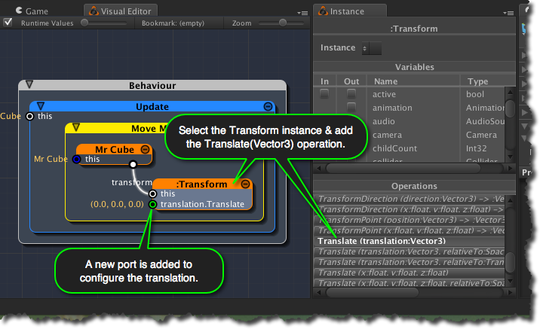
[<$figure=add-mr-cube-translation>. Add Mr Cube translation operation.]

With the _Translate_ operation added, you'll notice a new port named _"translation.Translate"_ appearing on the _Transform_ node. As you may have guessed, this new input port configures the translation to be applied by the _Translate_ operation.

The default value for the translation is (0,0,0). You will learn to create a visual script to dynamically change the translation value in the sections to follow.

