Creating a visual script with iCanScript requires that you install the iCanScript Visual Script component on your game object. The iCanScript Visual Script component can be attached using Unity's top-level _Component_ menu as well as the _Add Component_ button located in the Inspector.

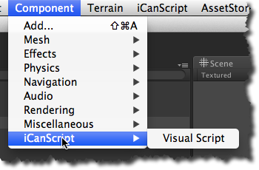
[<$figure=menu-component>. iCanScript Component menu extension.]

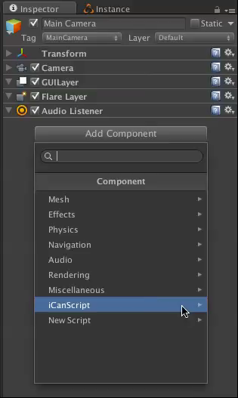
[<$figure=menu-component2>. iCanScript Inspector->Component menu extension.]

