The ***User Preferences*** is used to customize the default behaviour and the look and feel of iCanScript.

This information is saved in the user profile and applied to all iCanScript projects opened by the user.

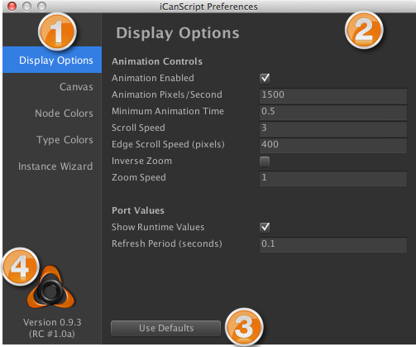
[<$figure=editor-user-preferences>. User Preferences]

 **Panel Selection:** The panel selection is used to navigate the different configuration panels available to the iCanScript user. Clicking on the panel name reveals the configuration details in the panel area.

 **Configuration Panel:** The configuration panel is the largest section of the user preference window. It includes all of the configurable attributes for the selected product area. Changing the product area will reveal a new panel with its configurable attributes. The user can modify these attributes customize the behaviour and the look and feel of iCanScript.

 **Use Defaults Button:** Clicking this button will restore all parameters of the active configuration panel to their factory default values.

 **iCanScript Version Information:** The iCanScript product version and user registration information is displayed in this area.

---

