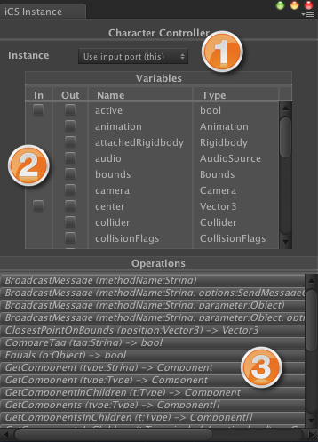
[<$figure=editor-instance-wizard>. Instance Wizard]

 **Instance Builder:** This drop-down list enumerates the available builders for the instance node selected in the visual editor. A builder for the instance node can be created by selecting an element from this list. Note that selecting the special *"Use input port (this)"* item will remove the builder (if it exists) and leave open the instance port *"this"* for manual connection.

 **Variables Selection:** Lorem ipsum dolor sit amet, sapien platea morbi dolor lacus nunc, nunc ullamcorper. Felis aliquet egestas vitae, nibh ante quis quis dolor sed mauris. Erat lectus sem ut lobortis, adipiscing ligula eleifend, sodales fringilla mattis dui nullam. Ac massa aliquet.

 **Operations Selection:** Lorem ipsum dolor sit amet, sapien platea morbi dolor lacus nunc, nunc ullamcorper. Felis aliquet egestas vitae, nibh ante quis quis dolor sed mauris. Erat lectus sem ut lobortis, adipiscing ligula eleifend, sodales fringilla mattis dui nullam. Ac massa aliquet.

