Disruptive software is pleased to announce the community and professional editions of iCanScript. iCanScript is a powerful modelling engine allowing both novices and experts to create visual scripts for the Unity Game Engine.

iCanScript integrates both multi-level functional diagrams and state charts into a single visual script. You can mix-and-match both concepts to realize your scripts in a natural way, in the same visual graph.

In addition, iCanScript supports nesting and grouping of sections of your visual script in what are referred to as packages. Packages can be folded and unfolded to work at the level of details desired at any point in time.

iCanScript provides a visual scripting environment that has a one-to-one mapping with all Unity Engine API’s. Full games can be created without a single line of code. At the same time iCanScript is designed to co-exist with code and other tools, allowing for a mix of technologies when best suited.

These capabilities put iCanScript in a class of its own, allowing for true next generation Visual Scripting!

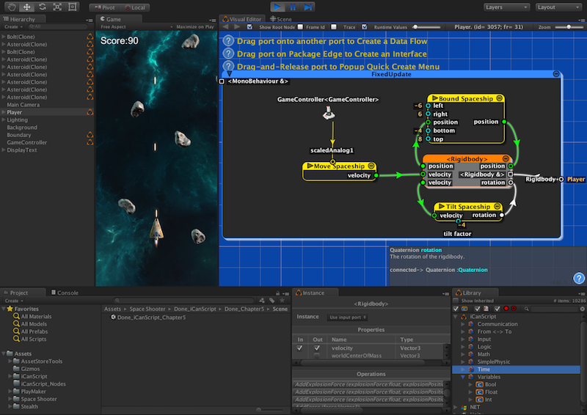
[<$figure=mkt-functional-diagram>. iCanScript _Functional Diagram_ for controlling space ship movements.]

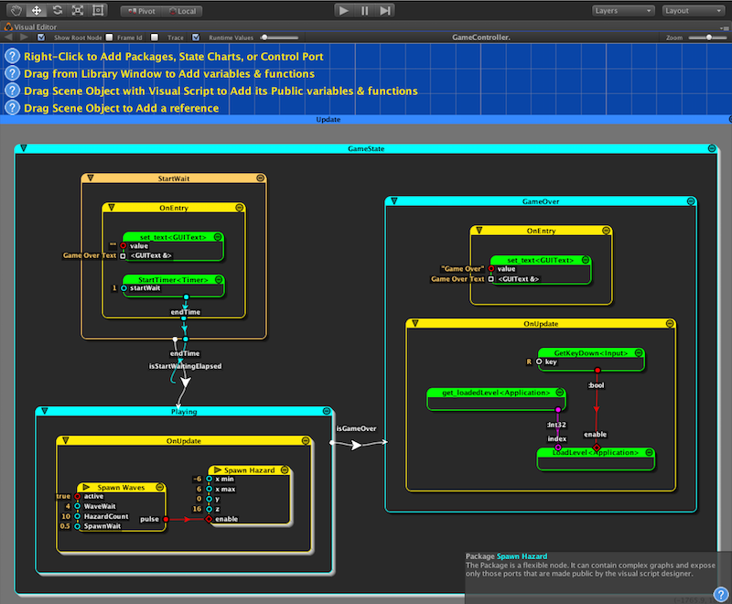
[<$figure=mkt-state-chart-diagram>. iCanScript _State Chart_ for controlling game states.]

The community edition is fully featured and targets smaller projects. The <professional edition> is not limited by project size. You are invited to try iCanScript and provide feedback that will help its continued evolution, making this product even better!

Our recreation of the “Unity Space Shooter Tutorial”, entirely scripted using iCanScript, is an excellent way to learn the basics. Install the community or professional edition of iCanScript and follow along with the tutorials: iCanScript YouTube Channel

Homepage: <http://www.icanscript.com>

Community Forum: <http://www.icanscript.com/forum>

Don’t forget to provide feedback!

