iCanScript installs its own menu for easy access to product services. These services include access to online documentation, feature request form, and product updates.

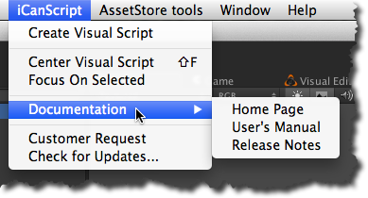
[Figure <$n:figure:iCanScriptMenu>. iCanScript Menu]

