The ***User Preferences*** is used to customize the look and feel as well as the default behaviour of iCanScript. This information is saved in the user profile and applied to all iCanScript projects opened by the user.
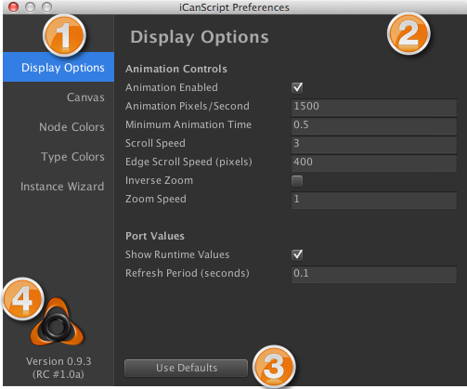
[Figure <$n:figure>. User Preferences]

![Figure <$n:figure>. User Preferences](http://www.user-guide.icanscript.com/resources/images/editor-user-preferences.png)
*Panel Selection:* The panel selection is used to navigate the different configuration panels available to the iCanScript user. Clicking on the panel name reveals the configuration details in the panel area.
![](http://www.user-guide.icanscript.com/resources/images/stamp-2-orange.png) **Configuration Panel:** Lorem ipsum dolor sit amet, sapien platea morbi dolor lacus nunc, nunc ullamcorper. Felis aliquet egestas vitae, nibh ante quis quis dolor sed mauris. Erat lectus sem ut lobortis, adipiscing ligula eleifend, sodales fringilla mattis dui nullam. Ac massa aliquet.
![](http://www.user-guide.icanscript.com/resources/images/stamp-3-orange.png) **Use Defaults Button:** Clicking this button will restore all parameters of the active configuration panel to their factory default values.
![](http://www.user-guide.icanscript.com/resources/images/stamp-4-orange.png) **iCanScript Version Information:** The iCanScript product version and user registration information is displayed in this area.
![](http://www.user-guide.icanscript.com/resources/images/stamp-1-orange.png)
[Back to Top][]
---

