iCanScript includes several .NET attributes to control which part of your source code is to be included in the iCanScript library. These attributes enables fine control over which fields, properties and functions become visible to the iCanScript user.

Populating the iCanScript library using iCanScript attribute is the recommended procedure if you are in control of the source code.

The iCanScript library can be extended with your own C# or JavaScript code. The usage of custom .NET attributes can be use to specify the functionality published to iCanScript (an alternate publishing approach is discussed in [Importing Existing Libraries]).

### iCS_Class attribute

iCanScript adds a node to its library for each class and structure marked with the *\[iCS_Class ...]* attribute. Note that iCanScript will only add *public* classes and structures.

**Example:**

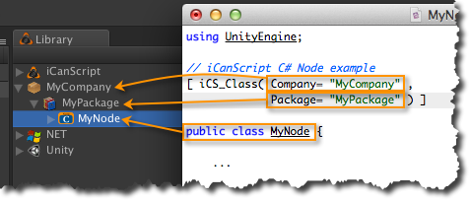
[Figure <$n:figure>. iCS_Class attribute example.]

### iCS_Function attribute

**Example:**

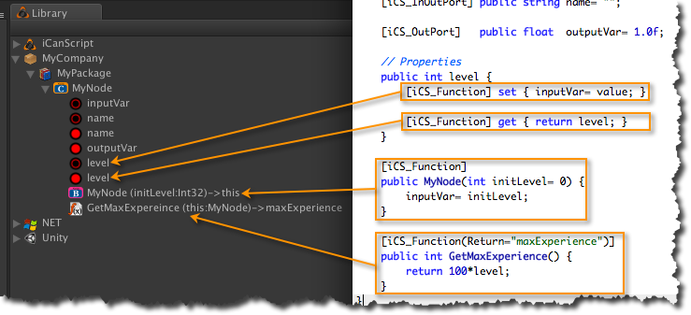
[Figure <$n:figure>. iCS_Function attribute example.]

### iCS_InPort, iCS_OutPort, and iCS_InOutPort attributes

**Example:**

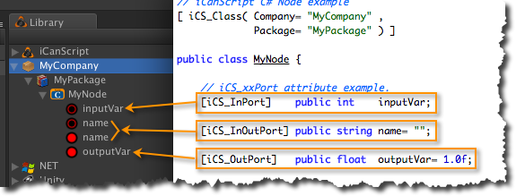
[Figure <$n:figure>. iCS_xxPort attribute example.]

### iCanScript .NET Attribute Reference

The following two tables enumerates the supported iCanScript attributes and their associated parameters:

| Attribute Name | Targets | Parameters |
| :---------------- | :----------------- | :--------- |
| **iCS_Class** | class or structure | **Company**<br>**Package**<br>**Icon**<br>**Tooltip**<br>**BaseVisibility** |
| **iCS_Function** | constructor,<br>function,<br>property get,<br>property set | **Name**<br>**Return**<br>**Icon**<br>**Tooltip** |
| **iCS_InPort** | field | |
| **iCS_OutPort** | field | |
| **iCS_InOutPort** | field | |
[Table <$n:table>. iCanScript .NET Attributes]

| Parameter Name | Type | Description |
| :----------------- | :----- | :--------------------- |
| **BaseVisibility** | bool | if true: adds the base classes public variables and functions. |
| **Company** | string | The name shown at the first level of the library tree. |
| **Icon** | string | Path to the iconic representation of the node. |
| **Name** | string | Function name substitute. |
| **Package** | string | The name shown at the second level of the library tree. |
| **Return** | string | Port name for the function *return value*. |
| **Tooltip** | string | Brief description of the component. |
[Table <$n:table>. iCanScript .NET Attribute Parameters.]

[Back to Top][]

---

