The primary ingredient of a visual script is the node. The node is the cornerstone defining specific functionalities available to the visual script designer. To that end, iCanScript offers a variety of node types classified as follows:
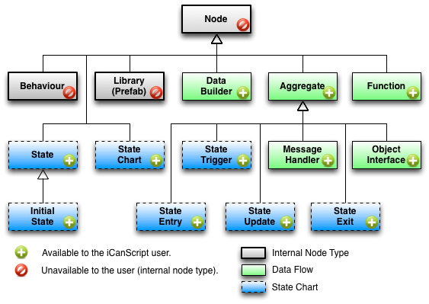
[Figure <$n:figure>. Node types classification tree.]

1. **Node:** The base for all iCanScript nodes is the *Node*. It includes a common set of attributes available to all nodes you instantiate with iCanScript.

| Attribute | Description |
| :------------------ | :-------------------------------------------- |
| **Name** | User definable node name |
| **Tooltip** | User definable short description of the node |
| **Display State** | Either *unfolded* or *iconized* |
| **Layout Position** | Display position within the visual script |
| **Parent Node** | The aggregate node containing *this* node |
| **Icon** | User definable icon to display while iconized |
| **Port List** | List of ports available on the node |
[Table <$n:table>. Node common attributes.]

2. **Function:** A *Function node* is:
* an execution building block of visual script;
* implemented externally and imported into iCanScript;
* mapped to a programmatic function of a type.

3. **Aggregate:** An *Aggregate node* is:
* a container (parent node) of nodes (children nodes);
* a base node type for node types containing child nodes;
* contains any type of node including itself;
* enables hierarchical visual script designs;
* supports the *folded* display state to hide nested nodes;
* a base for encapsulating complex logic into packages (see [Libraries & Prefabs]);

4. **Data Builder:** A *Data Builder node* is:
* use to initialize an instance of a data type;
* executes only once;
* has a single output which is the created instance (named *"this"*);
* mapped to a programmatic class constructor.

5. **Message Handler:** A *Message Handler node* is:
* use to define a behaviour on Unity message;
* an aggregate node

6. **Object Interface:** An *Object Interface node* is:

7. **State Chart:** A *State Chart node* is:

8. **State:** A *State node* is:

9. **Algorithm:** An *Algorithm node* is:

10. **State Entry:** A *State Entry node* is:

11. **State Update:** A *State Update node* is:

12. **State Exit:** A *State Exit node* is:

13. **State Trigger:** A *State Trigger node* is:

### Node Type Characteristics

The following table summarizes the characteristics of each type of node supported by iCanScript.

| Node Type || Allowed Parent |
| :------------------ | :--------- | :-------------------- |
|  **1 Behaviour** || Visual Script |
|  **3 Function** || Aggregate |
|  **4 Data Builder** || Aggregate |
|  **5 Aggregate** || Aggregate |
||  **5.1 Message Handler** | Behaviour |
||  **5.2 Object Interface** | Aggregate |
||  **5.3 Transition Trigger** | State Chart or State |
||  **5.4 State Entry** | State |
||  **5.5 State Update** | State |
||  **5.6 State Exit** | State |
|  **6 State Chart** || Aggregate |
|  **7 State** || State Chart or State |
||  **7.1 Initial State** | State Chart or State |
[Table <$n:table>. Allowed parent per node type.]

[Back to Top][]

