The _node_ is by far the most elaborate component of visual scripts. It plays a key role in the structure, execution, and layout of the visual script.

All nodes in iCanScript share a common set of attributes:

- **Name:** A character string representation of the node;
- **Type:** Identifies the node specialization.
- **Tree-like Hierarchical Structure:**
- A parent node;
- Zero or more child components:
- _Ports_;
- _Child Nodes_ (nested Visual Script).
- **Graphical Representation:** (see figure <$rfigure=ics-hierarchy-tree-example>
- Position within the parent node;
- Display State:
- _Unfolded_;
- _Folded_; or
- _Iconized_.

The following image depicts an unfolded node as seen in the _Visual Editor_:

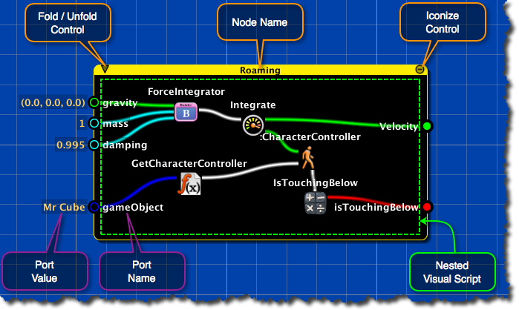
[<$figure=ics-node-anatomy>. Anatomy of an unfolded node as seen in the _Visual Editor_.]

The following image depicts the same unfolded node as seen in the _Tree View_:

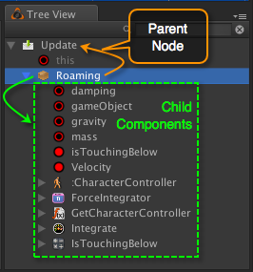
[<$figure=ics-hierarchy-tree-example>. Anatomy of an unfolded node as seen in the _Tree View_.]

1. **Node Name:** User configurable name for the node. The name is editable in the inspector or the hierarchy tree. The programmatic function / type name is used by default.
2. **Iconize Control:** Clicking this pictogram causes the node to take its iconic representation.
3. **Fold/Unfold Control:** Clicking this pictogram toggles the node between its folded and unfolded representation. The fold/unfold control is available only for those node types that can contain nested visual scripts. (see [Node Types] for details).
4. **Node Ports:** Ports are positioned on any of the four node edges.
- _Port Name_ is displayed inside the node;
- _Port Value_ is display outside the node.
5. **Nested Visual Script:** The central area of the node is used to manage the nested child nodes. The child node container is only visible when the node is unfolded. See section [Node Types] for details on which node types support nested children.

