You are almost ready to create your first visual script. Before you do so, you need to open the following four iCanScript editors:

- Visual Editor;
- Library Tree;
- Hierarchy Tree and;
- Instance Wizard.

All of the editors can be opened for the `Window->iCanScript->...` menu item. The _Visual Editor_ requires a significant screen area so I propose that you combine it with the _Scene_ or _Game_ window. All of the other editors are narrow and tall and may be combine with the Unity _Project_, _Hierarchy_, or _Inspector_ panels.

My preferred window setup for working with iCanScript is:

- the _**Visual Editor**_ is combined with _Unity's Scene_;
- the _**Library Tree**_ and _**Hierarchy Tree**_ share the bottom section with _Unity's Project_ and;
- the _**Instance Wizard**_ is combined with _Unity's Inspector_.

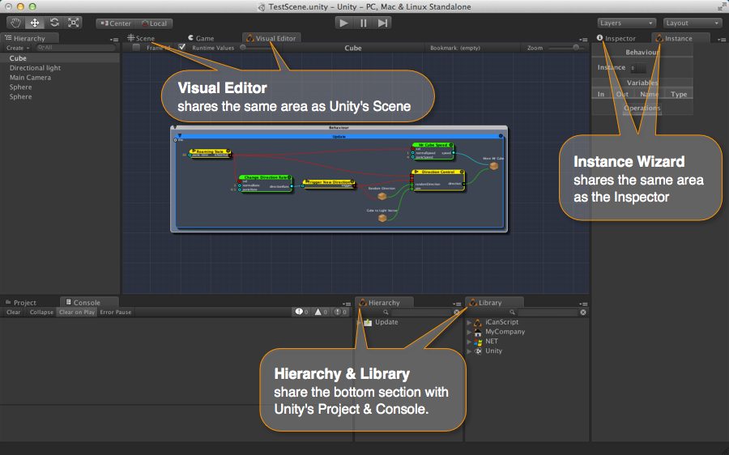
[<$figure=icanscript-window-layout>. Proposed iCanScript Window Layout.]

Of course the layout is a matter of taste and you should organize it to your licking (a two screen layout is the best!).

