Now you have completed the functionality of the _Move Mr Cube_ package. The last step is to publish the _speed_ and _direction_ ports so that they can be accessed from outside the _Move Mr Cube_ package. This is easily done by dragging them on the left edge of the _Move Mr Cube_ package. The final build of the _Move Mr Cube_ package can be seen in figure <$rfigure=publish-speed-and-direction>.

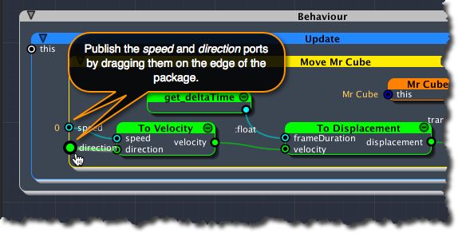
[<$figure=publish-speed-and-direction>. Publish speed and direction ports.]

