Let's take this opportunity to discuss some of the basic debugging features of iCanScript.

The visual editor remains active while the script is running. Selecting the visual editor tab will bring it forward. You may decide to relocate it so that both the visual editor and the game window be visible.

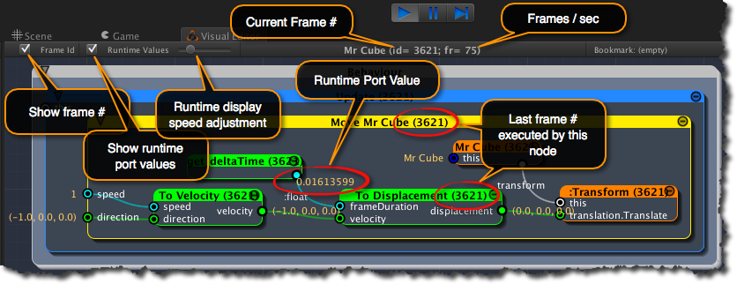
[<$figure=runtime-debug-overview>. iCanScript Visual Editor with runtime debug information.]

The visual editor displays the following runtime information in the centre of it's toolbar:

- the current frame #;
- the average frame rate (in frames / sec).

In addition, the Visual Editor toolbar includes several options to control the display of runtime information. These options are:

**Enable/Disable display of the frame #**
: Enable this control to display the last executed frame # in the title bar of each node. The display of the last executed frame # is especially useful when conditional execution is used. It helps differentiate the nodes that are executing from the nodes that are stalled.

**Enable/Disable display of port values**
: Enable this control to display the runtime values of the ports. The runtime values are displayed in beige and are periodically refreshed.

**Slider to control the refresh period**
: This slider is used to control the frequency at which the runtime information is displayed in the visual editor. Depending on the performance of your computer, the display of runtime information could impair on the frame rate of your game. Reducing the refresh rate of the runtime information will reduce the performance impact on your game.

