The two trigger zones are spheric in shape and are create with the `GameObject->Create Other->Sphere` menu.

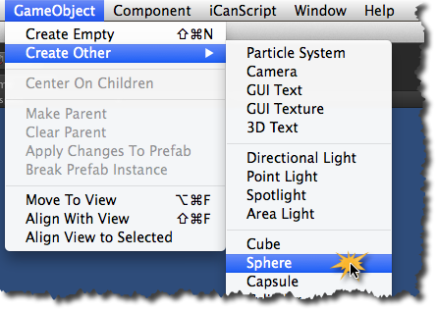
[<$figure=adding-trigger-zones>. Adding Trigger Zones to the Scene.]

After you have created both _trigger zones_, you need to configure them as follows:

1. Name one of them _"Near Trigger Zone"_ and the other _"Far Trigger Zone"_;
2. As for _Ms Light_, position both trigger zones at (0,0,0);
3. Now resize the _"Near Trigger Zone"_ to 2 meters and the _"Far Trigger Zone"_ to 3 meters by setting the scale to (2,2,2) and (3,3,3) respectively;
4. The final step is to enable the **trigger** behaviour of both spheres. This is realized by clicking the `Is Trigger` checkbox in the _Sphere Collider_ component of the trigger zones (see <$rfigure=config-trigger-zones>).

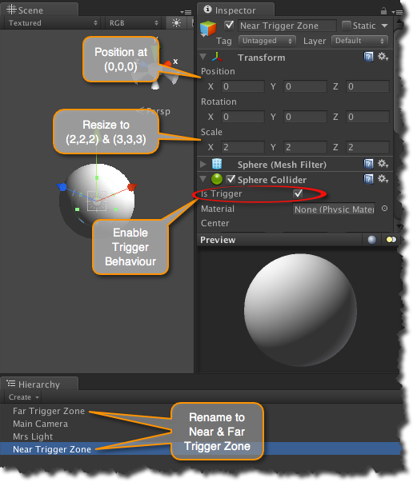
[<$figure=config-trigger-zones>. Configuring Near & Far Trigger Zones.]

