Referencing back to the [overview of the visual script][Visual Script Overview] depicted in figure <$rfigure=mr-cube-script-overview>, you will notice that the _Move Mr Cube_ package receives its input values from the _Adjust Direction_ & _Adjust Speed_ packages (you will build these packages later on). This means that separate controls for direction and speed are required.

Your next task is to extend your visual script to:

- accept two (2) inputs: a _direction_ and a _speed_ value;
- compute the velocity value from the _direction_ and _speed_ inputs;
- bind the "computed velocity" to the _velocity_ input of the _To Displacement_ node created in the previous section.

In our example, the _speed_ and _direction_ are defined as:

- the distance travel in one (1) second and;
- a unit vector pointing in the direction of movement;

respectively.

From these definitions, you can calculate the velocity by scaling the direction vector (a unit vector) by the speed (a scale value) as described in equation #<$n#equation:calculate_velocity>:

{\Scrv_annot \color={\R=0.000000\G=0.000000\B=0.000000} \text=<$begin{tipbox}>
**Eq. #<$n:equation:calculate_velocity>. Calculation of the velocity.**

velocity = speed * direction

<$end{tipbox}>
\end_Scrv_annot}

{\Scrv_annot \color={\R=0.000000\G=0.000000\B=0.000000} \text=<$begin{tipbox}>
 **Note:** A _unit vector_ is a vector who's length is equal to one (1).

<$end{tipbox}>
\end_Scrv_annot}
Equation #<$n#equation:calculate_velocity> has exactly the same structure as the displacement calculation performed in the previous section: you need to multiply a vector value and a scaler value. This is your chance at trying another cool feature of iCanScript: **node cloning** (without social or legal issues!!!).

To clone the multiply operator, you need to press the `Shift` key and drag the _To Displacement_ node in an empty area inside the _Move Mr Cube_ package (see figure <$rfigure=duplicate-vector-scale>).

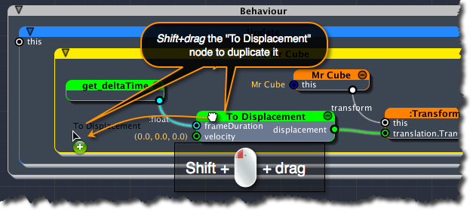
[<$figure=duplicate-vector-scale>. Duplicating the vector scale node.]

Once more, you should rename the node and ports to better describe the intent. Use the _Hierarchy Tree_ as you have done for the _To Displacement_ node to rename the new node and its ports as shown in figure <$rfigure=rename-to-velocity-node>.

You also need to bind the _velocity_ output port of the new _To Velocity_ node to the _velocity_ input port of the _To Displacement_ node.

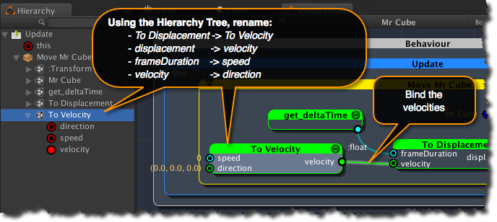
[<$figure=rename-to-velocity-node>. Properly rename the "To Velocity" node.]

