iCanScript extends Unity's `Help` menu to provide quick access to the product web site, documentation and support pages.

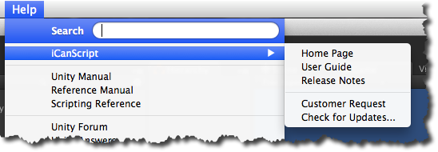
[<$figure=help-menu>. iCanScript Help menu extension.]

