iCanScript installs menu items to open its five (5) editors & panels in Unity's top-level *Window* menu.

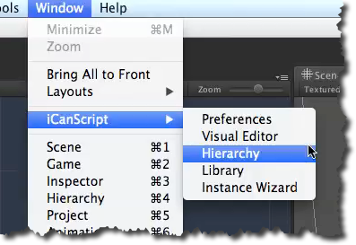
[Figure <$n:figure:iCanScriptWindowMenu>. iCanscript Window Menu]

