COMP 4421 Assignment 1 (written section)

Student: LEE Lok Yin (20450512)

1a)

To demonstrate the different of two sequences, let High-frequency emphasis be (1) and Histogram equalization be (2).

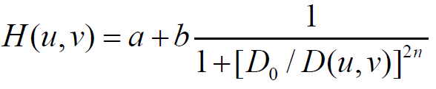

According to the definition mention in class, h(x,y) is the High-frequency emphasis function H(u,v) after Fourier transform. It involves convolution operation between input f(x,y) and h(x,y). However, Histogram equalization is a linear operation which can written as T[f] function.

For apply high-frequency emphasis first,

g(x,y) = T[h(x,y) \* f(x,y)]

For apply Histogram equalization first,

g(x,y) = h(x,y) \* T[f(x,y)]

Thus, the result of them are different.

1b)

To sharpen edge and remain high contrast at the same time, the procedure should be applying high-frequency emphasis first then progress histogram equalization. The high-frequency emphasis can extract the edge detail by apply a high pass filter at frequency domain but may also concentrate the intensity. The following histogram equalization can restore the intensity balance. If the procedure reversed, the effect of contrast will lost in consecutive filtering operation that output a low contrast image.