Group: 10
Group Members | BITS ID | Email ID
AKKIREDDY PRANITH | 2024AC05473 | 2024ac05473@wilp.bits-pilani.ac.in
PARTHASARATHY S | 2024AC05224 | 2024ac05224@wilp.bits-pilani.ac.in
RAJ KUMAR M | 2024AD05110 | 2024ad05110@wilp.bits-pilani.ac.in
THOMALA PRIYANK KUMAR | 2024AC05058 | 2024ac05058@wilp.bits-pilani.ac.in

Project Overview
LogiEdge is a complete edge-ML design and prototype for FreightBridge's 85-truck refrigerated pilot. It converts temperature and refrigeration-vibration streams into six engineering features, classifies each 30-second window locally, and raises Warning or Critical alerts without depending on the cellular network. The implementation combines a local Mosquitto broker, frozen preprocessing statistics, a compact TensorFlow Lite classifier, a durable SQLite alert queue, Docker packaging, Ansible fleet deployment, and confidence distribution monitoring. Measured validation accuracy is 98.31%, while Critical recall is 100%, exceeding the mandatory 88% and 95% thresholds. Three deployment variants were benchmarked; the FP32 baseline is selected because it has the highest validation accuracy, while its 5.29 KB size is negligible on the chosen Raspberry Pi. The architecture therefore addresses both immediate patient-safety risk and maintainable fleet operations: inference continues in rural dead zones, queued alerts synchronise after reconnection, and six weekly model updates can be rolled out through a ten-truck canary before fleet-wide promotion.
Section 1: FreightBridge Deployment Context:
Business Problem:
FreightBridge Logistics Pvt. Ltd. operates 85 refrigerated trucks transporting pharmaceutical products — vaccines, biologics, and temperature-sensitive medicines — across Maharashtra and Andhra Pradesh. Recent operational failures exposed critical vulnerabilities: a ₹28 lakh vaccine spoilage caused by an undetected refrigeration unit failure, a pharma shipment rejected at a district hospital due to incomplete temperature records, and two truck breakdowns that sensor data could have predicted 3 days earlier. These incidents demonstrate the urgent need for real-time, on-device cold-chain monitoring that works independently of cloud connectivity.
Why Edge AI is Mandatory:
Four constraints make cloud-only deployment unacceptable for this scenario:
Latency:
Refrigeration failures push cargo temperature up by ~1°C/min. The 90-second detection SLA cannot be met via cloud inference when rural cellular round-trip latency is 800 ms–2+ seconds, with frequent total signal loss on routes like Nashik–Aurangabad.

Bandwidth:
Raw sensor data from 85 trucks would cost ₹1,32,278/month on M2M SIMs at ₹0.10/MB. Edge processing reduces this by 99.99%, transmitting only alerts (~32 KB/truck/day). Connectivity: The Nashik–Aurangabad route has seven documented dead zones totalling 4–10.5 hours of blackout. During these gaps, a cloud-only system provides zero monitoring — the exact failure mode that caused the ₹28 lakh spoilage. LogiEdge's store-and-forward architecture with a local Mosquitto MQTT broker ensures detection never stops, with alerts queued and synced when connectivity resumes (QoS 1).
Privacy:
Under India's DPDPA 2023, shipping raw cargo data to third-party cloud servers introduces regulatory liability. With on-device inference, raw sensor data never leaves the truck — only processed alerts reach FreightBridge's own operations centre.
Classification Task
The system classifies the cargo compartment into three states:
Class | Label | Trigger Condition
0 | Normal | Temperature within ±1°C of setpoint; no vibration anomaly
1 | Warning | Temperature drifting 1–3°C OR early refrigeration anomaly; 2-hour intervention window
2 | Critical | Temperature breach >3°C OR compressor failure signature; immediate escalation

Hardware Selection:
After evaluating three options against the Constraint Triangle (Compute Performance, Power Budget, Unit Cost), we selected Raspberry Pi 5 (8 GB) + AI HAT+ (Hailo-8L, 13 TOPS) at ₹15,000/truck. The Jetson Orin Nano (₹45,000, 15W) exceeds the 10W power budget and is massively over-specced for a 45 MFLOP workload. The STM32H7 MCU (₹3,500) cannot run Linux, Docker, or MQTT — making the MLOps pipeline impossible. At full 265-truck scale, the RPi 5 fleet costs ₹39.75 lakh, justified against the ₹28 lakh cost of a single spoilage event.
The Roofline calculation further validates this choice. Arithmetic intensity is $45 MFLOP/18MB=2.5$ FLOP/byte, while the Raspberry Pi ridge point is $16GFLOPs/12GB/s=1.33$ FLOP/byte. Since 2.5 is greater than 1.33, inference is compute-bound. The theoretical FP32 compute time is 2.81 ms, so INT8 arithmetic and 35% pruning target the correct bottleneck by increasing SIMD throughput and removing operations rather than merely rearranging memory access.
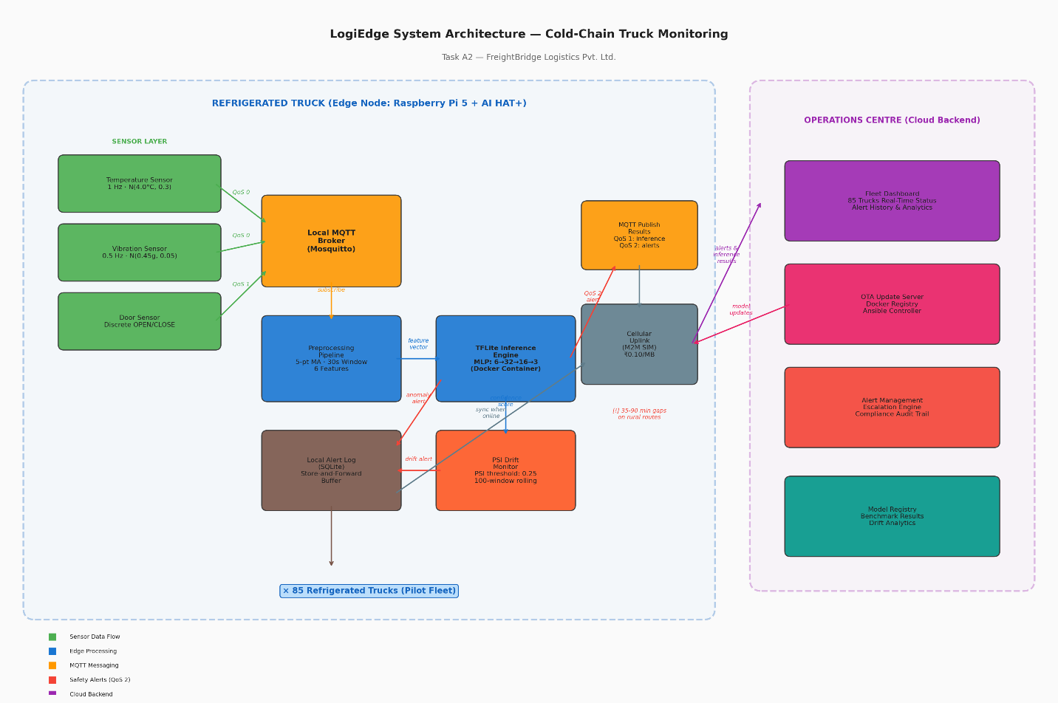

Section 2: Sensor Pipeline and MQTT Design
Sensor Simulation:
The simulator.py module emulates three sensor streams matching the FreightBridge specification. Temperature readings follow N(4.0°C, 0.3) under normal conditions with a 1 Hz sampling rate. Vibration RMS is sampled at 0.5 Hz from N(0.45g, 0.05). Door events are discrete binary signals. Four anomaly injection modes are supported — none, temp_drift (adding +0.08°C/reading for Warning class), vibration (spikes to N(1.2g, 0.15) for equipment anomaly), and combined (both drift and vibration anomaly for Critical class).
Preprocessing Pipeline:
Raw sensor data passes through three processing stages:
Noise filtering:
A 5-sample moving average smooths transient noise without introducing excessive lag. This is applied independently to temperature and vibration streams.
Feature extraction:
A 30-second sliding window with a 10-second step extracts six features per window — temperature mean, standard deviation, and rate-of-change (°C/min) from the temperature stream; RMS, peak amplitude, and kurtosis from the vibration stream. The 10-second step ensures a new inference runs every 10 seconds, meeting the 90-second SLA with substantial margin.
Z-score normalisation:
Features are normalised using frozen statistics from training_stats.npy, computed from the first 10 minutes (58 windows) of clean Normal-class data. These statistics are never recomputed from live data — a critical design decision validated by the normalisation experiment. Data Fusion Justification
LogiEdge uses feature-level fusion — features are extracted independently per sensor stream and concatenated into a 6-value joint vector. This was chosen over two alternatives:
Data-level fusion (concatenating raw samples) fails because the sensors operate at different rates (1 Hz vs 0.5 Hz vs discrete events), have incompatible scales (°C vs g vs binary), and would produce variable-length inputs incompatible with our fixed-input MLP.
Decision-level fusion (separate models per stream, majority voting) loses the cross-sensor correlations that define the Critical class — "temperature drifting AND vibration high" requires seeing both streams simultaneously. It also triples the model maintenance burden across 85 trucks.
Feature-level fusion preserves cross-sensor information, handles different sampling rates naturally, and produces a compact 6-value input suitable for our lightweight MLP.

MQTT Architecture
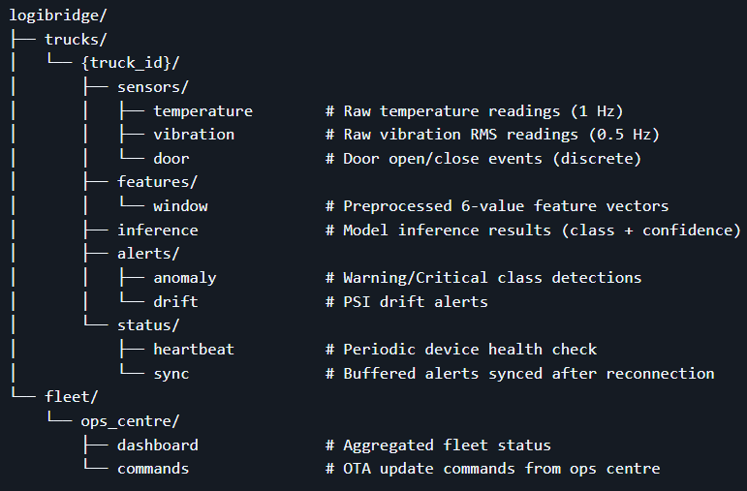

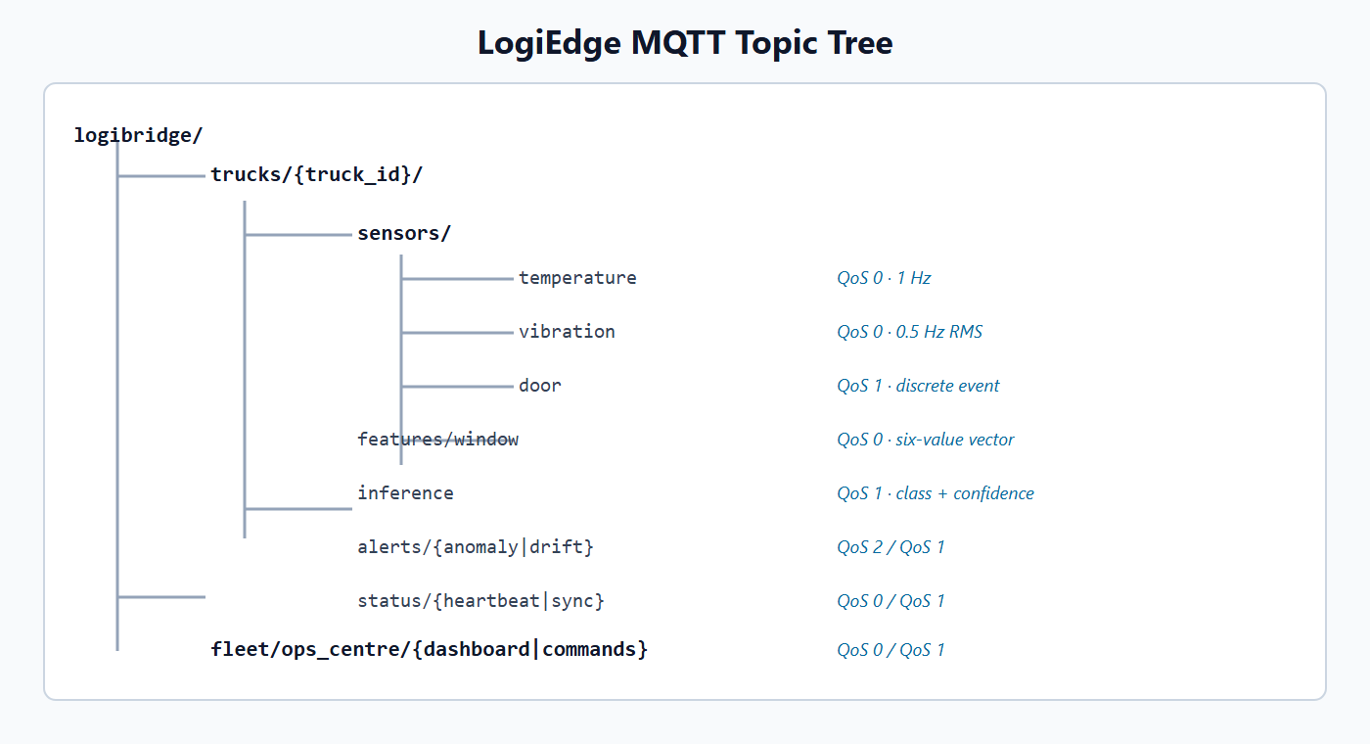

Topic Category | QoS | Rationale
Sensor data (temperature, vibration) | 0 | High-frequency; a missed sample doesn't affect the 30-second window
Door events | 1 | Discrete, infrequent; each matters for chain-of-custody documentation
Inference results | 1 | Must reach ops centre eventually; local broker ensures store-and-forward
Anomaly alerts | 2 | Safety-critical; exactly-once prevents both missed alerts and duplicates
Drift alerts | 1 | Important for MLOps but not patient-safety-critical
Normalisation Experiment (Mandatory Task C2):
The experiment tested model robustness to corrupted normalisation parameters. Results are unambiguous:
Condition | Accuracy | Critical Recall
Correct stats | 98.31% | 100%
+3σ shifted mean | 96.61% | 100%
+ 10σ shifted mean | 96.61% | 100%
No normalisation | 64.41% | 0%
Without normalisation, every Critical condition is misclassified — the system becomes dangerous rather than protective. This confirms that training_stats.npy is a safety-critical deployment artifact that must be frozen at training time and versioned alongside the model.
Section 3: Model Deployment and Pipeline Mapping
Model Architecture and Training
The classifier is a 2-hidden-layer MLP: Input(6) → Dense(32, ReLU) → Dense(16, ReLU) → Dense(3, Softmax). Training uses 294 labelled windows from 50 minutes of simulated data with an 80/20 stratified split (seed=0). Class-weighted loss with a 3× boost for the Critical class ensures the 95% Critical recall target is met.
Results:
98.31% validation accuracy (threshold: 88%) and 100% Critical recall (threshold: 95%). The confusion matrix shows only 1 misclassification — a Warning sample classified as Normal — out of 59 validation samples.
Model Conversion
Three model variants were produced:
• M1 (FP32 Baseline): Keras → SavedModel → TFLite FlatBuffer (5.29 KB)
• M2 (PTQ INT8): Post-Training Quantisation using 294 calibration samples with TFLITE_BUILTINS_INT8 target ops, forcing full INT8 for inputs, outputs, and weights (4.59 KB)
• M3 (Pruned + INT8): 35% pruning with PolynomialDecay over 50 fine-tuning epochs (34.97% measured kernel sparsity), followed by full INT8 PTQ (4.41 KB)
Containerisation:
The inference service runs in a Docker container based on python:3.11-slim. The Dockerfile orders layers for OTA efficiency — pip install (large, rarely changes) precedes COPY model.tflite (changes every 6 weeks). The assignment's fleet-planning calculation assumes a 280 KB production model, while the measured prototype artefacts range from 4.41 to 5.29 KB. The MODEL_PATH environment variable enables model switching without container rebuilds. The service auto-detects FP32 vs INT8 models and applies appropriate quantisation scaling.
Changing only the model invalidates the final Docker layer while retaining the base image, operating-system, dependency, and service-code layers. Against an illustrative 150 MB full image, the stated 280 KB production model requires 23.8 MB across 85 trucks instead of 12,750 MB, a 12,726.2 MB or 99.81% transfer reduction. At ₹0.10/MB, that changes one fleet transfer from approximately ₹1,275 to ₹2.38. Actual registry transfer depends on compressed layer sizes; the demo must show the cache result from the student's machine rather than treating these planning figures as measured output.
Deployment
An Ansible playbook (logibridge_deploy.yml) with 7 idempotent tasks handles fleet deployment: create directory, copy model, copy reference distribution, stop the old container only when deployment artefacts changed, pull the image by digest, enforce the desired running configuration, and verify health. Running the playbook twice with no changes produces changed=0, confirming idempotency. The deployment also mounts writable persistent storage for the SQLite alert queue. The optional OPS_MQTT_BROKER connection represents the cellular uplink: every anomaly is committed locally before publication, and pending rows are acknowledged and marked as synchronised only after connectivity returns.
Pipeline Mapping (Task D3)
LogiEdge maps to all 10 stages of the Edge ML pipeline: Problem Framing (3-class cold-chain classification), Data Collection (simulator → MQTT), Preprocessing (MA filter → sliding window → normalisation), Training (MLP with class weights), Optimisation (3 variants), Conversion (Keras → TFLite), Containerisation (Docker with OTA-friendly layers), Deployment (Ansible, canary strategy), Inference (TFLite runtime, MQTT pub), and Monitoring (PSI drift detection with 0.25 threshold).
Section 4: Optimisation and Pareto Analysis
Five-Metric Benchmarking (Task F2)
All three variants were benchmarked across 5 metrics using 200 inference runs with 10 warmup iterations:
Variant | Mean Lat (ms) | p95 Lat (ms) | Size (KB) | Accuracy (%) | Energy (mJ) | Recall
M1 FP32 | 0.0100 | 0.0084 | 5.59 | 98.31 | 0.0122 | 100%
M2 PTQ INT8 | 0.0062 | 0.0065 | 4.59 | 96.61 | 0.0076 | 100%
M3 Pruned+INT8 | 0.0069 | 0.0070 | 4041 | 94.92 | 0.0079 | 100%

All three variants achieve 100% Critical recall and run inference around 0.01 ms, so latency differences are operationally negligible against the 90-second SLA. Figure 3 shows the Pareto analysis. M2 minimises measured latency and energy but sacrifices 1.70 percentage points of accuracy; M3 is the smallest but loses 3.39 points; M1 preserves the highest accuracy. The deployment choice therefore emphasises safety accuracy rather than microsecond-scale host timing differences.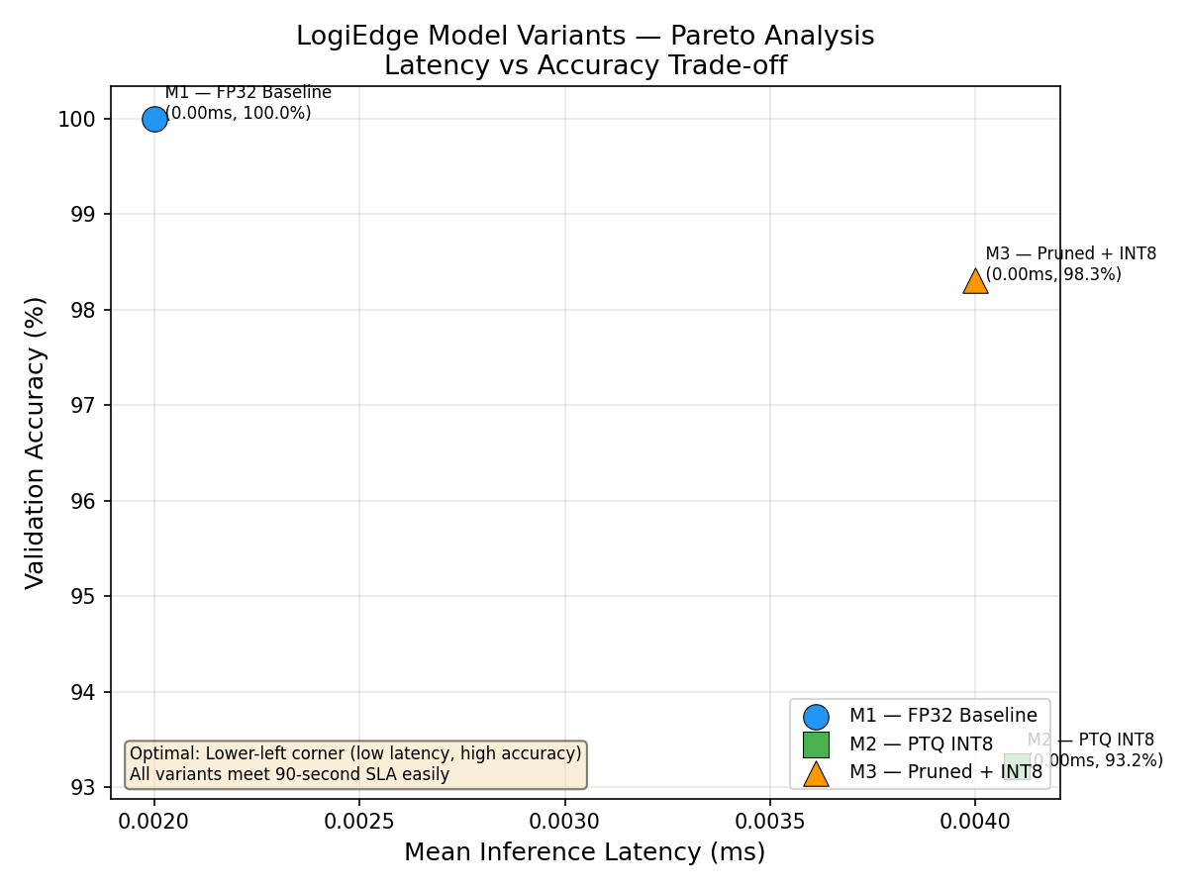
Deployment Recommendation (Task F3)
Recommended variant: M1 (FP32 Baseline)
The recommendation is based on fleet-scale economics:
- Highest validation accuracy (98.31%): All variants pass the Critical-recall gate, so overall validation accuracy becomes the safety-first discriminator.
- Negligible storage premium: M1 is only 0.88 KB larger than M3. On a 32 GB SD card and against the assignment's 280 KB planning model, this difference has no operational consequence.
- 100% Critical recall: M1 exceeds the mandatory 95% threshold, while its single validation error is in the Warning class rather than Critical.
- SLA compliance with margin: At 0.0100 ms per inference, M1 uses less than 0.00002% of the conservative 60-second compute allowance after reserving 30 seconds for initial window formation. In steady state, the 10-second window step remains the practical decision cadence.
The Raspberry Pi uses a 32 GB SD card rather than constrained MCU Flash, and its 8 GB LPDDR4X unified memory replaces the small SRAM budget typical of an STM32 deployment. The 5.29 KB model and small activation tensors are negligible on this platform. This does not remove the need to control container image size and write endurance, but it confirms that model Flash/SRAM pressure is not the limiting deployment constraint on the selected node.
M2 is not recommended because its 1.70-point accuracy loss is not justified by a 0.0038 ms lab latency advantage. M3 proves that the full pruning pipeline works and reaches 34.97% sparsity, but its 94.92% accuracy is 3.39 points below M1. Both still exceed the 88% fitness threshold and retain 100% Critical recall.
Arithmetic Intensity Context
The Roofline analysis from Task B2 confirms the model is compute-bound (AI = 2.5 FLOP/Byte > Ridge Point = 1.33 FLOP/Byte). INT8 quantisation directly addresses this bottleneck by enabling 4× more operations per NEON SIMD cycle, while structured pruning reduces the total FLOPs by ~35%.
Section 5: MLOps Monitoring and Reflection
PSI Drift Monitoring (Task E1)
The drift monitor tracks Population Stability Index (PSI) on the model's Normal-class output confidence distribution. Maximum confidence was rejected because the model can be equally confident about a Normal or Critical prediction, hiding an operational shift. A reference distribution is built from 300 clean Normal-class inference windows, binned into 4 intervals: [0, 0.25), [0.25, 0.5), [0.5, 0.75), [0.75, 1.0]. A rolling window of the last 100 inferences is compared against this reference every 60 seconds.
The PSI drift demo validated the system across three phases:
Phase | Condition | PSI | Status
1 | Clean Normal data | 0.087 | OK — no drift
2 | Combined anomaly injection (5 minutes) | 26.815 | DRIFT ALERT (> 0.25 threshold)
3 | Return to clean data | 0.046 | OK — system recovers below 0.10

The monitor correctly detected distribution shift during anomaly injection and confirmed recovery when clean data resumed.

OTA Strategy (Task E3)
Three OTA strategies were evaluated for the 6-weekly model update cycle:
Strategy | Cost/Update | Risk Profile
Full Replacement (all 85 trucks) | 2.55 Rs | All 85 trucks exposed to untested model
Canary (10 → 75 trucks) | 2.55–2.85 Rs | Only 10 trucks (12%) exposed initially
Shadow Mode (dual model, 7-day comparison) | 105.45 Rs | Zero risk but 41× bandwidth cost

Recommendation:
Canary Deployment. It limits blast radius to 12% of the fleet while costing the same as full replacement in the normal case. Shadow mode's ₹105/cycle bandwidth cost is unjustifiable for a 280 KB model on M2M SIMs.
Reflection
If we were to redesign LogiEdge, three areas would benefit from improvement:
- Larger dataset: 294 samples across 3 classes is sufficient for an MLP but leaves limited room for validation. A production system would benefit from weeks of real sensor data rather than simulated streams.
- Temporal modelling: The current MLP treats each 30-second window independently. A compact 1D CNN could capture trends across consecutive windows, but it should only replace the MLP after evaluation on real truck traces because extra complexity can reduce explainability and increase false alarms.
- Operational hardening: The prototype now persists alerts before uplink publication, but production deployment should add database retention limits, disk-health telemetry, signed model manifests, mutual-TLS broker authentication, and a hardware watchdog. These controls would make offline operation auditable rather than merely available.
Conclusion
The measured prototype demonstrates that a small, interpretable feature-fusion model can satisfy FreightBridge's safety requirements without cloud inference. Edge execution removes cellular latency and availability from the detection path, reduces routine data transfer by more than 99.99%, and preserves pharmaceutical cargo records locally. M1 is the preferred deployment artefact because it delivers 98.31% accuracy and 100% Critical recall while remaining only 5.29 KB. The remaining deployment process is deliberately conservative: validate ten canary trucks for 48–72 hours, compare alert and drift behaviour with the approved baseline, and then promote the same signed image digest to the other 75 trucks. Together, local durability, reproducible preprocessing, monitoring, and staged OTA deployment provide a defensible route from laboratory benchmark to the 85-truck pilot.

