## SOFTWARE QUALITY ASSURANCE MANAGEMENT

## NAME:S.Logitha

## REG NO:192121138

**11.USING RAPTOR – CHECK GIVEN NUMBER PALINDROME OR NOT**

**FLOWCHART**

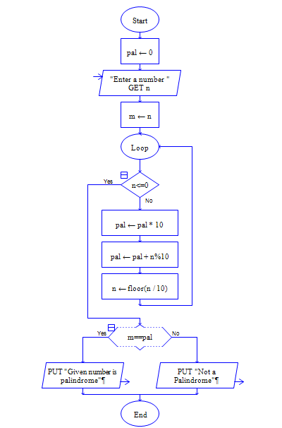

**OUTPUT**

INPUT IS 1234321

