## SOFTWARE QUALITY ASSURANCE MANAGEMENT

## NAME:S.Logitha

## REG NO:192121138

**9.USING RAPTOR – CHECK GIVEN NUMBER PRIME OR NOT**

**FLOWCHART**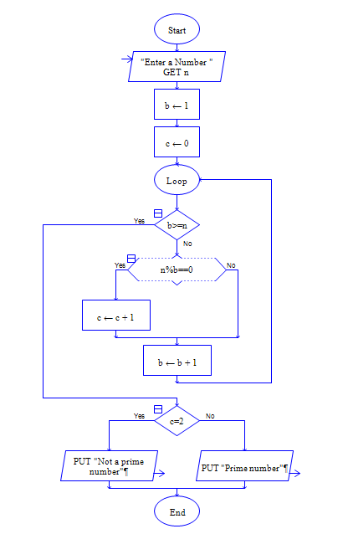

**OUTPUT**

INPUT IS 5

