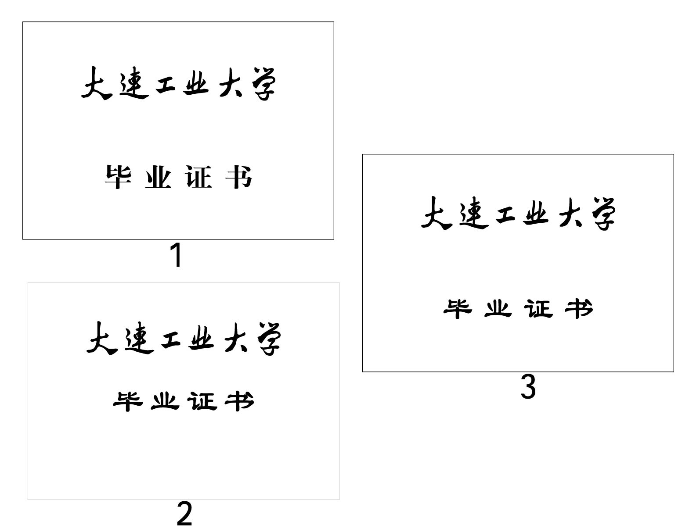
管理学院

《数据采集与处理》
实验报告

专 业： 大数据管理与应用
班级学号： 大数据242-29
学生姓名： 洪翼雄
指导教师： 曹玉琳

实验二
实验题目：Scrapy框架实现网页数据爬取
实验目的和要求：
- 能够使用Scrapy框架进行网络数据采集。
- 掌握使用Scrapy框架处理post、get请求的方法。
- 使用Scrapy框架抓取链家、东方财富股吧等数据。
1.创建第一个scrapy应用（下面以Pycharm为例）：
新建工程：
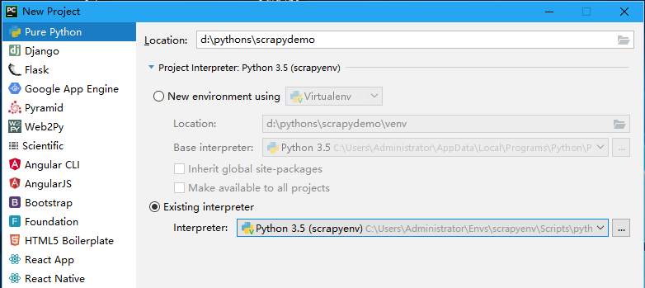
在命令行中使用命令pip install scrapy:
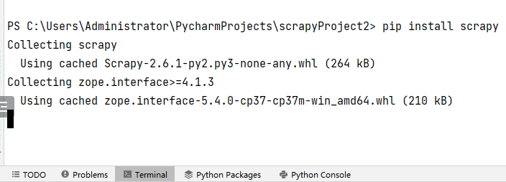

在命令行中使用命令创建scrapy应用：
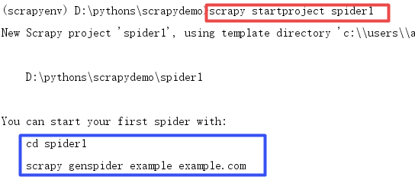
注意蓝框部分的提示，可以用scrapy genspider命令创建爬虫模板。
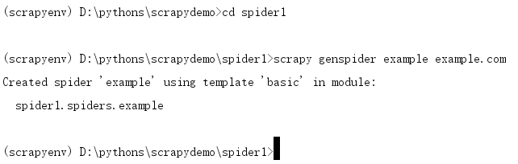
程序结构变为：
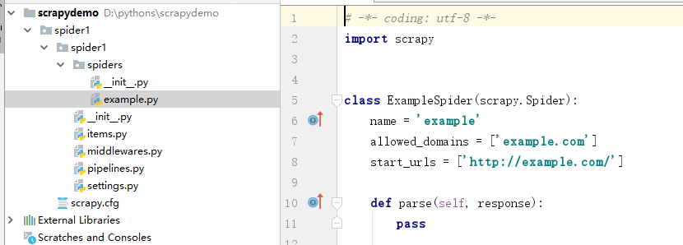
修改代码：
# -*- coding: utf-8 -*-
import scrapy
class ExampleSpider(scrapy.Spider):
name = 'example'
# allowed_domains = ['example.com']
start_urls = ['http://news.163.com/']
def parse(self, response):
print(response.text)

新建文件spidermain：
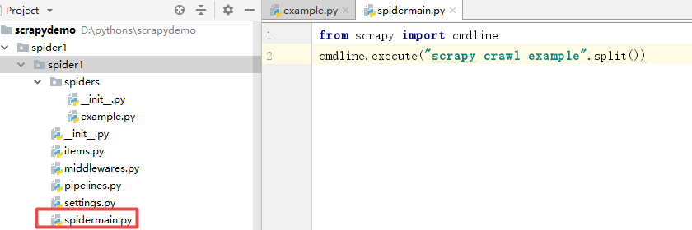
from scrapy import cmdline
cmdline.execute("scrapy crawl example".split())
运行此文件即可
2.从豆瓣电影获取数据：
import requests
from bs4 import BeautifulSoup
import csv
import time
import random
import re

HEADERS = {
'User-Agent': 'Mozilla/5.0 (Windows NT 10.0; Win64; x64) AppleWebKit/537.36 (KHTML, like Gecko) Chrome/120.0.0.0 Safari/537.36',
'Accept': 'text/html,application/xhtml+xml,application/xml;q=0.9,image/webp,*/*;q=0.8',
'Accept-Language': 'zh-CN,zh;q=0.9,en;q=0.8',
'Connection': 'keep-alive',
}
BASE_URL = "https://movie.douban.com/top250"
def get_page_html(url):
"""发送请求获取页面HTML"""
try:
response = requests.get(url, headers=HEADERS, timeout=10)
response.raise_for_status()
response.encoding = 'utf-8'
return response.text
except requests.RequestException as e:
print(f"请求失败: {e}")
return None

def parse_movie_item(movie_item):
"""解析单个电影条目，提取信息"""
movie_info = {}

title = movie_item.find('span', class_='title')
movie_info['title'] = title.text.strip() if title else 'N/A'

other_title = movie_item.find('span', class_='other')
movie_info['other_title'] = other_title.text.strip() if other_title else ''

link = movie_item.find('div', class_='hd').find('a')
movie_info['detail_url'] = link.get('href') if link else ''

rating = movie_item.find('span', class_='rating_num')
movie_info['rating'] = rating.text.strip() if rating else '0'

star = movie_item.find('div', class_='star')
if star:
rating_people = star.find_all('span')[-1].text
movie_info['rating_people'] = re.findall(r'\d+', rating_people)[0]
else:
movie_info['rating_people'] = '0'

bd = movie_item.find('div', class_='bd')
if bd:
p = bd.find('p')
if p:
p_text = p.text.strip().split('\n')
if len(p_text) > 0:
director_actor = p_text[0].strip()
director_match = re.search(r'导演:(.*?)(?:主演:|$)', director_actor)
movie_info['director'] = director_match.group(1).strip() if director_match else ''
actor_match = re.search(r'主演:(.*?)$', director_actor)
movie_info['actors'] = actor_match.group(1).strip() if actor_match else ''

if len(p_text) > 1:
year_area = p_text[1].strip().split('/')
movie_info['year'] = year_area[0].strip() if len(year_area) > 0 else ''
movie_info['area'] = year_area[1].strip() if len(year_area) > 1 else ''
movie_info['genre'] = year_area[2].strip() if len(year_area) > 2 else ''

quote = movie_item.find('span', class_='inq')
movie_info['quote'] = quote.text.strip() if quote else ''

return movie_info
def crawl_douban_top250():
"""主爬虫函数"""
all_movies = []

for page in range(0, 250, 25):
url = f"{BASE_URL}?start={page}&filter="
print(f"正在爬取第 {page//25 + 1} 页: {url}")

html = get_page_html(url)
if not html:
print(f"第 {page//25 + 1} 页爬取失败")
continue

soup = BeautifulSoup(html, 'html.parser')
movie_items = soup.find_all('div', class_='item')

for item in movie_items:
movie_info = parse_movie_item(item)
all_movies.append(movie_info)
print(f"已获取: {movie_info['title']} - 评分: {movie_info['rating']}")

time.sleep(random.uniform(1, 3))

return all_movies
def save_to_csv(movies, filename='douban_top250.csv'):
"""保存数据到CSV文件"""
if not movies:
print("没有数据可保存")
return

keys = ['title', 'other_title', 'director', 'actors', 'year',
'area', 'genre', 'rating', 'rating_people', 'quote', 'detail_url']

with open(filename, 'w', newline='', encoding='utf-8-sig') as f:
writer = csv.DictWriter(f, fieldnames=keys)
writer.writeheader()
writer.writerows(movies)

print(f"\n数据已保存到 {filename}，共 {len(movies)} 条记录")
def main():
"""主函数"""
print("开始爬取豆瓣电影Top250...")
movies = crawl_douban_top250()
save_to_csv(movies)
print("爬取完成！")
if __name__ == "__main__":
main()

3.练习使用XPATH来获取网页节点
import requests
from lxml import html
import csv
import time
import random

HEADERS = {'User-Agent': 'Mozilla/5.0 (Windows NT 10.0; Win64; x64) AppleWebKit/537.36'}
def get_movies(url):
resp = requests.get(url, headers=HEADERS)
tree = html.fromstring(resp.text)

movies = []
for item in tree.xpath('//div[@class="item"]'):
movie = {
'title': item.xpath('.//span[@class="title"]/text()')[0],
'rating': item.xpath('.//span[@class="rating_num"]/text()')[0],
'quote': item.xpath('.//span[@class="inq"]/text()')[0] if item.xpath('.//span[@class="inq"]/text()') else '',
'url': item.xpath('.//div[@class="hd"]/a/@href')[0],
}
movies.append(movie)
print(f"{movie['title']} - {movie['rating']}")

return movies
movies = get_movies("https://movie.douban.com/top250?start=0")
print(f"共获取 {len(movies)} 部电影")

4.Scrapy Shell

scrapy shell "https://movie.douban.com/top250"
2026-03-15 21:23:21 [scrapy.utils.log] INFO: Scrapy 2.14.2 started (bot: scrapybot)
2026-03-15 21:23:21 [scrapy.utils.log] INFO: Versions:
{'lxml': '6.0.2',
'libxml2': '2.11.9',
'cssselect': '1.4.0',
'parsel': '1.11.0',
'w3lib': '2.4.0',
'Twisted': '25.5.0',
'Python': '3.13.5 (tags/v3.13.5:6cb20a2, Jun 11 2025, 16:15:46) [MSC v.1943 '
'64 bit (AMD64)]',
'pyOpenSSL': '25.3.0 (OpenSSL 3.5.5 27 Jan 2026)',
'cryptography': '46.0.5',
'Platform': 'Windows-11-10.0.26100-SP0'}
2026-03-15 21:23:21 [scrapy.crawler] DEBUG: Using AsyncCrawlerProcess
2026-03-15 21:23:21 [asyncio] DEBUG: Using selector: SelectSelector
2026-03-15 21:23:21 [scrapy.addons] INFO: Enabled addons:
[]
2026-03-15 21:23:21 [scrapy.utils.log] DEBUG: Using reactor: twisted.internet.asyncioreactor.AsyncioSelectorReactor
2026-03-15 21:23:21 [scrapy.utils.log] DEBUG: Using asyncio event loop: asyncio.windows_events._WindowsSelectorEventLoop
2026-03-15 21:23:21 [scrapy.extensions.telnet] INFO: Telnet Password: bad7d4ee05fa794c
2026-03-15 21:23:21 [scrapy.middleware] INFO: Enabled extensions:
['scrapy.extensions.corestats.CoreStats',
'scrapy.extensions.logcount.LogCount',
'scrapy.extensions.telnet.TelnetConsole']
2026-03-15 21:23:21 [scrapy.crawler] INFO: Overridden settings:
{'DUPEFILTER_CLASS': 'scrapy.dupefilters.BaseDupeFilter',
'LOGSTATS_INTERVAL': 0}
2026-03-15 21:23:22 [scrapy.middleware] INFO: Enabled downloader middlewares:
['scrapy.downloadermiddlewares.offsite.OffsiteMiddleware',
'scrapy.downloadermiddlewares.httpauth.HttpAuthMiddleware',
'scrapy.downloadermiddlewares.downloadtimeout.DownloadTimeoutMiddleware',
'scrapy.downloadermiddlewares.defaultheaders.DefaultHeadersMiddleware',
'scrapy.downloadermiddlewares.useragent.UserAgentMiddleware',
'scrapy.downloadermiddlewares.retry.RetryMiddleware',
'scrapy.downloadermiddlewares.redirect.MetaRefreshMiddleware',
'scrapy.downloadermiddlewares.httpcompression.HttpCompressionMiddleware',
'scrapy.downloadermiddlewares.redirect.RedirectMiddleware',
'scrapy.downloadermiddlewares.cookies.CookiesMiddleware',
'scrapy.downloadermiddlewares.httpproxy.HttpProxyMiddleware',
'scrapy.downloadermiddlewares.stats.DownloaderStats']
2026-03-15 21:23:22 [scrapy.middleware] INFO: Enabled spider middlewares:
['scrapy.spidermiddlewares.start.StartSpiderMiddleware',
'scrapy.spidermiddlewares.httperror.HttpErrorMiddleware',
'scrapy.spidermiddlewares.referer.RefererMiddleware',
'scrapy.spidermiddlewares.urllength.UrlLengthMiddleware',
'scrapy.spidermiddlewares.depth.DepthMiddleware']
2026-03-15 21:23:22 [scrapy.middleware] INFO: Enabled item pipelines:
[]
2026-03-15 21:23:22 [scrapy.extensions.telnet] INFO: Telnet console listening on 127.0.0.1:6023
2026-03-15 21:23:22 [scrapy.core.engine] INFO: Spider opened
2026-03-15 21:23:22 [scrapy.core.engine] DEBUG: Crawled (403) <GET https://movie.douban.com/top250> (referer: None)
[s] Available Scrapy objects:
[s] scrapy scrapy module (contains scrapy.Request, scrapy.Selector, etc)
[s] crawler <scrapy.crawler.Crawler object at 0x000002407BC18D70>
[s] item {}
[s] request <GET https://movie.douban.com/top250>
[s] response <403 https://movie.douban.com/top250>
[s] settings <scrapy.settings.Settings object at 0x000002407BB2A710>
[s] Useful shortcuts:
[s] fetch(url[, redirect=True]) Fetch URL and update local objects (by default, redirects are followed)
[s] fetch(req) Fetch a scrapy.Request and update local objects
[s] shelp() Shell help (print this help)
[s] view(response) View response in a browser

2. 抓取https://guba.eastmoney.com/list,600030.html中的数据并写入csv文件。
预备知识：写入和读取csv文件。
写入：方法1
import csv

headers = ['name', 'age', 'email']
datas = [
('zhangsan', 20, 'zhangsan@163.com'), # 此处不能是大括号，否则顺序就乱了
('李四', 30, 'lisi@163.com'),
('王五', 40, 'wangwu@163.com')
]
with open('data.csv', 'w', encoding='utf-8', newline='') as fp:
writer = csv.writer(fp)
writer.writerow(headers)
writer.writerows(datas)
方法2：使用字典格式写入
import csv

headers = ['name', 'age', 'email']
datas = [
{'name':'zhangsan', 'age':20, 'email':'zhangsan@163.com'}, # 此处是大括号，且name等值必须与headers中的相同
{'name':'李四', 'age':30, 'email':'；李四@163.com'},
]
with open('data.csv', 'w', encoding='utf-8', newline='') as fp:
writer = csv.DictWriter(fp,headers)
writer.writeheader()
writer.writerows(datas)

读取：方法1
import csv

with open('data2.csv','r', encoding='utf-8') as fp:
reader = csv.reader(fp) #reader是一个迭代器
next(reader) #指针往下走一行，比如跳过标题,参数
for x in reader: #此种方式x是列表类型
# print(x)
date = x[0]
count = x[-1]
print({'date':date,'count':count})
方法2：
import csv

with open('csv/data2.csv','r', encoding='utf-8') as fp:
reader = csv.DictReader(fp,dialect='unix') #使用字典格式读取数据，不会包含列头
for x in reader: #此种方式x是列表类型
# print(x)
date = x['date']
count = x['Adj Close']
print({'date':date,'count':count})

