实验一
实验题目：逻辑回归
实验目的和要求：
- 能够理解逻辑回归的特点、使用方法和使用场景。
- 掌握使用原生python代码和sklearn实现逻辑回归算法。
实验条件：每名同学使用一台计算机。小组同学相邻，方便讨论。
实验内容：
根据实验目的和要求进行，编写相应的python文件，并将文件的主要设计代码写在报告中，附图也可。
1.使用python代码实现阶跃函数和sigmod函数，并将其可视化。
import numpy as np
import matplotlib.pyplot as plt
plt.rcParams["font.sans-serif"] = ["Microsoft YaHei", "SimHei"]
plt.rcParams["axes.unicode_minus"] = False
import os
os.makedirs(os.path.join(os.path.dirname(__file__), "结果图"), exist_ok=True)
def step_function(x):
"""阶跃函数：x > 0 时输出 1，否则输出 0"""
return np.where(x > 0, 1.0, 0.0)
def sigmoid(x):
"""Sigmoid 函数：f(x) = 1 / (1 + e^(-x))"""
return np.where(
x >= 0,
1.0 / (1.0 + np.exp(-x)),
np.exp(x) / (1.0 + np.exp(x)),
)
def main():
x = np.linspace(-10, 10, 400)
fig, axes = plt.subplots(1, 2, figsize=(11, 4.2))
axes[0].plot(x, step_function(x), linewidth=2, color="#2c7fb8")
axes[0].axhline(0, color="gray", lw=0.8, ls="--")
axes[0].axhline(1, color="gray", lw=0.8, ls="--")
axes[0].axvline(0, color="gray", lw=0.8, ls="--")
axes[0].set_title("阶跃函数 (Step Function)")
axes[0].set_xlabel("x")
axes[0].set_ylabel("f(x)")
axes[0].set_ylim(-0.15, 1.15)
axes[0].grid(alpha=0.3)
# 右图：Sigmoid 函数
y_sig = sigmoid(x)
axes[1].plot(x, y_sig, linewidth=2, color="#e6550d")
axes[1].axhline(0.5, color="gray", lw=0.8, ls="--")
axes[1].axhline(1, color="gray", lw=0.8, ls="--")
axes[1].axvline(0, color="gray", lw=0.8, ls="--")
axes[1].set_title("Sigmoid 函数 (Sigmoid Function)")
axes[1].set_xlabel("x")
axes[1].set_ylabel("f(x)")
axes[1].set_ylim(-0.05, 1.05)
axes[1].grid(alpha=0.3)
axes[1].annotate("σ(0) = 0.5", xy=(0, 0.5), xytext=(-6.5, 0.7),
arrowprops=dict(arrowstyle="->"), fontsize=10)
fig.suptitle("阶跃函数与 Sigmoid 函数", fontsize=14)
fig.tight_layout(rect=[0, 0, 1, 0.95])
out_path = os.path.join(os.path.dirname(__file__), "结果图", "task1_阶跃函数与sigmoid.png")
fig.savefig(out_path, dpi=150)
print("图像已保存：", out_path)
print("sigmoid(-10) =", round(float(sigmoid(-10)), 6))
print("sigmoid(0) =", round(float(sigmoid(0)), 6))
print("sigmoid(10) =", round(float(sigmoid(10)), 6))
if __name__ == "__main__":
main()

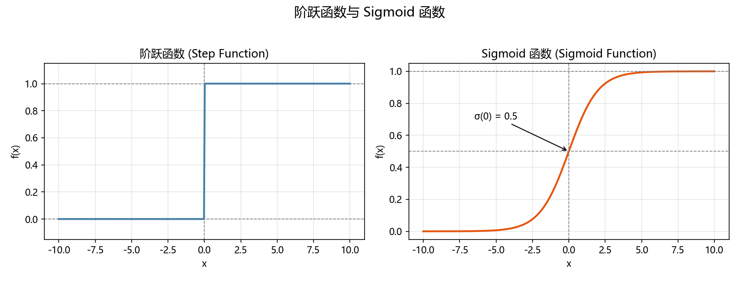

2. 理解纯python代码1和2中实现逻辑回归的方法。
代码 1（纯python代码1/logistic_regression.py）和代码 2（纯python代码2/lr_train.py、lr_test.py）都是老师提供的、用批量梯度下降从零实现的二分类逻辑回归，但写法不同：代码 1 是面向对象的类，代码 2 是脚本式的函数组合，并且把“训练—保存权重—载入权重—预测—保存结果”拆成了两个文件。

3. 用纯python代码1对下面的红酒数据集进行分类。
import os
import sys
import numpy as np
import matplotlib.pyplot as plt
from sklearn.metrics import confusion_matrix, ConfusionMatrixDisplay
plt.rcParams["font.sans-serif"] = ["Microsoft YaHei", "SimHei"]
plt.rcParams["axes.unicode_minus"] = False
BASE = os.path.dirname(os.path.abspath(__file__))
IMG_DIR = os.path.join(BASE, "结果图")
os.makedirs(IMG_DIR, exist_ok=True)
# 把老师提供的“纯python代码1”目录加入搜索路径，直接复用其中的 LogisticRegression
sys.path.insert(0, os.path.join(BASE, "纯python代码1"))
from logistic_regression import LogisticRegression
def load_wine_data(path):
"""读取老师提供的 wine.data：第 1 列是类别(1/2)，其余 13 列是特征"""
rows = []
with open(path, encoding="utf-8-sig") as f:
for line in f:
line = line.strip()
if line:
rows.append([float(v) for v in line.split(",")])
data = np.array(rows)
y = (data[:, 0].astype(int) == 2).astype(int) # 类别 1→0，2→1
X = data[:, 1:]
return X, y
def train_test_split_manual(X, y, test_size=0.3, random_state=42):
"""不使用 sklearn，手动划分训练集与测试集"""
rng = np.random.default_rng(random_state)
idx = rng.permutation(len(y))
n_test = int(len(y) * test_size)
test_idx, train_idx = idx[:n_test], idx[n_test:]
return X[train_idx], X[test_idx], y[train_idx], y[test_idx]
def standardize(X_train, X_test):
"""z-score 标准化：用训练集的均值/标准差处理训练集和测试集"""
mean, std = X_train.mean(axis=0), X_train.std(axis=0)
std[std == 0] = 1.0
return (X_train - mean) / std, (X_test - mean) / std
FEATURE_NAMES = ["Alcohol", "Malic acid", "Ash", "Alcalinity of ash", "Magnesium",
"Total phenols", "Flavanoids", "Nonflavanoid phenols", "Proanthocyanins",
"Color intensity", "Hue", "OD280/OD315", "Proline"]
def main():
# ---------------------------------------------------------- 1. 读取数据
data_path = os.path.join(BASE, "纯python代码1", "wine.data")
X_raw, y = load_wine_data(data_path)
print("红酒数据集（老师提供）：", X_raw.shape, "，类别数：", len(np.unique(y)))
print("每类样本数（class 1 / class 2）：", np.bincount(y).tolist())
# ------------------------------------------------ 2. 划分 + 标准化
X_train_raw, X_test_raw, y_train, y_test = train_test_split_manual(X_raw, y, test_size=0.3)
X_train, X_test = standardize(X_train_raw, X_test_raw)
# ----------------------------- 3. 直接用老师提供的纯python代码1训练
np.random.seed(42) # 老师的代码用随机数初始化 w，这里固定随机种子以便复现
model = LogisticRegression(n_iter=5000, eta=0.5)
model.train(X_train, y_train)
# ---------------------------------------------------------- 4. 评估
pred_train = model.predict(X_train)
pred_test = model.predict(X_test)
print("\n=== 梯度下降逻辑回归（老师提供的纯python代码1）===")
print("训练集准确率：%.4f" % np.mean(pred_train == y_train))
print("测试集准确率：%.4f" % np.mean(pred_test == y_test))
print("最终损失：%.4f" % model.loss_list[-1])
cm = confusion_matrix(y_test, pred_test)
print("混淆矩阵（行=真实类别，列=预测类别）：\n", cm)
# -------------------------------------------------- 5. 损失收敛曲线
plt.figure(figsize=(8, 5))
plt.plot(model.loss_list, color="#2c7fb8", lw=2)
plt.xlabel("迭代次数")
plt.ylabel("交叉熵损失")
plt.title("任务3：红酒分类损失收敛曲线（纯python代码1，梯度下降）")
plt.grid(alpha=0.3)
out = os.path.join(IMG_DIR, "task3_红酒分类_损失收敛曲线.png")
plt.tight_layout()
plt.savefig(out, dpi=150)
plt.close()
print("损失收敛曲线已保存：", out)
disp = ConfusionMatrixDisplay(cm, display_labels=["class 1", "class 2"])
disp.plot(cmap="Blues")
plt.title("任务3：红酒分类混淆矩阵（纯python代码1）")
plt.tight_layout()
out = os.path.join(IMG_DIR, "task3_红酒分类_混淆矩阵.png")
plt.savefig(out, dpi=150)
plt.close()
print("混淆矩阵图已保存：", out)
# ------------------------- 7. 用前两个特征画二维决策边界
X2_train_raw, X2_test_raw, _, _ = train_test_split_manual(X_raw[:, :2], y, test_size=0.3)
X2_train, X2_test = standardize(X2_train_raw, X2_test_raw)
np.random.seed(42)
model2d = LogisticRegression(n_iter=3000, eta=0.5)
model2d.train(X2_train, y_train)
x_min, x_max = X2_train[:, 0].min() - 0.5, X2_train[:, 0].max() + 0.5
y_min, y_max = X2_train[:, 1].min() - 0.5, X2_train[:, 1].max() + 0.5
xx, yy = np.meshgrid(np.linspace(x_min, x_max, 300), np.linspace(y_min, y_max, 300))
Z = model2d.predict(np.c_[xx.ravel(), yy.ravel()]).reshape(xx.shape)
plt.figure(figsize=(8, 6))
plt.contourf(xx, yy, Z, alpha=0.3, cmap="Set2")
plt.contour(xx, yy, Z, colors="k", linewidths=0.8)
plt.scatter(X2_train[:, 0], X2_train[:, 1], c=y_train, cmap="Set2",
edgecolor="k", s=50, label="训练集")
plt.scatter(X2_test[:, 0], X2_test[:, 1], c=y_test, cmap="Set2",
edgecolor="k", s=50, marker="^", label="测试集")
plt.xlabel("特征1（酒精，标准化后）")
plt.ylabel("特征2（苹果酸，标准化后）")
plt.title("任务3：红酒分类决策边界（前 2 个特征，梯度下降逻辑回归）")
plt.legend()
plt.tight_layout()
out = os.path.join(IMG_DIR, "task3_红酒分类_决策边界.png")
plt.savefig(out, dpi=150)
plt.close()
print("决策边界图已保存：", out)
print("仅用前 2 个特征时的测试集准确率：",
round(float(np.mean(model2d.predict(X2_test) == y_test)), 4))
# -------------------------------------- 8. 看一下各特征的权重（已标准化）
w = model.w[1:] # 第 0 个是偏置
order = np.argsort(np.abs(w))[::-1]
print("\n对分类影响最大的特征（标准化后权重绝对值前 5）：")
for i in order[:5]:
print(f" {FEATURE_NAMES[i]}：权重 {w[i]:.3f}")
if __name__ == "__main__":
main()
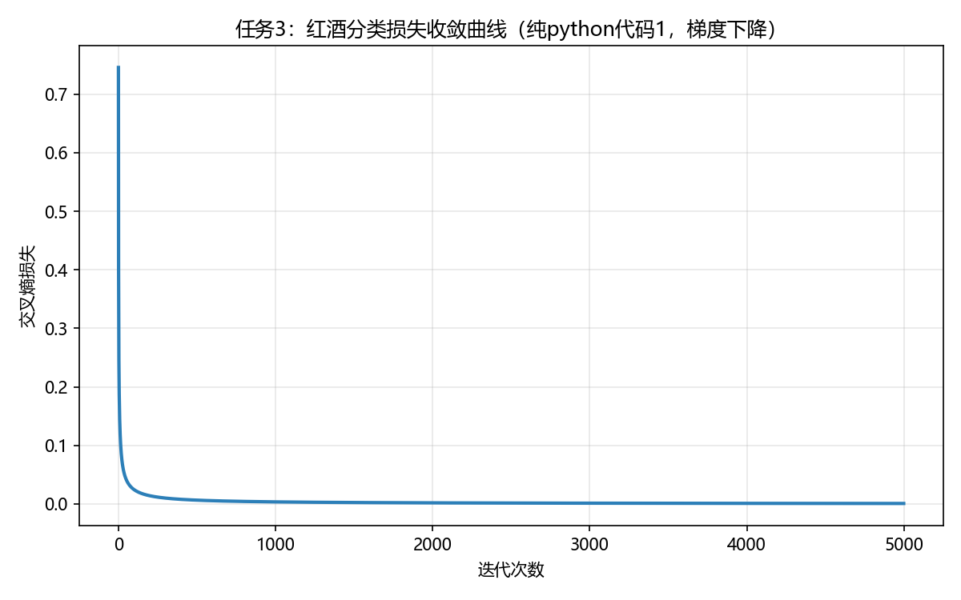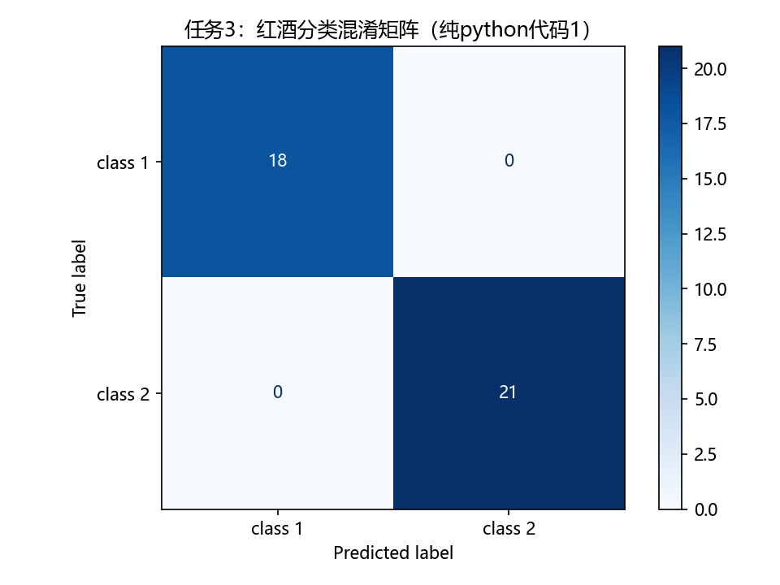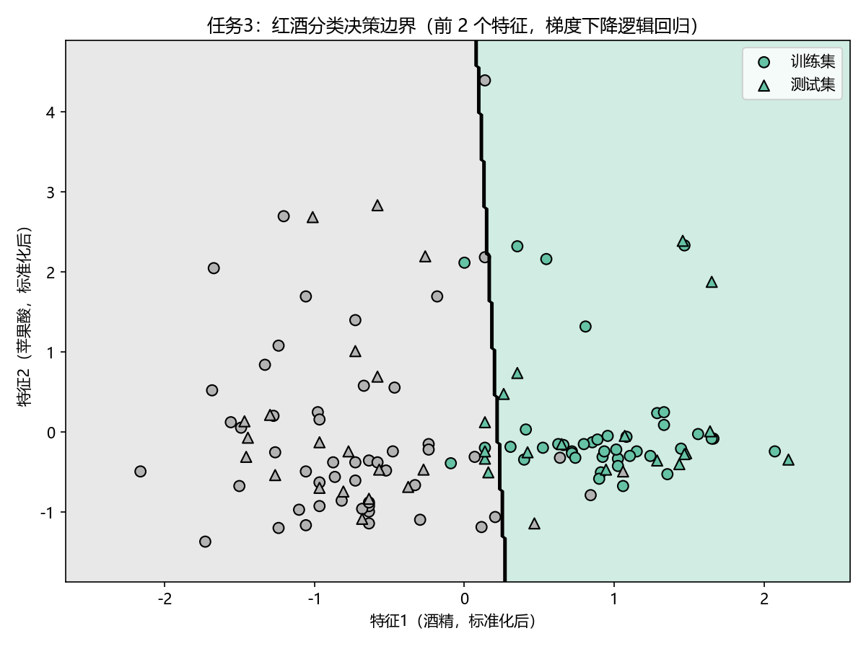

4. 用纯python代码2对下面的数据集进行分类。
"""
实验一 任务4：用纯python代码2对下面的数据集进行分类

纯python代码2（老师提供）：纯python代码2/lr_train.py、纯python代码2/lr_test.py
- lr_train.py：load_data() 读入制表符分隔的数据，lr_train_bgd() 用批量梯度下降训练逻辑回归，
error_rate() 计算损失，save_model() 保存权重；
- lr_test.py ：load_weight() 载入权重，load_data() 读取测试集，predict() 输出 0/1 预测，
save_result() 保存预测结果。

数据集（老师提供）：
- 纯python代码2/data.txt ：200 个样本、2 个特征，最后 1 列是类别标签（0/1）
- 纯python代码2/test_data：200 个样本、2 个特征，没有标签

说明：lr_train.py / lr_test.py 中使用了 np.mat，而 NumPy 2.0 已经移除该函数，
因此脚本开头加了兼容处理 np.mat = np.asmatrix，让老师提供的代码可以直接运行。

流程：
1. 完整复现老师代码 2 的原始流程：用 data.txt 训练 → 保存权重 weights
→ 用 test_data 预测 → 保存结果 result；
2. 为了能计算准确率等指标，再把 data.txt 按 7:3 划分成训练集/测试集
import os
import sys
import io
import contextlib
import tempfile
import numpy as np
import matplotlib.pyplot as plt
from sklearn.metrics import confusion_matrix, ConfusionMatrixDisplay
if not hasattr(np, "mat"): # NumPy 2.0 移除了 np.mat，这里做兼容
np.mat = np.asmatrix
plt.rcParams["font.sans-serif"] = ["Microsoft YaHei", "SimHei"]
plt.rcParams["axes.unicode_minus"] = False
BASE = os.path.dirname(os.path.abspath(__file__))
IMG_DIR = os.path.join(BASE, "结果图")
CODE2_DIR = os.path.join(BASE, "纯python代码2")
os.makedirs(IMG_DIR, exist_ok=True)
sys.path.insert(0, CODE2_DIR)
import lr_train
import lr_test
def read_matrix(path, has_label=True):
"""把制表符分隔的文本读成 (X, y) 两个 ndarray"""
X, y = [], []
with open(path, encoding="utf-8-sig") as f:
for line in f:
line = line.strip()
if not line:
continue
vals = [float(v) for v in line.split("\t")]
if has_label:
X.append(vals[:-1])
y.append(vals[-1])
else:
X.append(vals)
X = np.array(X)
y = np.array(y).astype(int) if has_label else None
return X, y
def write_matrix(path, X, y=None):
"""按老师代码2的格式（制表符分隔）写文件"""
with open(path, "w", encoding="utf-8") as f:
for i in range(len(X)):
if y is None:
f.write("\t".join(str(v) for v in X[i]) + "\n")
else:
f.write("\t".join(str(v) for v in X[i]) + "\t" + str(y[i]) + "\n")
def run_original_flow():
"""完整复现老师代码 2 的原始流程：data.txt 训练 → weights → test_data 预测 → result"""
cwd = os.getcwd()
os.chdir(CODE2_DIR)
try:
with contextlib.redirect_stdout(io.StringIO()):
feature, label = lr_train.load_data("data.txt")
w = lr_train.lr_train_bgd(feature, label, 1000, 0.01) # 老师代码里的默认参数
lr_train.save_model("weights", w)
w_loaded = lr_test.load_weight("weights")
test_mat = lr_test.load_data("test_data", np.shape(w_loaded)[1])
h = lr_test.predict(test_mat, w_loaded)
lr_test.save_result("result", h)
finally:
os.chdir(cwd)
return w, np.asarray(h).ravel().astype(int)
def main():
data_path = os.path.join(CODE2_DIR, "data.txt")
print("=== 1. 完整复现老师代码2的原始流程（data.txt 训练 → test_data 预测）===")
w, pred_test_data = run_original_flow()
print("训练得到的权重 w（含偏置项）：", np.round(np.asarray(w).ravel(), 4).tolist())
print("已在 纯python代码2/ 目录生成 weights（权重）与 result（对 test_data 的预测结果）")
print("test_data 中被预测为类别 1 的样本数：", int(pred_test_data.sum()), "/", len(pred_test_data))
X, y = read_matrix(data_path, has_label=True)
print("\n=== 2. 把 data.txt 按 7:3 划分训练/测试集，评估分类效果 ===")
print("数据形状：", X.shape, "，两类样本数：", np.bincount(y).tolist())
rng = np.random.default_rng(42)
idx = rng.permutation(len(y))
n_test = int(len(y) * 0.3)
test_idx, train_idx = idx[:n_test], idx[n_test:]
with tempfile.TemporaryDirectory() as tmp:
train_file = os.path.join(tmp, "train_data")
test_file = os.path.join(tmp, "test_feature")
write_matrix(train_file, X[train_idx], y[train_idx])
write_matrix(test_file, X[test_idx]) # 测试集只写特征，格式与 test_data 相同
with contextlib.redirect_stdout(io.StringIO()):
feature, label = lr_train.load_data(train_file)
w_split = lr_train.lr_train_bgd(feature, label, 2000, 0.1)
lr_train.save_model(os.path.join(tmp, "weights"), w_split)
w_row = lr_test.load_weight(os.path.join(tmp, "weights"))
test_mat = lr_test.load_data(test_file, np.shape(w_row)[1])
pred = np.asarray(lr_test.predict(test_mat, w_row)).ravel().astype(int)
loss = lr_train.error_rate(lr_train.sig(feature * w_split), label)
acc = float(np.mean(pred == y[test_idx]))
print("训练集损失 error_rate = %.6f" % loss)
print("测试集准确率 = %.4f（测试集 %d 个样本）" % (acc, n_test))
cm = confusion_matrix(y[test_idx], pred)
print("混淆矩阵（行=真实类别，列=预测类别）：\n", cm)
disp = ConfusionMatrixDisplay(cm, display_labels=["类别 0", "类别 1"])
disp.plot(cmap="Blues")
plt.title("任务4：数据集分类混淆矩阵（纯python代码2）")
plt.tight_layout()
out = os.path.join(IMG_DIR, "task4_数据集分类_混淆矩阵.png")
plt.savefig(out, dpi=150)
plt.close()
print("混淆矩阵图已保存：", out)
cycles = [10, 25, 50, 100, 200, 400, 700, 1000, 1500, 2000]
losses = []
with contextlib.redirect_stdout(io.StringIO()):
feature_all, label_all = lr_train.load_data(data_path)
for c in cycles:
w_c = lr_train.lr_train_bgd(feature_all, label_all, c, 0.1)
losses.append(float(lr_train.error_rate(lr_train.sig(feature_all * w_c), label_all)))
plt.figure(figsize=(8, 5))
plt.semilogy(cycles, losses, "o-", color="#2c7fb8")
plt.xlabel("迭代次数")
plt.ylabel("交叉熵损失（对数刻度）")
plt.title("任务4：损失随迭代次数的下降（纯python代码2，批量梯度下降）")
plt.grid(alpha=0.3, which="both")
plt.tight_layout()
out = os.path.join(IMG_DIR, "task4_数据集分类_损失收敛曲线.png")
plt.savefig(out, dpi=150)
plt.close()
print("损失收敛曲线已保存：", out)
with tempfile.TemporaryDirectory() as tmp:
w_path = os.path.join(tmp, "weights")
with contextlib.redirect_stdout(io.StringIO()):
w_all = lr_train.lr_train_bgd(feature_all, label_all, 2000, 0.1)
lr_train.save_model(w_path, w_all)
w_row = lr_test.load_weight(w_path)
x_min, x_max = X[:, 0].min() - 0.5, X[:, 0].max() + 0.5
y_min, y_max = X[:, 1].min() - 0.5, X[:, 1].max() + 0.5
xx, yy = np.meshgrid(np.linspace(x_min, x_max, 300), np.linspace(y_min, y_max, 300))
grid = np.c_[xx.ravel(), yy.ravel()]
grid_mat = np.mat(np.c_[np.ones(len(grid)), grid]) # 加上偏置列 x0 = 1
Z = np.asarray(lr_test.predict(grid_mat, w_row)).ravel().reshape(xx.shape)
plt.figure(figsize=(8, 6))
plt.contourf(xx, yy, Z, alpha=0.3, cmap="Set1")
plt.contour(xx, yy, Z, colors="k", linewidths=0.8)
plt.scatter(X[y == 0, 0], X[y == 0, 1], c="#4d4d4d", edgecolor="k", s=45, label="类别 0")
plt.scatter(X[y == 1, 0], X[y == 1, 1], c="#e6550d", edgecolor="k", s=45, label="类别 1")
plt.xlabel("特征 1")
plt.ylabel("特征 2")
plt.title("任务4：二维数据上的逻辑回归决策边界（纯python代码2）")
plt.legend()
plt.tight_layout()
out = os.path.join(IMG_DIR, "task4_数据集分类_决策边界.png")
plt.savefig(out, dpi=150)
plt.close()
print("决策边界图已保存：", out)
h_all = lr_train.sig(feature_all * w_all)
acc_all = float(np.mean((np.asarray(h_all) >= 0.5).astype(int) == np.asarray(label_all)))
print("在全部 200 个样本上的训练准确率：%.4f" % acc_all)
if __name__ == "__main__":
main()
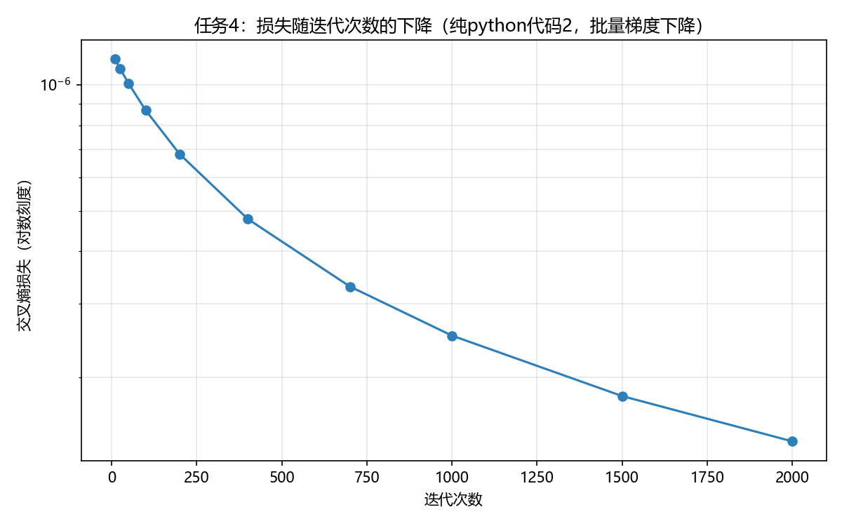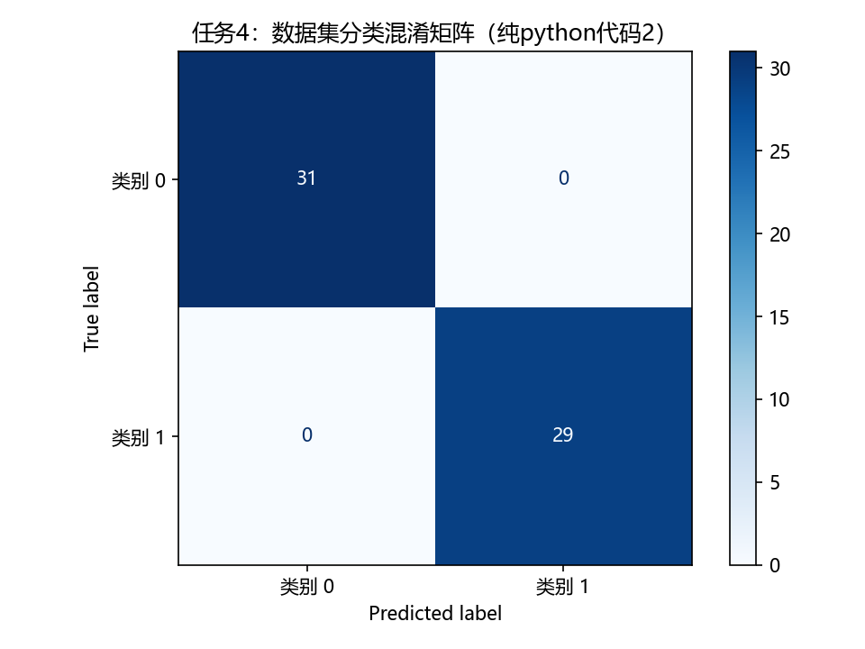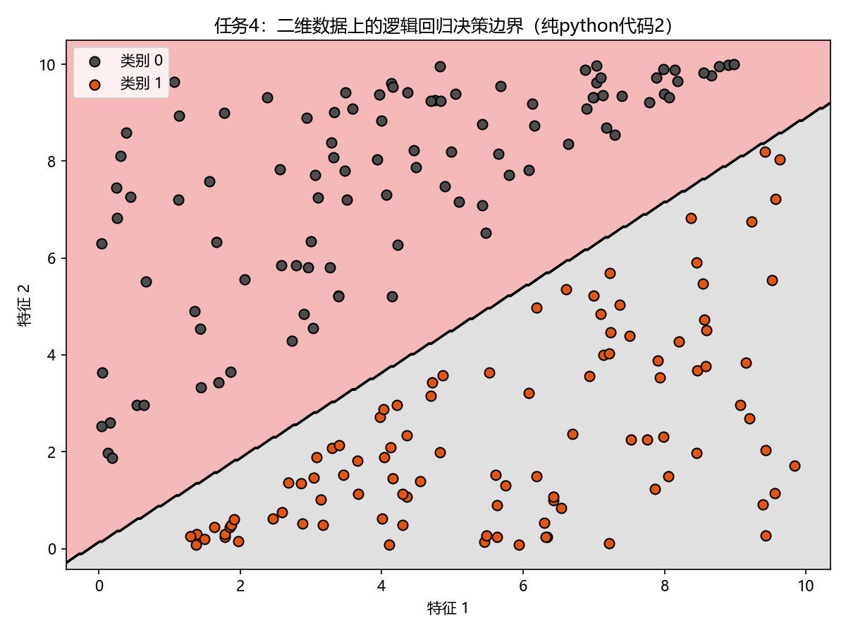

5.自己找一个合适的数据集，使用逻辑回归解决一个分类问题，把解决思路和代码写在下面，可以使用原生python代码或sklearn等机器学习框架。
import os
import numpy as np
import matplotlib.pyplot as plt
from sklearn.datasets import load_breast_cancer
from sklearn.model_selection import train_test_split
from sklearn.preprocessing import StandardScaler
from sklearn.linear_model import LogisticRegression
from sklearn.metrics import (accuracy_score, precision_score, recall_score,
f1_score, confusion_matrix, ConfusionMatrixDisplay,
roc_curve, auc)
plt.rcParams["font.sans-serif"] = ["Microsoft YaHei", "SimHei"]
plt.rcParams["axes.unicode_minus"] = False
IMG_DIR = os.path.join(os.path.dirname(__file__), "结果图")
os.makedirs(IMG_DIR, exist_ok=True)
def main():
# 1. 加载数据
cancer = load_breast_cancer()
X, y = cancer.data, cancer.target
print("数据集形状：", X.shape)
print("类别分布：", dict(zip(*np.unique(y, return_counts=True))))
print("类别含义：", dict(enumerate(cancer.target_names)))
# 2. 划分训练集 / 测试集
X_train, X_test, y_train, y_test = train_test_split(
X, y, test_size=0.25, random_state=42, stratify=y)
# 3. 数据预处理：标准化（逻辑回归对特征尺度敏感）
scaler = StandardScaler()
X_train_s = scaler.fit_transform(X_train)
X_test_s = scaler.transform(X_test)
# 4. 训练逻辑回归模型（sklearn）
model = LogisticRegression(max_iter=2000, C=1.0, random_state=42)
model.fit(X_train_s, y_train)
# 5. 预测与评估
y_pred = model.predict(X_test_s)
y_prob = model.predict_proba(X_test_s)[:, 1]
print("\n=== 测试集评估结果 ===")
print("准确率 Accuracy :", round(accuracy_score(y_test, y_pred), 4))
print("精确率 Precision:", round(precision_score(y_test, y_pred), 4))
print("召回率 Recall :", round(recall_score(y_test, y_pred), 4))
print("F1 值 F1-score :", round(f1_score(y_test, y_pred), 4))
# 混淆矩阵
cm = confusion_matrix(y_test, y_pred)
disp = ConfusionMatrixDisplay(cm, display_labels=cancer.target_names)
disp.plot(cmap="Blues")
plt.title("乳腺癌分类混淆矩阵")
out1 = os.path.join(IMG_DIR, "task5_乳腺癌分类_混淆矩阵.png")
plt.tight_layout()
plt.savefig(out1, dpi=150)
plt.close()
print("\n混淆矩阵图已保存：", out1)
print("混淆矩阵：\n", cm)
# ROC 曲线
fpr, tpr, _ = roc_curve(y_test, y_prob)
roc_auc = auc(fpr, tpr)
plt.figure(figsize=(7, 6))
plt.plot(fpr, tpr, color="#d62728", lw=2, label=f"逻辑回归 (AUC = {roc_auc:.4f})")
plt.plot([0, 1], [0, 1], "k--", lw=1, label="随机猜测")
plt.xlabel("假正率 (FPR)")
plt.ylabel("真正率 (TPR)")
plt.title("乳腺癌分类 ROC 曲线")
plt.legend()
plt.grid(alpha=0.3)
out2 = os.path.join(IMG_DIR, "task5_乳腺癌分类_ROC曲线.png")
plt.tight_layout()
plt.savefig(out2, dpi=150)
plt.close()
print("ROC 曲线图已保存：", out2)
print("AUC =", round(roc_auc, 4))
# 6. 展示最重要的特征（系数绝对值）
coef = np.abs(model.coef_[0])
top_idx = np.argsort(coef)[::-1][:8]
print("\n对分类影响最大的特征：")
for i in top_idx:
print(f" {cancer.feature_names[i]}：系数 {model.coef_[0][i]:.3f}")
if __name__ == "__main__":
main()

