实验三
实验题目：决策树
实验目的和要求：
- 能够理解ID3和C4.5算法的特点、使用方法和使用场景。
- 掌握使用原生python代码和sklearn实现决策树算法。
- 初步掌握CART算法的原理，并能够应用到实际问题中
实验条件：每名同学使用一台计算机。小组同学相邻，方便讨论。
实验内容：
根据实验目的和要求进行，编写相应的python文件，并将文件的主要设计代码写在报告中，附图也可。
1.理解纯python代码2中实现ID3和C4.5算法。
import os
import sys
import io
import contextlib
import numpy as np
import matplotlib.pyplot as plt
from collections import Counter

BASE = os.path.dirname(os.path.abspath(__file__))
IMG_DIR = os.path.join(BASE, "结果图")
os.makedirs(IMG_DIR, exist_ok=True)
# 把课程提供的纯python代码2加入搜索路径，直接复用其中的函数
# （代码放在“决策树/纯python代码1”“决策树/纯python代码2”两个子文件夹里）
CODE_DIR = os.path.join(BASE, "决策树")
sys.path.insert(0, os.path.join(CODE_DIR, "纯python代码2"))
import id3 # noqa: E402 课程提供的 ID3 代码
import c45 # noqa: E402 课程提供的 C4.5 代码
import dt_utils # noqa: E402 本实验的公共绘图工具
# 兼容补丁：现有代码/示例基于旧版 NumPy，np.mat 别名在 NumPy 2.0 中已被移除
if not hasattr(np, "mat"):
np.mat = np.asmatrix
@contextlib.contextmanager
def quiet():
"""临时屏蔽现有代码里的调试打印（不改动源代码）"""
buf = io.StringIO()
with contextlib.redirect_stdout(buf):
yield buf
def load_dataset(file_name, delimiter=","):
"""读取 CSV 数据集，返回 np.mat（与demo 的加载方式保持一致，元素为字符串）"""
with open(file_name, encoding="utf-8") as file:
content = file.readlines()
return np.mat([line.strip("\n").split(delimiter) for line in content])
# ----------------------------------------------------------------------------
# 一、手算验证：信息熵 / 信息增益（ID3）/ 信息增益率（C4.5）
# ----------------------------------------------------------------------------
def entropy(labels):
"""计算一组标签的信息熵（base=2）"""
n = len(labels)
return -sum((c / n) * np.log2(c / n) for c in Counter(labels).values())
def info_gain_and_ratio(data, feat_idx):
"""对离散特征，返回 (信息增益, 分裂信息, 信息增益率)"""
labels = [str(v) for v in data[:, -1].T.tolist()[0]]
n = len(labels)
base_entropy = entropy(labels)
new_entropy, split_info = 0.0, 0.0
for value in sorted(set(data[:, feat_idx].T.tolist()[0])):
idx = np.nonzero(data[:, feat_idx] == value)[0]
prob = len(idx) / n
sub_labels = [labels[i] for i in idx]
new_entropy += prob * entropy(sub_labels)
split_info -= prob * np.log2(prob)
gain = base_entropy - new_entropy
return gain, split_info, gain / split_info
def manual_analysis():
"""手算天气数据集的熵、信息增益与增益率，帮助理解 ID3 与 C4.5 的差别"""
data = load_dataset(os.path.join(BASE, "data", "weather_nominal.csv"))
feature_names = ["outlook", "temperature", "humidity", "windy"]
labels = [str(v) for v in data[:, -1].T.tolist()[0]]
print("=" * 78)
print("一、手算验证：信息熵、信息增益（ID3）与信息增益率（C4.5）")
print("=" * 78)
print("数据集：weather_nominal.csv，共 %d 个样本，标签 play 的分布：%s"
% (len(labels), dict(Counter(labels))))
print("标签的信息熵 Ent(D) = %.4f bit" % entropy(labels))
print()
print("%-12s %12s %12s %12s" % ("特征", "信息增益", "分裂信息", "信息增益率"))
rows = []
for idx, name in enumerate(feature_names):
gain, split_info, ratio = info_gain_and_ratio(data, idx)
rows.append((name, gain, split_info, ratio))
print("%-12s %12.4f %12.4f %12.4f" % (name, gain, split_info, ratio))
best_gain = max(rows, key=lambda r: r[1])
best_ratio = max(rows, key=lambda r: r[3])
print()
print("按“信息增益”最大选特征（ID3） -> %s（增益 %.4f）" % (best_gain[0], best_gain[1]))
print("按“信息增益率”最大选特征（C4.5）-> %s（增益率 %.4f）" % (best_ratio[0], best_ratio[3]))
print("说明：ID3 偏向取值多的特征；C4.5 除以“分裂信息”做修正，抑制这种偏好。")
# 画一张“信息增益 vs 信息增益率”的对比柱状图
names = [r[0] for r in rows]
gains = [r[1] for r in rows]
ratios = [r[3] for r in rows]
x = np.arange(len(names))
fig, axes = plt.subplots(1, 2, figsize=(11, 4.2))
axes[0].bar(x, gains, color="#3498db", width=0.55)
axes[0].set_xticks(x); axes[0].set_xticklabels(names)
axes[0].set_ylabel("信息增益"); axes[0].set_title("ID3：信息增益", fontsize=11)
axes[0].grid(alpha=0.3, axis="y")
for i, v in enumerate(gains):
axes[0].text(i, v + 0.004, "%.4f" % v, ha="center", fontsize=9)
axes[1].bar(x, ratios, color="#e67e22", width=0.55)
axes[1].set_xticks(x); axes[1].set_xticklabels(names)
axes[1].set_ylabel("信息增益率"); axes[1].set_title("C4.5：信息增益率", fontsize=11)
axes[1].grid(alpha=0.3, axis="y")
for i, v in enumerate(ratios):
axes[1].text(i, v + 0.004, "%.4f" % v, ha="center", fontsize=9)
fig.suptitle("天气数据集：两种特征选择准则对比", fontsize=13)
fig.tight_layout(rect=[0, 0, 1, 0.93])
out = os.path.join(IMG_DIR, "task1_特征选择_信息增益与增益率.png")
fig.savefig(out, dpi=150); plt.close(fig)
print("已保存：", out)
return rows
# ----------------------------------------------------------------------------
# 二、使用ID3 / C4.5 代码建树
# ----------------------------------------------------------------------------
def encode_for_sklearn(data):
"""把全离散的字符串数据编码成整数矩阵，供 sklearn 使用；返回 (X, y, 编码表)"""
n, d = data.shape
X = np.zeros((n, d - 1), dtype=int)
mapping = []
for j in range(d - 1):
values = sorted(set(data[:, j].T.tolist()[0]))
mapping.append(dict(zip(values, range(len(values)))))
for i in range(n):
X[i, j] = mapping[j][data[i, j]]
y_values = sorted(set(data[:, -1].T.tolist()[0]))
y_map = dict(zip(y_values, range(len(y_values))))
y = np.array([y_map[data[i, -1]] for i in range(n)])
return X, y, mapping
def evaluate(tree, feature_list, data, name):
"""用决策树对训练集分类，返回预测结果与正确率"""
y_hat = []
for i in range(len(data)):
y_hat.append(str(c45.classify(tree, feature_list, data[i, :-1])
if name.startswith("C4.5") else id3.classify(tree, feature_list, data[i, :-1])))
y_true = [str(v) for v in data[:, -1].T.tolist()[0]]
acc = float(np.mean(np.array(y_hat) == np.array(y_true)))
return y_hat, acc
def pretty_tree(tree, indent=0):
"""把字典形式的决策树打印成带缩进的可读文本"""
if not isinstance(tree, dict):
return " " * indent + "└─ 叶节点：" + str(tree)
key = list(tree.keys())[0]
lines = [" " * indent + "├─ 判断特征：" + str(key)]
for value, sub in tree[key].items():
lines.append(" " * (indent + 2) + "├─ 取值 %s：" % value)
lines.append(pretty_tree(sub, indent + 4))
return "\n".join(lines)
def run_teacher_code():
print()
print("=" * 78)
print("二、调用现有代码：ID3（离散）与 C4.5（含连续特征）")
print("=" * 78)
feature_list = ["outlook", "temperature", "humidity", "windy"]
# --- ID3：只能处理离散特征，用 weather_nominal.csv ---
data = load_dataset(os.path.join(BASE, "data", "weather_nominal.csv"))
id3_tree = id3.build_id3_tree(data, feature_list)
y_hat, acc = evaluate(id3_tree, feature_list, data, "ID3")
depth, leaves, inner = dt_utils.tree_stats(id3_tree)
print("[ID3] 数据 weather_nominal.csv（4 个离散特征）")
print(" 树的深度 = %d，叶子数 = %d，内部节点数 = %d" % (depth, leaves, inner))
print(" 训练集分类正确率 = %.2f%%" % (acc * 100))
print(" 决策树结构（缩进文本）：")
print(pretty_tree(id3_tree, 4))
dt_utils.plot_dict_tree(id3_tree, os.path.join(IMG_DIR, "task1_ID3决策树_天气数据.png"),
"ID3 决策树（weather_nominal.csv）")
with open(os.path.join(IMG_DIR, "task1_ID3决策树.dot"), "w", encoding="utf-8") as f:
f.write(dt_utils.dict_tree_to_dot(id3_tree))
# --- C4.5：能处理连续特征，用 weather_numeric.csv ---
data_num = load_dataset(os.path.join(BASE, "data", "weather_numeric.csv"))
with quiet():
c45_tree = c45.build_c45_tree(data_num, feature_list)
y_hat45, acc45 = evaluate(c45_tree, feature_list, data_num, "C4.5")
depth45, leaves45, inner45 = dt_utils.tree_stats(c45_tree)
print()
print("[C4.5] 数据 weather_numeric.csv（temperature、humidity 为连续特征）")
print(" 树的深度 = %d，叶子数 = %d，内部节点数 = %d" % (depth45, leaves45, inner45))
print(" 训练集分类正确率 = %.2f%%" % (acc45 * 100))
print(" 决策树结构（缩进文本）：")
print(pretty_tree(c45_tree, 4))
print(" 提示：C4.5 对连续特征会学出形如“humidity <= 某阈值”的分裂点，这是 ID3 做不到的。")
dt_utils.plot_dict_tree(c45_tree, os.path.join(IMG_DIR, "task1_C45决策树_天气数据.png"),
"C4.5 决策树（weather_numeric.csv）")
with open(os.path.join(IMG_DIR, "task1_C45决策树.dot"), "w", encoding="utf-8") as f:
f.write(dt_utils.dict_tree_to_dot(c45_tree))
return id3_tree, c45_tree, data, data_num, feature_list
# ----------------------------------------------------------------------------
# 三、与 sklearn 决策树对比
# ----------------------------------------------------------------------------
def compare_with_sklearn(data, feature_list):
from sklearn.tree import DecisionTreeClassifier
print()
print("=" * 78)
print("三、与 sklearn 决策树对比（同样用天气数据）")
print("=" * 78)
X, y, _ = encode_for_sklearn(data)
class_names = sorted(set(str(v) for v in data[:, -1].T.tolist()[0]))
clf = DecisionTreeClassifier(criterion="entropy", random_state=42)
clf.fit(X, y)
acc = clf.score(X, y)
print("sklearn 决策树（criterion=entropy）：深度 = %d，叶子数 = %d，训练集正确率 = %.2f%%"
% (clf.get_depth(), clf.get_n_leaves(), acc * 100))
print("说明：sklearn 的决策树是“二叉树”，对多取值特征会拆成多层的 <= 判断；")
print(" ID3 是“多叉树”，一个特征一次就能分出 outlook 的 3 个取值。")
dt_utils.plot_sklearn_tree(clf, feature_list, class_names,
os.path.join(IMG_DIR, "task1_sklearn决策树_天气数据.png"),
"sklearn 决策树（criterion=entropy）")
dt_utils.export_sklearn_dot(clf, feature_list, class_names,
os.path.join(IMG_DIR, "task1_sklearn决策树.dot"))
return clf
# ----------------------------------------------------------------------------
# 四、熵与 Gini 系数曲线（与 plot_entropy_gini.py 一致）
# ----------------------------------------------------------------------------
def plot_entropy_gini():
x = np.linspace(0.001, 0.999, 400)
entropy_curve = -x * np.log2(x) - (1 - x) * np.log2(1 - x)
gini_curve = 1 - (x ** 2 + (1 - x) ** 2)
fig, ax = plt.subplots(figsize=(6.4, 4.4))
ax.plot(x, entropy_curve / 2, "--", label="熵之半 H(p)/2", color="#3498db")
ax.plot(x, gini_curve, ":", label="Gini 系数 Gini(p)", color="#e67e22")
ax.set_xlabel("正类样本比例 p"); ax.set_ylabel("不纯度")
ax.set_title("二分类问题的不纯度曲线：熵与 Gini 系数", fontsize=12)
ax.legend(); ax.grid(alpha=0.3)
fig.tight_layout()
out = os.path.join(IMG_DIR, "task1_熵与Gini系数.png")
fig.savefig(out, dpi=150); plt.close(fig)
print()
print("=" * 78)
print("四、熵与 Gini 系数")
print("=" * 78)
print("两者都在 p=0.5 时最大、在 p=0 或 1 时为 0，且 Gini 恒不超过熵之半；")
print("ID3/C4.5 用熵，CART 用 Gini 系数，本质都是“让子节点尽可能纯”。")
print("已保存：", out)
def main():
manual_analysis()
run_teacher_code()
data = load_dataset(os.path.join(BASE, "data", "weather_nominal.csv"))
compare_with_sklearn(data, ["outlook", "temperature", "humidity", "windy"])
plot_entropy_gini()
print()
print("任务1 运行完毕，所有图片与 .dot 文件都在：", IMG_DIR)
if __name__ == "__main__":
main()
① 天气数据共 14 个样本，标签 play 的分布为 no=5、yes=9，标签信息熵 Ent(D)=0.9403 bit。各特征的信息增益与信息增益率如下表：
特征 信息增益 分裂信息 信息增益率
outlook 0.2467 1.5774 0.1564
temperature 0.0292 1.5567 0.0188
humidity 0.1518 1.0000 0.1518
windy 0.0481 0.9852 0.0488
按信息增益最大（ID3）和按信息增益率最大（C4.5）都选中 outlook 作根节点；而温度 temperature 因为取值多、分裂信息大，增益率被明显压低。这说明 C4.5 用“分裂信息”做分母，修正了 ID3 偏向多取值特征的缺点。

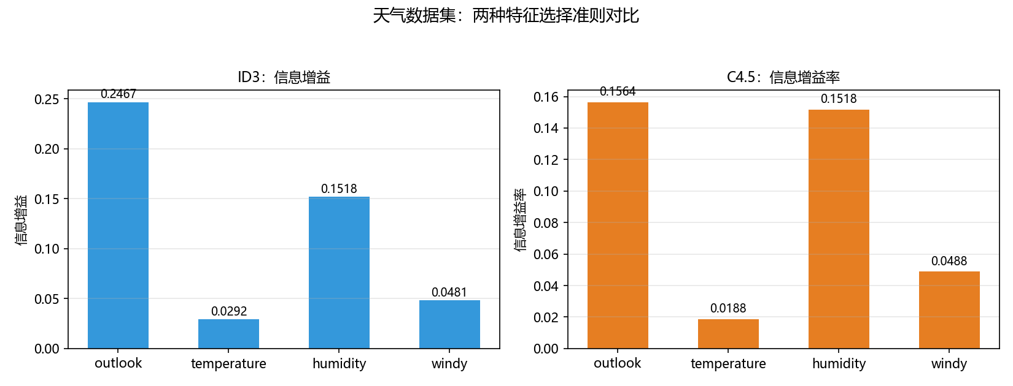
② ID3 在 weather_nominal.csv 上建出的树深度为 2、叶子数为 5、内部节点数为 3，训练集分类正确率 100%；结构为 outlook →（overcast: yes；rainy → windy；sunny → humidity）。

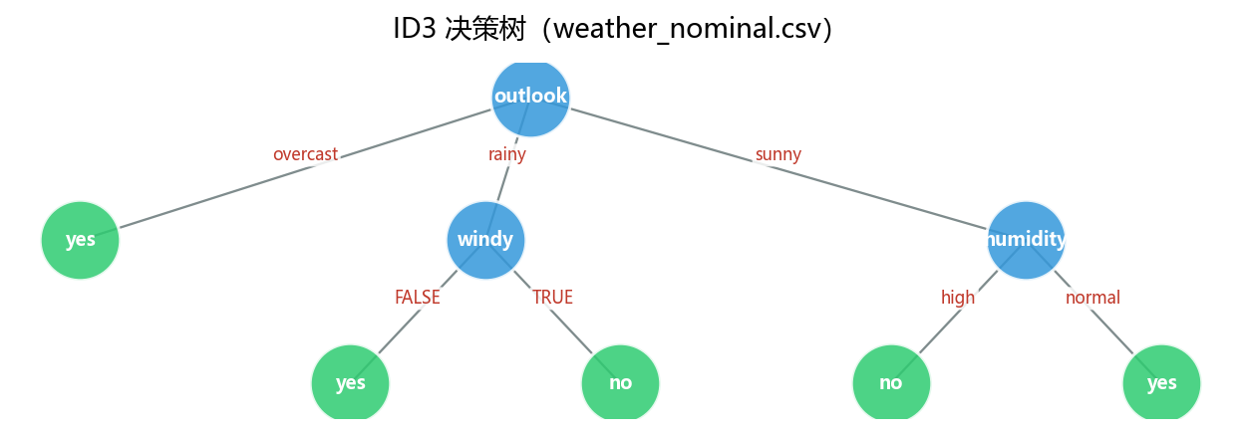
③ C4.5 在 weather_numeric.csv 上得到同样的整体结构，但对连续特征 humidity 学出了 “humidity <= 70.0” 的分裂点，把 sunny 分支干净地分开——这正是 ID3 做不到的地方。C4.5 的树深度 2、叶子 5，训练集正确率也是 100%。

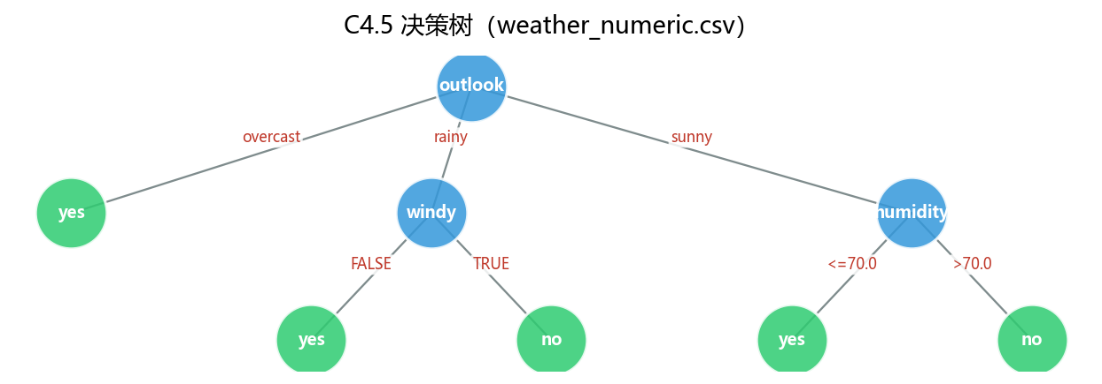
④ sklearn 的决策树（criterion=entropy）是二叉树，对多取值特征会拆成多层的 <= 判断，同数据上深度为 4、叶子数为 7，训练集正确率同样为 100%。ID3 是多叉树，一个特征一次就能分出 outlook 的 3 个取值，因此树更“矮”。

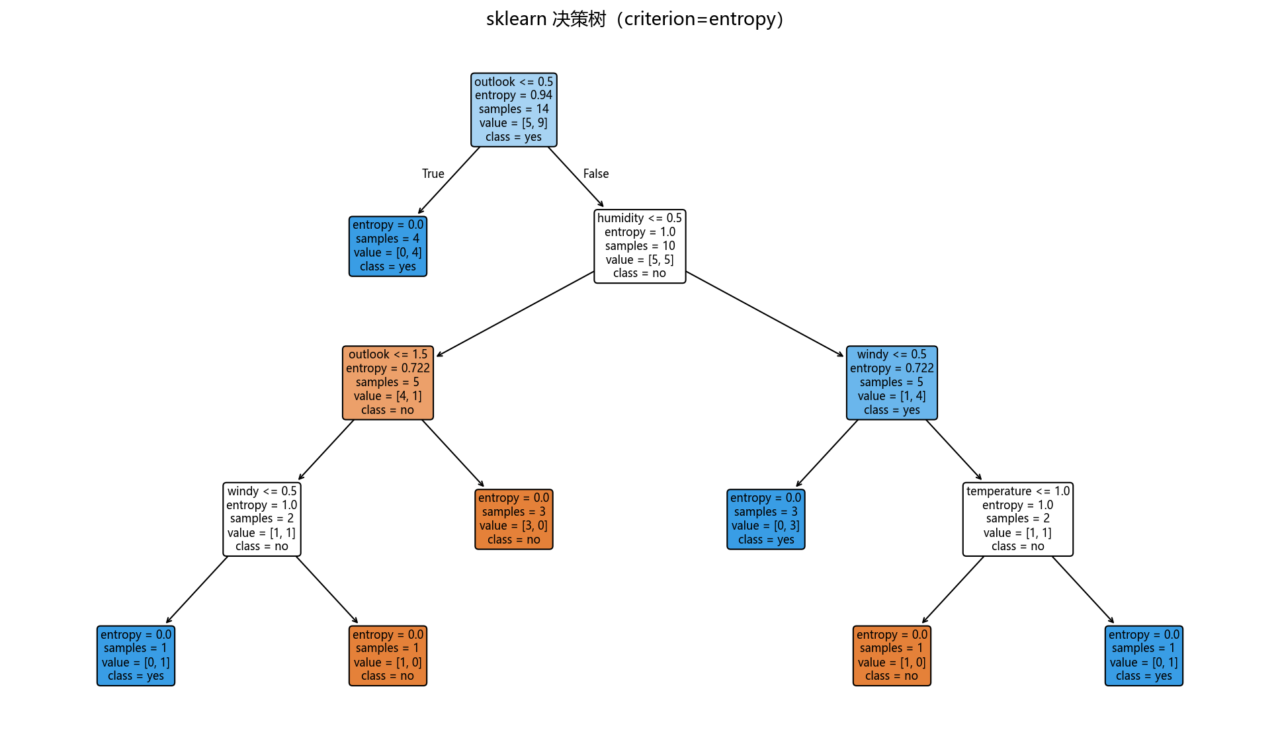
⑤ 熵与 Gini 系数都在 p=0.5 时最大、在 p=0 或 1 时为 0，且 Gini 恒不超过“熵之半”。ID3/C4.5 用熵、CART 用 Gini，本质都是让子节点尽量“纯”。
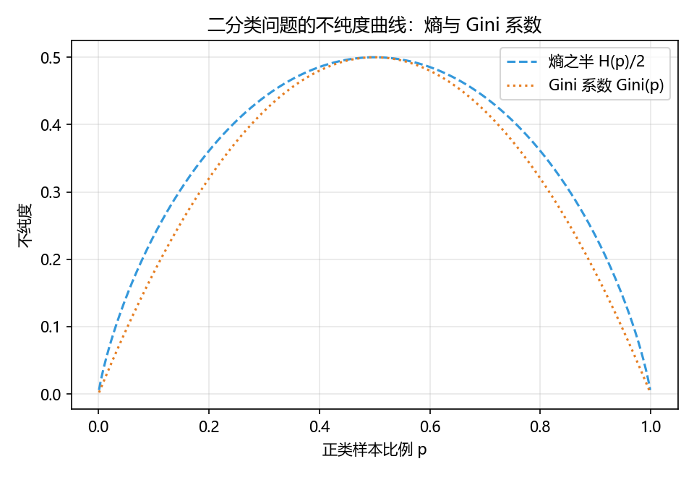

2. 用纯python中的代码对种子数据集进行分类。
import os
import sys
import io
import contextlib
import numpy as np
import matplotlib.pyplot as plt
from sklearn.model_selection import train_test_split, cross_val_score
from sklearn.tree import DecisionTreeClassifier
from sklearn.metrics import (accuracy_score, f1_score, confusion_matrix,
ConfusionMatrixDisplay)
from sklearn.decomposition import PCA

plt.rcParams["font.sans-serif"] = ["Microsoft YaHei", "SimHei"]
plt.rcParams["axes.unicode_minus"] = False
BASE = os.path.dirname(os.path.abspath(__file__))
IMG_DIR = os.path.join(BASE, "结果图")
CODE_DIR = os.path.join(BASE, "决策树")
os.makedirs(IMG_DIR, exist_ok=True)
# 把三份纯python代码加入搜索路径，直接复用其中的函数
sys.path.insert(0, os.path.join(CODE_DIR, "纯python代码2"))
sys.path.insert(0, os.path.join(CODE_DIR, "纯python代码1", "分类回归树"))
if not hasattr(np, "mat"):
np.mat = np.asmatrix
np.int, np.object = int, object
import id3 # noqa: E402 代码2：ID3
import c45 # noqa: E402 代码2：C4.5
import cart # noqa: E402 代码2：CART
from cart_classification import CartClassificationTree # noqa: E402 代码1：CART 分类树
import dt_utils # noqa: E402 本实验公共工具
FEATURE_NAMES = ["area", "perimeter", "compactness", "kernel_length",
"kernel_width", "asymmetry", "groove"]
CLASS_NAMES = ["Kama", "Rosa", "Canadian"]
@contextlib.contextmanager
def quiet():
"""临时屏蔽现有代码里的调试打印（不改动源代码）"""
buf = io.StringIO()
with contextlib.redirect_stdout(buf):
yield buf
def load_seeds(path):
"""读取种子数据集：前 7 列是特征，最后一列是类别 1/2/3（转成 0/1/2）"""
data = np.loadtxt(path)
X = data[:, :7]
y = data[:, 7].astype(int) - 1
return X, y
def to_teacher_mat(X, y):
"""把数值矩阵转成现有代码需要的 np.mat（元素是字符串，最后一列是类别 1/2/3）"""
rows = []
for i in range(X.shape[0]):
rows.append([repr(float(v)) for v in X[i]] + [str(int(y[i]) + 1)])
return np.mat(rows)
def teacher_predict(tree, feature_list, mat, classify_fn, fallback=None):
"""用代码里的 classify 函数逐行预测，返回 (整数标签数组, 回退次数)
id3.classify 在“测试样本的某个取值没在该节点的训练数据里出现过”时会返回 None，
这类情况用一个默认类别（训练集多数类）兜底，并统计回退次数。
"""
preds = []
n_fallback = 0
for i in range(mat.shape[0]):
pred = classify_fn(tree, feature_list, mat[i, :-1])
if pred is None:
n_fallback += 1
preds.append(fallback)
else:
preds.append(int(float(pred)) - 1)
return np.array(preds), n_fallback
def discretize_by_quantile(X_train, X_test, n_bins=3):
"""按训练集的分位数把连续特征离散化（ID3 只能处理离散特征）"""
edges = np.quantile(X_train, np.linspace(0, 1, n_bins + 1)[1:-1], axis=0)
def transform(X):
Xb = np.zeros(X.shape, dtype=int)
for j in range(X.shape[1]):
Xb[:, j] = np.searchsorted(edges[:, j], X[:, j], side="right")
return Xb
return transform(X_train), transform(X_test), edges
def metrics_row(y_true, y_pred):
return accuracy_score(y_true, y_pred), f1_score(y_true, y_pred, average="macro")
def main():
X, y = load_seeds(os.path.join(BASE, "data", "seeds_dataset.txt"))
print("=" * 78)
print("实验三 任务2：用纯python代码对种子数据集进行分类")
print("=" * 78)
print("数据规模：%d 个样本，%d 个特征，%d 个类别；每类样本数：%s"
% (X.shape[0], X.shape[1], len(CLASS_NAMES), np.bincount(y).tolist()))
# 按类别分层划分训练集 / 测试集
idx = np.arange(X.shape[0])
idx_train, idx_test, y_train, y_test = train_test_split(
idx, y, test_size=0.3, random_state=42, stratify=y)
X_train, X_test = X[idx_train], X[idx_test]
# ID3 遇到训练时没见过的取值会返回 None，用训练集多数类兜底
major = int(np.bincount(y_train).argmax())
results = {}
# ---------------- 1. 代码2：ID3（先把连续特征离散化） ----------------
Xb_train, Xb_test, _ = discretize_by_quantile(X_train, X_test, n_bins=3)
mat_train = to_teacher_mat(Xb_train, y_train) # 离散化后当离散特征用
mat_test = to_teacher_mat(Xb_test, y_test)
tree_id3 = id3.build_id3_tree(mat_train, FEATURE_NAMES)
pred_tr, fb1 = teacher_predict(tree_id3, FEATURE_NAMES, mat_train, id3.classify, fallback=major)
pred_te, fb2 = teacher_predict(tree_id3, FEATURE_NAMES, mat_test, id3.classify, fallback=major)
results["ID3（离散化）"] = {
"模型": tree_id3, "kind": "id3",
"训练预测": pred_tr, "测试预测": pred_te,
}
if fb1 + fb2:
print(" [ID3] 提示：训练集与测试集中共有 %d 个样本的取值在该节点未出现过，已用多数类兜底。"
% (fb1 + fb2))
# ---------------- 2. 代码2：C4.5（直接处理连续特征） ----------------
mat_train = to_teacher_mat(X_train, y_train)
mat_test = to_teacher_mat(X_test, y_test)
with quiet():
tree_c45 = c45.build_c45_tree(mat_train, FEATURE_NAMES)
pred_tr, fb1 = teacher_predict(tree_c45, FEATURE_NAMES, mat_train, c45.classify, fallback=major)
pred_te, fb2 = teacher_predict(tree_c45, FEATURE_NAMES, mat_test, c45.classify, fallback=major)
results["C4.5（连续）"] = {
"模型": tree_c45, "kind": "c45",
"训练预测": pred_tr, "测试预测": pred_te,
}
# ---------------- 3. 代码2：CART（连续特征 + Gini） ----------------
with quiet():
tree_cart2 = cart.build_cart_tree(mat_train, FEATURE_NAMES)
pred_tr, _ = teacher_predict(tree_cart2, FEATURE_NAMES, mat_train, cart.classify, fallback=major)
pred_te, _ = teacher_predict(tree_cart2, FEATURE_NAMES, mat_test, cart.classify, fallback=major)
results["CART（代码2）"] = {
"模型": tree_cart2, "kind": "cart",
"训练预测": pred_tr, "测试预测": pred_te,
}
# ---------------- 4. 代码1：CART 分类树（面向对象） ----------------
cart1 = CartClassificationTree(gini_threshold=0.0, gini_dec_threshold=0.0,
min_samples_split=2)
cart1.train(X_train, y_train)
results["CART（代码1）"] = {
"模型": cart1, "kind": "cart1",
"训练预测": cart1.predict(X_train).astype(int),
"测试预测": cart1.predict(X_test).astype(int),
}
# ---------------- 5. sklearn 决策树 ----------------
sk_tree = DecisionTreeClassifier(criterion="entropy", random_state=42)
sk_tree.fit(X_train, y_train)
results["sklearn（熵）"] = {
"模型": sk_tree, "kind": "sklearn",
"训练预测": sk_tree.predict(X_train),
"测试预测": sk_tree.predict(X_test),
}
# ---------------- 汇总指标 ----------------
print()
print("%-16s %14s %14s %14s" % ("方法", "训练准确率", "测试准确率", "测试宏F1"))
summary = {}
for name, res in results.items():
tr_acc, tr_f1 = metrics_row(y_train, res["训练预测"])
te_acc, te_f1 = metrics_row(y_test, res["测试预测"])
summary[name] = (tr_acc, te_acc, te_f1)
print("%-16s %13.2f%% %13.2f%% %14.3f" % (name, tr_acc * 100, te_acc * 100, te_f1))
# 5 折交叉验证（用 sklearn 的模型做参考）
cv = cross_val_score(DecisionTreeClassifier(criterion="entropy", random_state=42),
X, y, cv=5)
print()
print("sklearn（熵）5 折交叉验证准确率：%s，平均 %.2f%%"
% (" ".join("%.3f" % v for v in cv), cv.mean() * 100))
print("说明：ID3 需要先把连续特征离散化，离散化会损失信息，所以通常不如能直接处理连续的 C4.5/CART；")
print(" 现有代码在训练集上容易长成完全树（训练准确率 100%），测试准确率更能反映泛化能力。")
# ---------------- 可视化 ----------------
plot_metric_comparison(summary)
plot_trees(results, X_train, y_train)
plot_confusion(sk_tree, X_test, y_test)
plot_importance(sk_tree)
plot_pruning_curve(X_train, y_train, X_test, y_test)
plot_pca(X, y, sk_tree)
print()
print("任务2 运行完毕，所有图片都在：", IMG_DIR)
def plot_metric_comparison(summary):
"""各方法的训练/测试准确率与测试宏 F1 对比柱状图"""
names = list(summary.keys())
x = np.arange(len(names))
fig, axes = plt.subplots(1, 2, figsize=(13, 4.6))
w = 0.38
axes[0].bar(x - w / 2, [summary[n][0] for n in names], width=w, label="训练准确率", color="#3498db")
axes[0].bar(x + w / 2, [summary[n][1] for n in names], width=w, label="测试准确率", color="#e67e22")
for i, n in enumerate(names):
axes[0].text(i - w / 2, summary[n][0] + 0.01, "%.2f" % summary[n][0], ha="center", fontsize=8)
axes[0].text(i + w / 2, summary[n][1] + 0.01, "%.2f" % summary[n][1], ha="center", fontsize=8)
axes[0].set_xticks(x); axes[0].set_xticklabels(names, rotation=15)
axes[0].set_ylim(0, 1.32); axes[0].set_ylabel("准确率")
axes[0].set_title("准确率对比", fontsize=11)
axes[0].legend(loc="upper center", ncol=2, fontsize=9)
axes[0].grid(alpha=0.3, axis="y")
axes[1].bar(x, [summary[n][2] for n in names], color="#8e44ad", width=0.5)
for i, n in enumerate(names):
axes[1].text(i, summary[n][2] + 0.012, "%.3f" % summary[n][2], ha="center", fontsize=9)
axes[1].set_xticks(x); axes[1].set_xticklabels(names, rotation=15)
axes[1].set_ylim(0, 1.12); axes[1].set_ylabel("宏平均 F1")
axes[1].set_title("测试集宏平均 F1", fontsize=11); axes[1].grid(alpha=0.3, axis="y")
fig.suptitle("种子数据集：纯 python 决策树与 sklearn 对比", fontsize=13)
fig.tight_layout(rect=[0, 0, 1, 0.93])
out = os.path.join(IMG_DIR, "task2_种子数据集_各方法指标对比.png")
fig.savefig(out, dpi=150); plt.close(fig)
print("已保存：", out)
def plot_trees(results, X_train, y_train):
"""绘制 C4.5 / CART 的字典树，以及 sklearn 决策树"""
depth, leaves, inner = dt_utils.tree_stats(results["C4.5（连续）"]["模型"])
print("[C4.5] 树：深度 = %d，叶子数 = %d，内部节点数 = %d" % (depth, leaves, inner))
png = os.path.join(IMG_DIR, "task2_种子数据集_C45决策树.png")
dt_utils.plot_dict_tree(results["C4.5（连续）"]["模型"], png,
"C4.5 决策树（种子数据集）")
with open(os.path.join(IMG_DIR, "task2_种子数据集_C45决策树.dot"), "w", encoding="utf-8") as f:
f.write(dt_utils.dict_tree_to_dot(results["C4.5（连续）"]["模型"]))
print("已保存：", png)
depth, leaves, inner = dt_utils.tree_stats(results["CART（代码2）"]["模型"])
print("[CART-代码2] 树：深度 = %d，叶子数 = %d，内部节点数 = %d" % (depth, leaves, inner))
png = os.path.join(IMG_DIR, "task2_种子数据集_CART决策树.png")
dt_utils.plot_dict_tree(results["CART（代码2）"]["模型"], png,
"CART 决策树（种子数据集）")
print("已保存：", png)
sk = results["sklearn（熵）"]["模型"]
print("[sklearn] 树：深度 = %d，叶子数 = %d" % (sk.get_depth(), sk.get_n_leaves()))
png = os.path.join(IMG_DIR, "task2_种子数据集_sklearn决策树.png")
dt_utils.plot_sklearn_tree(sk, FEATURE_NAMES, CLASS_NAMES, png,
"sklearn 决策树（criterion=entropy，种子数据集）")
print("已保存：", png)
def plot_confusion(sk_tree, X_test, y_test):
y_pred = sk_tree.predict(X_test)
cm = confusion_matrix(y_test, y_pred)
fig, ax = plt.subplots(figsize=(5.6, 4.8))
ConfusionMatrixDisplay(cm, display_labels=CLASS_NAMES).plot(ax=ax, cmap="Blues", colorbar=False)
ax.set_title("sklearn 决策树：测试集混淆矩阵", fontsize=12)
fig.tight_layout()
out = os.path.join(IMG_DIR, "task2_种子数据集_混淆矩阵.png")
fig.savefig(out, dpi=150); plt.close(fig)
print("已保存：", out)
def plot_importance(sk_tree):
imp = sk_tree.feature_importances_
order = np.argsort(imp)[::-1]
fig, ax = plt.subplots(figsize=(7.6, 4.4))
ax.bar(range(len(imp)), imp[order], color="#16a085", width=0.6)
ax.set_xticks(range(len(imp)))
ax.set_xticklabels([FEATURE_NAMES[i] for i in order], rotation=20)
ax.set_ylabel("特征重要性")
ax.set_title("sklearn 决策树的特征重要性（种子数据集）", fontsize=12)
ax.grid(alpha=0.3, axis="y")
fig.tight_layout()
out = os.path.join(IMG_DIR, "task2_种子数据集_特征重要性.png")
fig.savefig(out, dpi=150); plt.close(fig)
print("已保存：", out)
def plot_pruning_curve(X_train, y_train, X_test, y_test):
"""预剪枝：限制最大深度 max_depth，观察训练/测试准确率与交叉验证准确率"""
depths = list(range(1, 13))
train_acc, test_acc, cv_acc = [], [], []
for d in depths:
clf = DecisionTreeClassifier(criterion="entropy", max_depth=d, random_state=42)
clf.fit(X_train, y_train)
train_acc.append(clf.score(X_train, y_train))
test_acc.append(clf.score(X_test, y_test))
cv_acc.append(cross_val_score(DecisionTreeClassifier(criterion="entropy", max_depth=d,
random_state=42),
X_train, y_train, cv=5).mean())
fig, ax = plt.subplots(figsize=(7.8, 4.6))
ax.plot(depths, train_acc, "o-", label="训练准确率", color="#3498db")
ax.plot(depths, test_acc, "s-", label="测试准确率", color="#e67e22")
ax.plot(depths, cv_acc, "^--", label="5 折交叉验证准确率", color="#27ae60")
best = depths[int(np.argmax(cv_acc))]
ax.axvline(best, color="#c0392b", ls=":", alpha=0.8)
ax.text(best + 0.1, 0.62, "交叉验证最优深度 = %d" % best, color="#c0392b", fontsize=10)
ax.set_xlabel("决策树最大深度 max_depth"); ax.set_ylabel("准确率")
ax.set_title("预剪枝：深度对决策树泛化能力的影响（种子数据集）", fontsize=12)
ax.legend(); ax.grid(alpha=0.3)
fig.tight_layout()
out = os.path.join(IMG_DIR, "task2_种子数据集_预剪枝_深度与准确率.png")
fig.savefig(out, dpi=150); plt.close(fig)
print("已保存：", out, "；交叉验证最优深度 =", best)
def plot_pca(X, y, sk_tree):
"""PCA 降到 2 维，展示真实类别与决策树预测的分布"""
pca = PCA(n_components=2, random_state=42)
X2 = pca.fit_transform(X)
y_pred = sk_tree.predict(X)
fig, axes = plt.subplots(1, 2, figsize=(12, 4.8))
colors = ["#e74c3c", "#3498db", "#27ae60"]
for k, name in enumerate(CLASS_NAMES):
axes[0].scatter(X2[y == k, 0], X2[y == k, 1], s=22, c=colors[k], label=name, alpha=0.8)
axes[1].scatter(X2[y_pred == k, 0], X2[y_pred == k, 1], s=22, c=colors[k], label=name, alpha=0.8)
axes[0].set_title("真实类别（PCA 2 维）", fontsize=11)
axes[1].set_title("决策树预测类别（PCA 2 维）", fontsize=11)
for ax in axes:
ax.set_xlabel("主成分 1"); ax.set_ylabel("主成分 2")
ax.legend(fontsize=9); ax.grid(alpha=0.3)
fig.suptitle("种子数据集：PCA 降维后的分类结果", fontsize=13)
fig.tight_layout(rect=[0, 0, 1, 0.93])
out = os.path.join(IMG_DIR, "task2_种子数据集_PCA分类结果.png")
fig.savefig(out, dpi=150); plt.close(fig)
print("已保存：", out)
if __name__ == "__main__":
main()

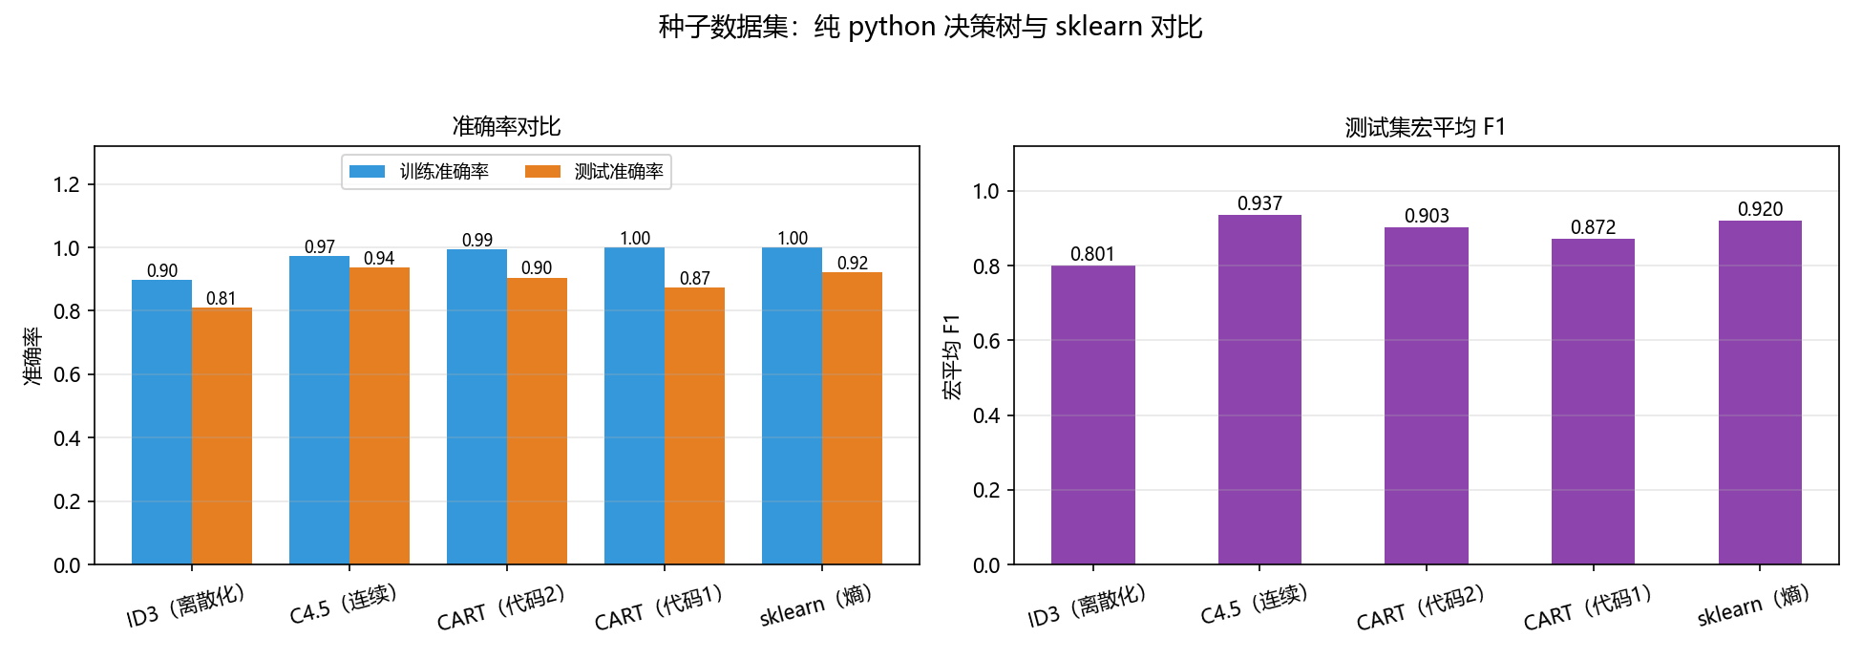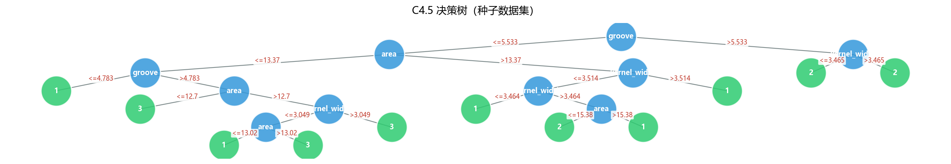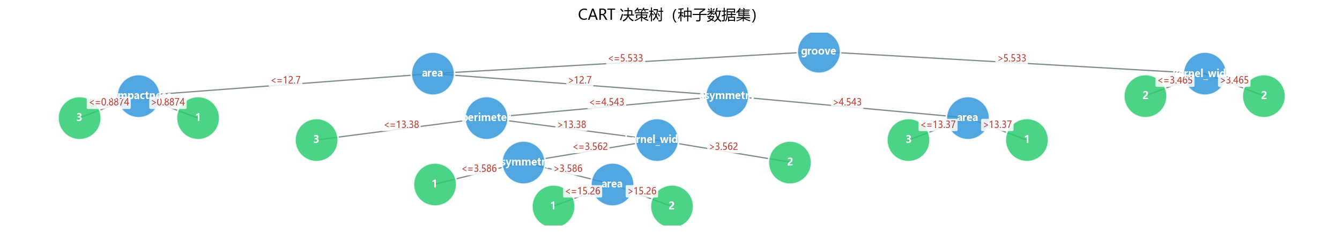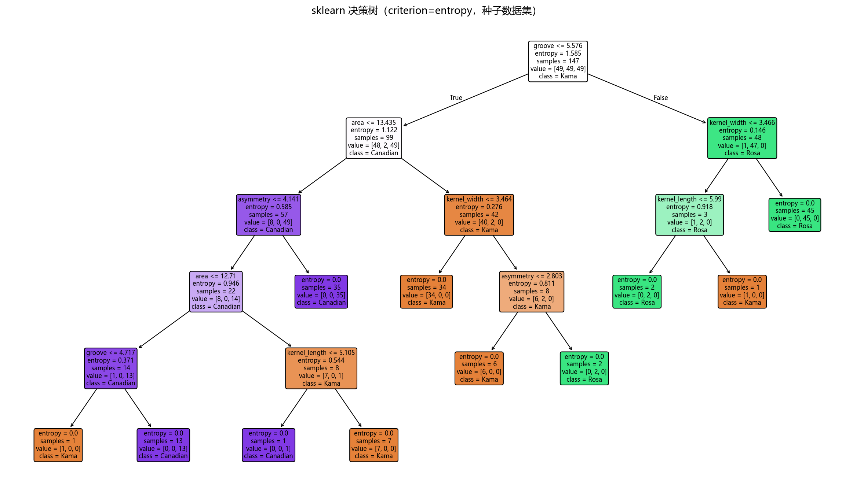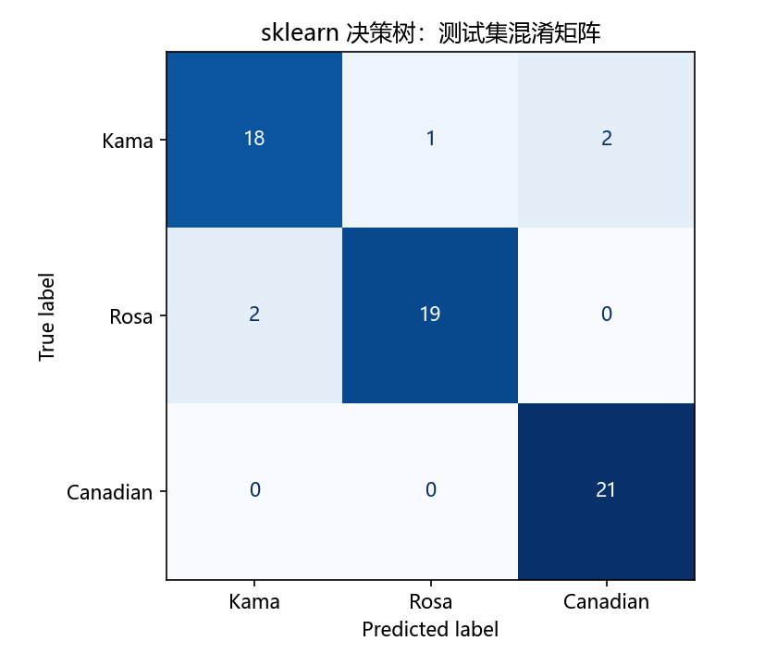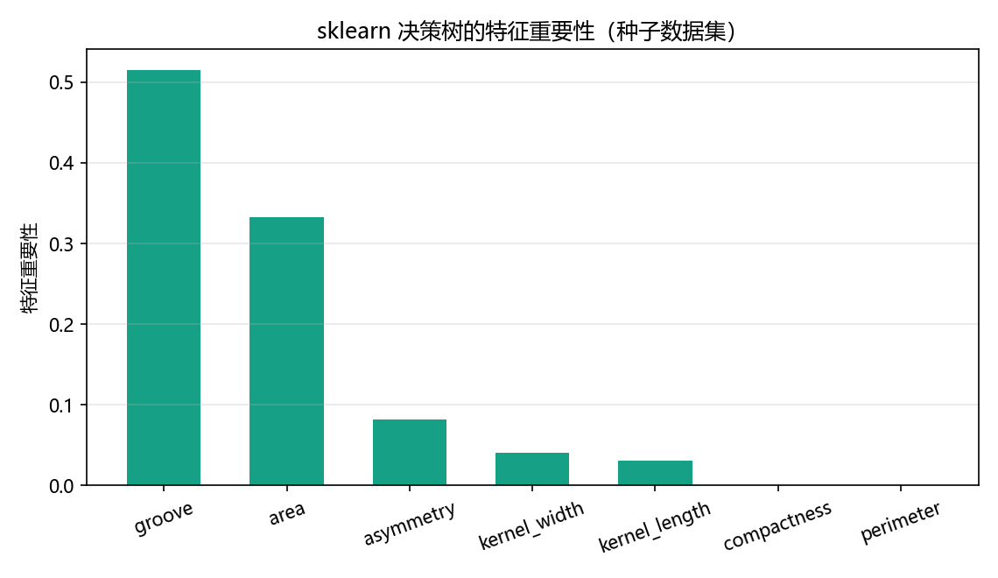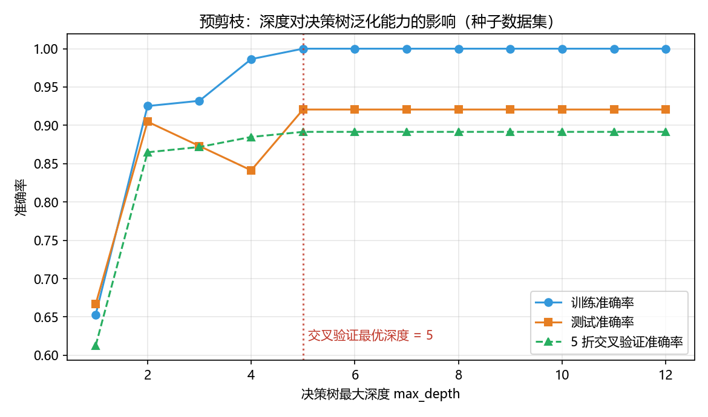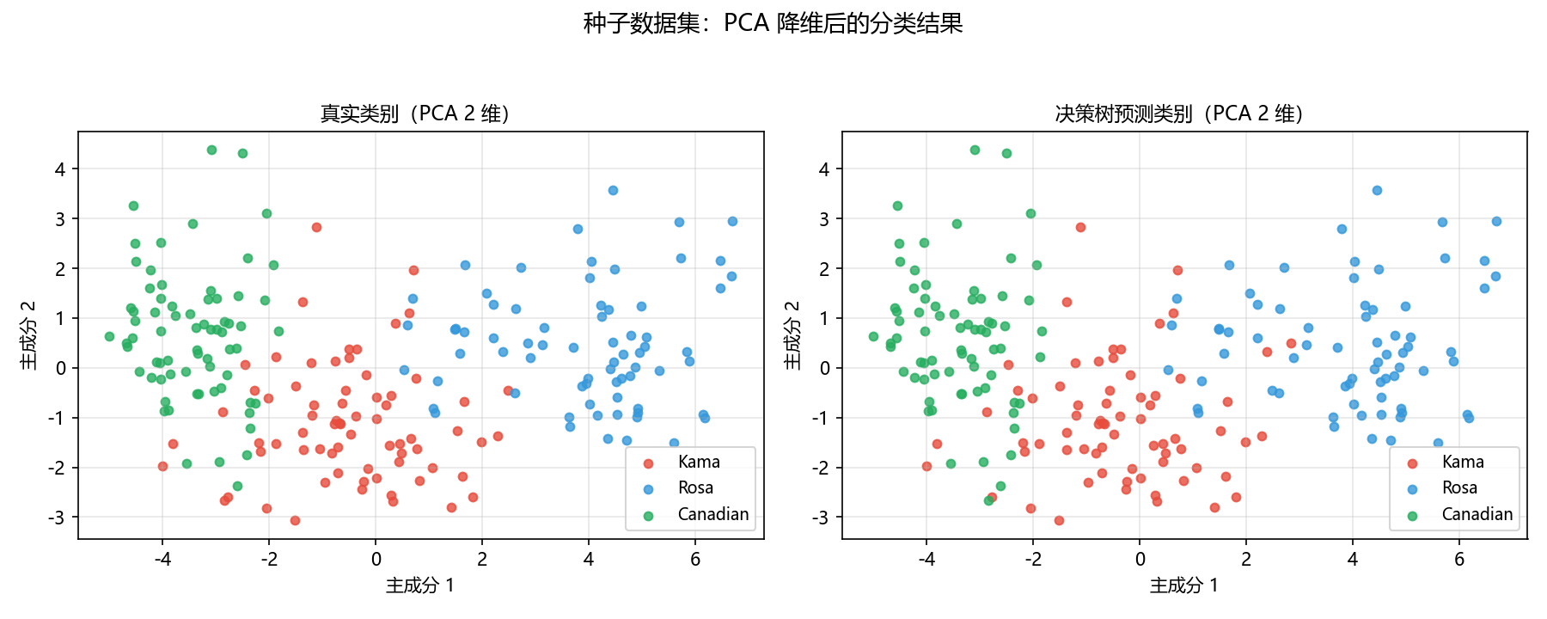

3.自己找一个合适的数据集，使用决策树算法解决分类和回归问题，把解决思路和代码写在下面，可以使用原生python代码或sklearn等机器学习框架。
import os
import sys
import time
import numpy as np
import matplotlib.pyplot as plt
from sklearn.datasets import load_wine, load_diabetes
from sklearn.model_selection import train_test_split, cross_val_score
from sklearn.tree import DecisionTreeClassifier, DecisionTreeRegressor
from sklearn.metrics import (accuracy_score, f1_score, confusion_matrix,
ConfusionMatrixDisplay, mean_squared_error,
mean_absolute_error, r2_score)

plt.rcParams["font.sans-serif"] = ["Microsoft YaHei", "SimHei"]
plt.rcParams["axes.unicode_minus"] = False

BASE = os.path.dirname(os.path.abspath(__file__))
IMG_DIR = os.path.join(BASE, "结果图")
os.makedirs(IMG_DIR, exist_ok=True)
sys.path.insert(0, os.path.join(BASE, "决策树", "纯python代码1", "分类回归树"))
import dt_utils
from cart_classification import CartClassificationTree # 代码1：CART 分类树
from cart_regression import CartRegressionTree # 代码1：CART 回归树
# ============================================================================
# 一、分类问题：wine 葡萄酒数据集
# ============================================================================
def run_classification():
print("=" * 78)
print("一、分类问题：wine 葡萄酒数据集（sklearn 决策树 + 纯 python CART）")
print("=" * 78)
data = load_wine()
X, y, names = data.data, data.target, list(data.feature_names)
class_names = [str(t) for t in data.target_names]
print("数据规模：%d 个样本，%d 个特征，%d 个类别（%s）"
% (X.shape[0], X.shape[1], len(class_names), class_names))
X_train, X_test, y_train, y_test = train_test_split(
X, y, test_size=0.3, random_state=42, stratify=y)
# --- 5 折交叉验证挑选最大深度（预剪枝） ---
depths = list(range(1, 11))
cv_scores = [cross_val_score(DecisionTreeClassifier(max_depth=d, random_state=42),
X_train, y_train, cv=5).mean() for d in depths]
best_depth = depths[int(np.argmax(cv_scores))]
print("5 折交叉验证最优最大深度 max_depth = %d（交叉验证准确率 %.2f%%）"
% (best_depth, max(cv_scores) * 100))
clf = DecisionTreeClassifier(max_depth=best_depth, random_state=42)
clf.fit(X_train, y_train)
y_pred = clf.predict(X_test)
acc = accuracy_score(y_test, y_pred)
f1 = f1_score(y_test, y_pred, average="macro")
print("sklearn 决策树：训练准确率 %.2f%%，测试准确率 %.2f%%，测试宏 F1 = %.3f"
% (clf.score(X_train, y_train) * 100, acc * 100, f1))
# --- 纯 python CART 分类树 ---
t0 = time.time()
cart1 = CartClassificationTree(gini_threshold=0.0, gini_dec_threshold=0.0,
min_samples_split=5)
cart1.train(X_train, y_train)
t_cart = time.time() - t0
cart_pred = cart1.predict(X_test).astype(int)
cart_train_acc = accuracy_score(y_train, cart1.predict(X_train).astype(int))
print("纯 python CART：训练准确率 %.2f%%，测试准确率 %.2f%%，测试宏 F1 = %.3f，训练耗时 %.2f 秒"
% (cart_train_acc * 100, accuracy_score(y_test, cart_pred) * 100,
f1_score(y_test, cart_pred, average="macro"), t_cart))
print("两者结果接近，说明纯 python 的 CART 实现是正确的。")
# --- 可视化 ---
fig, ax = plt.subplots(figsize=(7.2, 4.4))
ax.plot(depths, [1 - s for s in cv_scores], "o-", color="#e67e22")
ax.axvline(best_depth, color="#c0392b", ls=":", alpha=0.8)
ax.set_xlabel("最大深度 max_depth"); ax.set_ylabel("5 折交叉验证错误率")
ax.set_title("wine 分类：用交叉验证选择树的深度（预剪枝）", fontsize=12)
ax.grid(alpha=0.3)
fig.tight_layout()
fig.savefig(os.path.join(IMG_DIR, "task3_wine_预剪枝_深度与错误率.png"), dpi=150)
plt.close(fig)
dt_utils.plot_sklearn_tree(clf, names, class_names,
os.path.join(IMG_DIR, "task3_wine_决策树.png"),
"wine 分类决策树（sklearn，max_depth=%d）" % best_depth)
dot_path = dt_utils.export_sklearn_dot(clf, names, class_names,
os.path.join(IMG_DIR, "task3_wine_决策树.dot"))
render_graphviz(dot_path, os.path.join(IMG_DIR, "task3_wine_决策树_graphviz.png"))
cm = confusion_matrix(y_test, y_pred)
fig, ax = plt.subplots(figsize=(5.6, 4.8))
ConfusionMatrixDisplay(cm, display_labels=class_names).plot(
ax=ax, cmap="Greens", colorbar=False)
ax.set_title("wine 分类：测试集混淆矩阵", fontsize=12)
fig.tight_layout()
fig.savefig(os.path.join(IMG_DIR, "task3_wine_混淆矩阵.png"), dpi=150)
plt.close(fig)
imp = clf.feature_importances_
order = np.argsort(imp)[::-1][:10]
fig, ax = plt.subplots(figsize=(7.8, 4.4))
ax.bar(range(len(order)), imp[order], color="#16a085", width=0.62)
ax.set_xticks(range(len(order)))
ax.set_xticklabels([names[i] for i in order], rotation=30, ha="right")
ax.set_ylabel("特征重要性")
ax.set_title("wine 分类决策树的特征重要性", fontsize=12)
ax.grid(alpha=0.3, axis="y")
fig.tight_layout()
fig.savefig(os.path.join(IMG_DIR, "task3_wine_特征重要性.png"), dpi=150)
plt.close(fig)
print("wine 相关图已保存到：", IMG_DIR)
return clf, (X, y, names)
# ============================================================================
# 二、回归问题：diabetes 糖尿病数据集
# ============================================================================
def run_regression():
print()
print("=" * 78)
print("二、回归问题：diabetes 糖尿病数据集（sklearn 回归树 + 纯 python CART）")
print("=" * 78)
data = load_diabetes()
X, y, names = data.data, data.target, list(data.feature_names)
print("数据规模：%d 个样本，%d 个特征；标签取值范围 %.0f ~ %.0f（连续值）"
% (X.shape[0], X.shape[1], y.min(), y.max()))
X_train, X_test, y_train, y_test = train_test_split(
X, y, test_size=0.3, random_state=42)
depths = list(range(1, 13))
cv_r2 = [cross_val_score(DecisionTreeRegressor(max_depth=d, random_state=42),
X_train, y_train, cv=5, scoring="r2").mean() for d in depths]
best_depth = depths[int(np.argmax(cv_r2))]
print("5 折交叉验证最优最大深度 max_depth = %d（交叉验证 R2 = %.3f）"
% (best_depth, max(cv_r2)))
reg = DecisionTreeRegressor(max_depth=best_depth, random_state=42)
reg.fit(X_train, y_train)
y_pred = reg.predict(X_test)
report_regression("sklearn 回归树", y_test, y_pred)
# --- 纯 python CART 回归树 ---
t0 = time.time()
cart_reg = CartRegressionTree(mse_threshold=0.0, mse_dec_threshold=0.0,
min_samples_split=20)
cart_reg.train(X_train, y_train)
t_cart = time.time() - t0
cart_pred = cart_reg.predict(X_test)
report_regression("纯 python CART 回归树", y_test, cart_pred)
print("（纯 python 回归树训练耗时 %.2f 秒）" % t_cart)
# --- 可视化 ---
fig, ax = plt.subplots(figsize=(7.4, 4.4))
ax.plot(depths, cv_r2, "o-", color="#2980b9")
ax.axvline(best_depth, color="#c0392b", ls=":", alpha=0.8)
ax.set_xlabel("最大深度 max_depth"); ax.set_ylabel("5 折交叉验证 R2")
ax.set_title("diabetes 回归：用交叉验证选择树的深度", fontsize=12)
ax.grid(alpha=0.3)
fig.tight_layout()
fig.savefig(os.path.join(IMG_DIR, "task3_diabetes_预剪枝_深度与R2.png"), dpi=150)
plt.close(fig)
dt_utils.plot_sklearn_tree(reg, names, None,
os.path.join(IMG_DIR, "task3_diabetes_回归树.png"),
"diabetes 回归树（sklearn，max_depth=%d）" % best_depth)
dot_path = dt_utils.export_sklearn_dot(reg, names, None,
os.path.join(IMG_DIR, "task3_diabetes_回归树.dot"))
render_graphviz(dot_path, os.path.join(IMG_DIR, "task3_diabetes_回归树_graphviz.png"))
fig, axes = plt.subplots(1, 2, figsize=(12, 4.6))
axes[0].scatter(y_test, y_pred, s=22, c="#8e44ad", alpha=0.75)
lim = [min(y_test.min(), y_pred.min()), max(y_test.max(), y_pred.max())]
axes[0].plot(lim, lim, "k--", lw=1)
axes[0].set_xlabel("真实值"); axes[0].set_ylabel("预测值")
axes[0].set_title("预测值 vs 真实值", fontsize=11); axes[0].grid(alpha=0.3)
residual = y_test - y_pred
axes[1].scatter(y_pred, residual, s=22, c="#e67e22", alpha=0.75)
axes[1].axhline(0, color="k", ls="--", lw=1)
axes[1].set_xlabel("预测值"); axes[1].set_ylabel("残差（真实 - 预测）")
axes[1].set_title("残差图", fontsize=11); axes[1].grid(alpha=0.3)
fig.suptitle("diabetes 回归树：测试集预测效果", fontsize=13)
fig.tight_layout(rect=[0, 0, 1, 0.93])
fig.savefig(os.path.join(IMG_DIR, "task3_diabetes_预测与残差.png"), dpi=150)
plt.close(fig)
imp = reg.feature_importances_
order = np.argsort(imp)[::-1]
fig, ax = plt.subplots(figsize=(7.6, 4.4))
ax.bar(range(len(imp)), imp[order], color="#c0392b", width=0.62)
ax.set_xticks(range(len(imp)))
ax.set_xticklabels([names[i] for i in order], rotation=25, ha="right")
ax.set_ylabel("特征重要性")
ax.set_title("diabetes 回归树的特征重要性", fontsize=12)
ax.grid(alpha=0.3, axis="y")
fig.tight_layout()
fig.savefig(os.path.join(IMG_DIR, "task3_diabetes_特征重要性.png"), dpi=150)
plt.close(fig)
print("diabetes 相关图已保存到：", IMG_DIR)
return reg, (X, y, names)
def report_regression(title, y_true, y_pred):
rmse = float(np.sqrt(mean_squared_error(y_true, y_pred)))
mae = float(mean_absolute_error(y_true, y_pred))
r2 = float(r2_score(y_true, y_pred))
print("%-26s MSE = %7.1f，RMSE = %5.1f，MAE = %5.1f，R2 = %.3f"
% (title, mean_squared_error(y_true, y_pred), rmse, mae, r2))
def render_graphviz(dot_path, png_path):
"""尝试用 Graphviz 渲染 .dot；没装 Graphviz 就只保留 .dot 文件"""
if dt_utils.try_render_dot(dot_path, png_path):
print("已用 Graphviz 渲染：", png_path)
else:
print("已导出 DOT 文件（本机未安装 Graphviz，可用 .dot 文件手动渲染）：",
os.path.basename(dot_path))
def main():
run_classification()
run_regression()
print()
print("任务3 运行完毕：分类问题（wine）与回归问题（diabetes）的图片都在：", IMG_DIR)
print("提示：想得到 graphviz 渲染的图，可先安装 Graphviz 程序并 pip install graphviz，再重新运行本脚本。")
if __name__ == "__main__":
main()

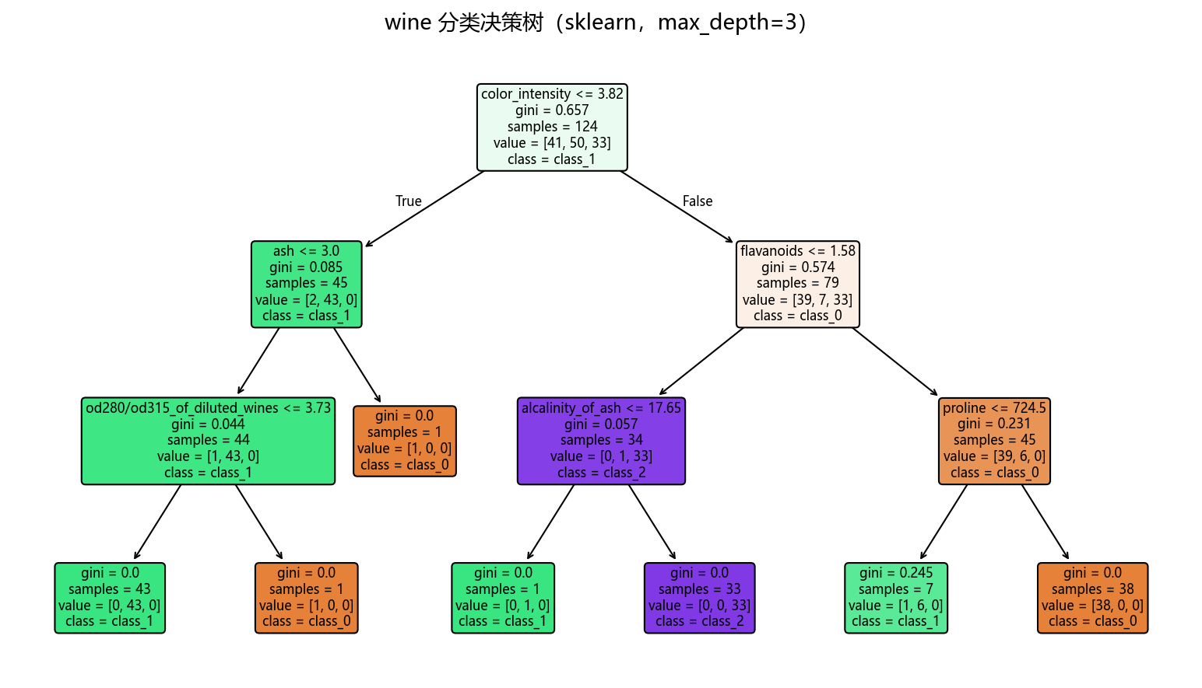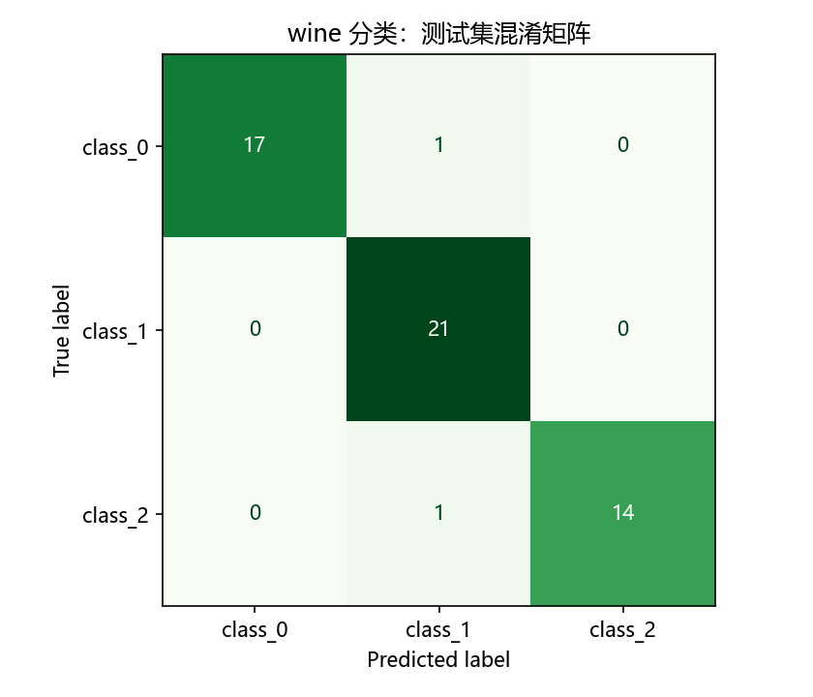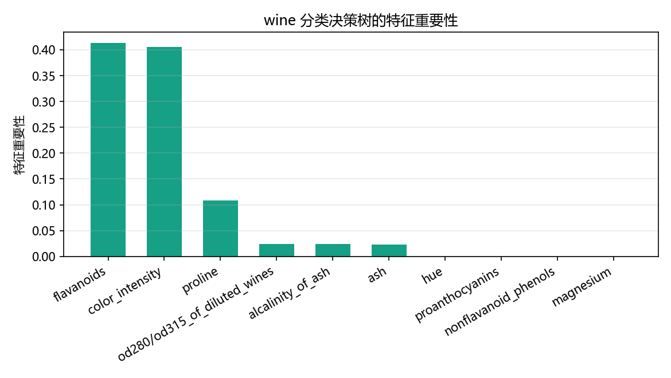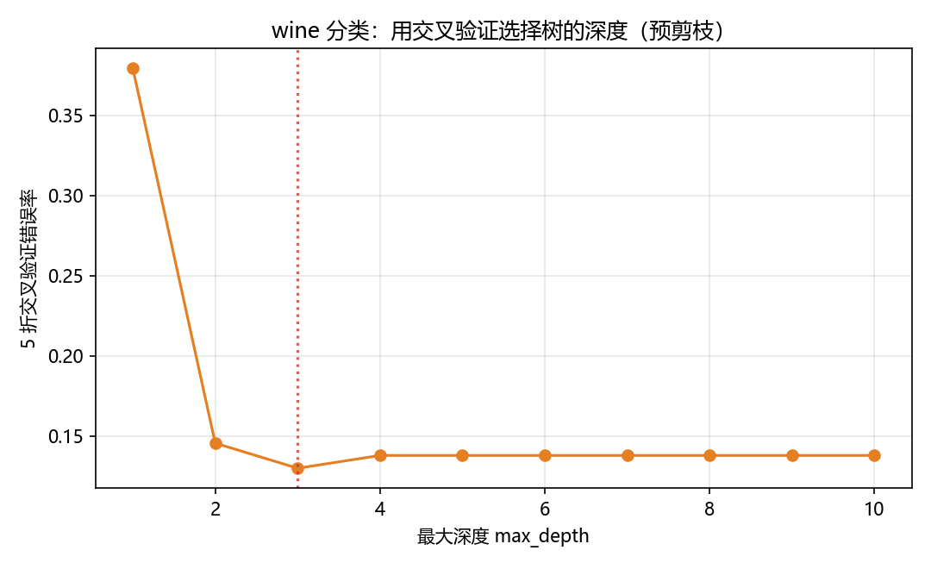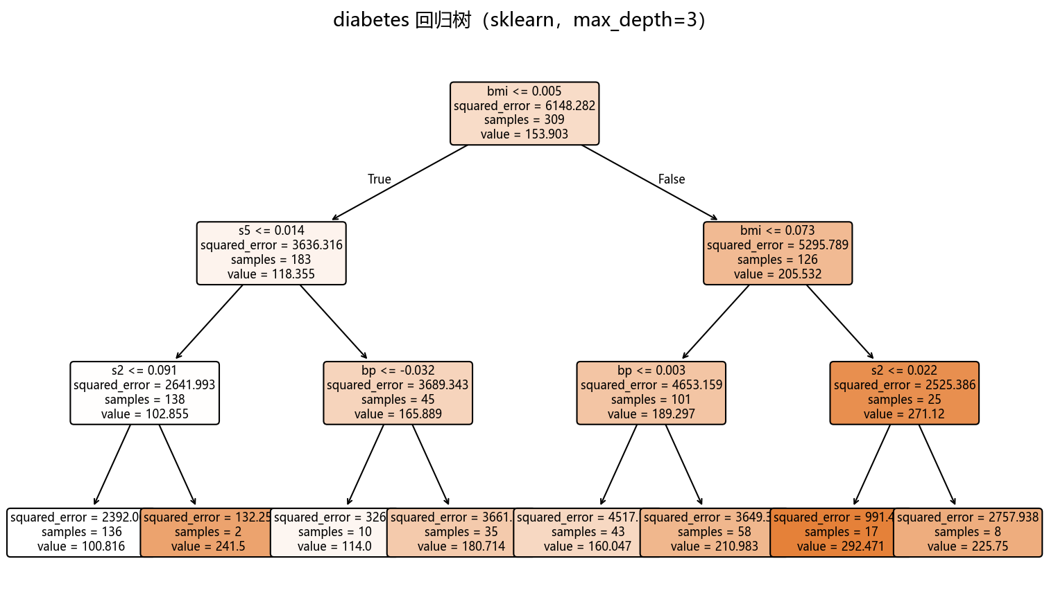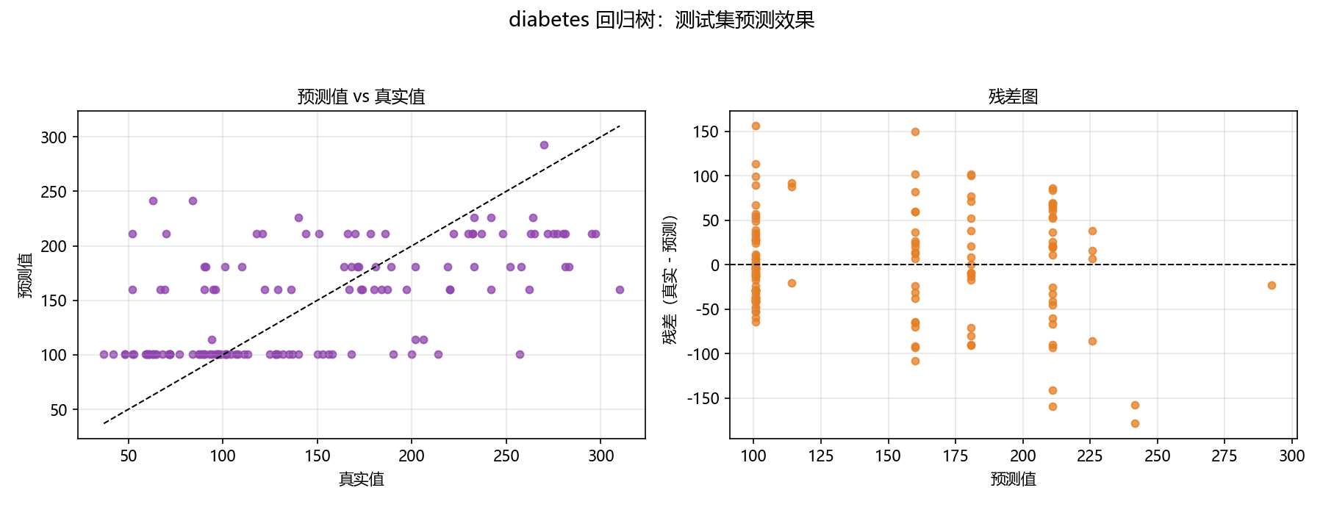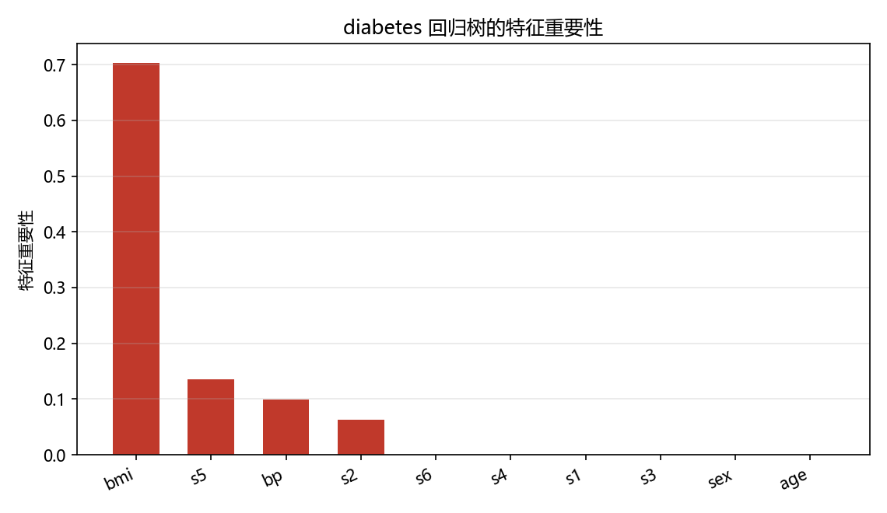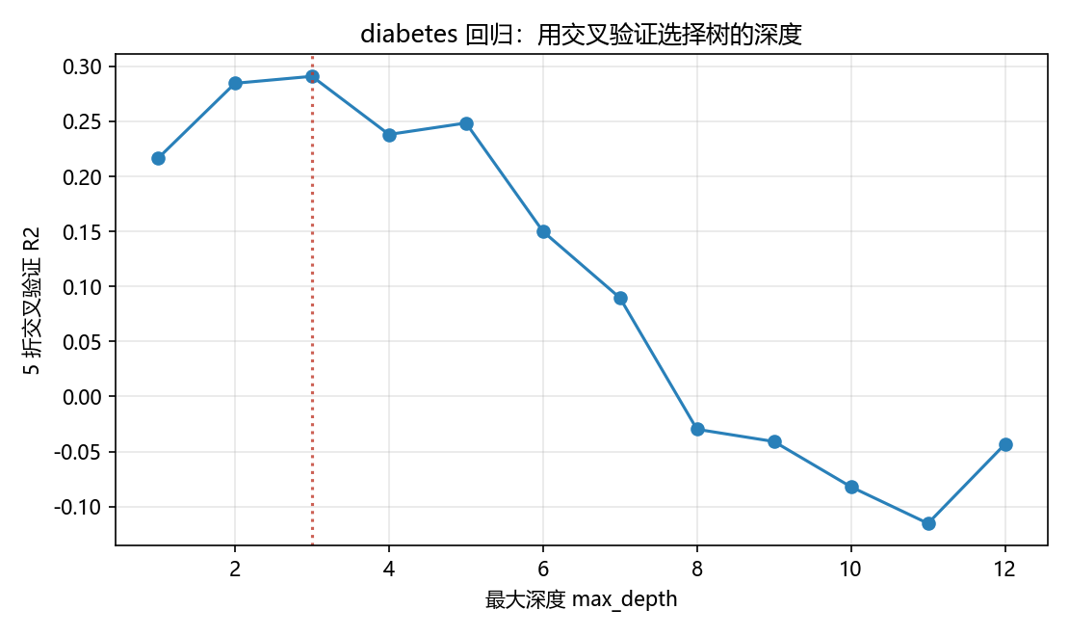

使用graphviz对决策树进行可视化：
https://blog.csdn.net/qq_42294351/article/details/119754109

https://blog.csdn.net/qq_36206070/article/details/83343603

