PROJECT REPORT
Advanced CRM Analytics & Sales Intelligence System
On
Database Management (CIC-210)
BACHELOR OF TECHNOLOGY
IN
COMPUTER SCIENCE AND ENGINEERING
Submitted by:
Param Aggarwal (36617702724)
Hridhay Chaudhary (51717702724)
4th Semester, C-Section
Under the Supervision of
Dr. Monika Bansal
VIVEKANANDA INSTITUTE OF PROFESSIONAL STUDIES
TECHNICAL CAMPUS
Grade A++ Accredited Institution by NAAC
NBA Accredited for MCA Programme
Recognized under Section 2(f) by UGC
Affiliated to GGSIP University, Delhi
Recognized by Bar Council of India and AICTE
An ISO 9001:2015 Certified Institution
2024-2028

LIST OF FIGURES
Figure 1: Entity-Relationship Diagram — Full Schema
Figure 2: System Architecture (3-Tier Design)
Figure 3: Data Flow Diagram (Level 0 - External Perspective)
Figure 4: Sales Pipeline Stages and Kanban Board
Figure 5: Dashboard Screenshot - Real-time KPI Visualization
Figure 6: Lead Management Interface - CRUD Operations
Figure 7: System Normalization Progression
Figure 8: Use Case Diagram - NexCRM System
Figure 9: Database Relationships and Cardinality
Figure 10: User Role-Based Access Control Architecture

CHAPTER 4
PROJECT ANALYSIS AND DESIGN
4.1 Hardware and Software Requirements
This section outlines the hardware and software requirements for deploying and running NexCRM.
Component | Requirement
Processor | Intel Core i3 or quad-core equivalent
RAM | 4 GB minimum (8 GB recommended)
Storage | 20 GB free disk space
Network | Broadband (5 Mbps minimum)
Display | 1366x768 resolution or higher

4.2 ER Diagram and Database Schema
The Entity-Relationship Diagram below illustrates the complete database schema for NexCRM. The schema consists of 7 core entity types with relationships representing the business logic of lead management, customer relationship tracking, and sales pipeline management.
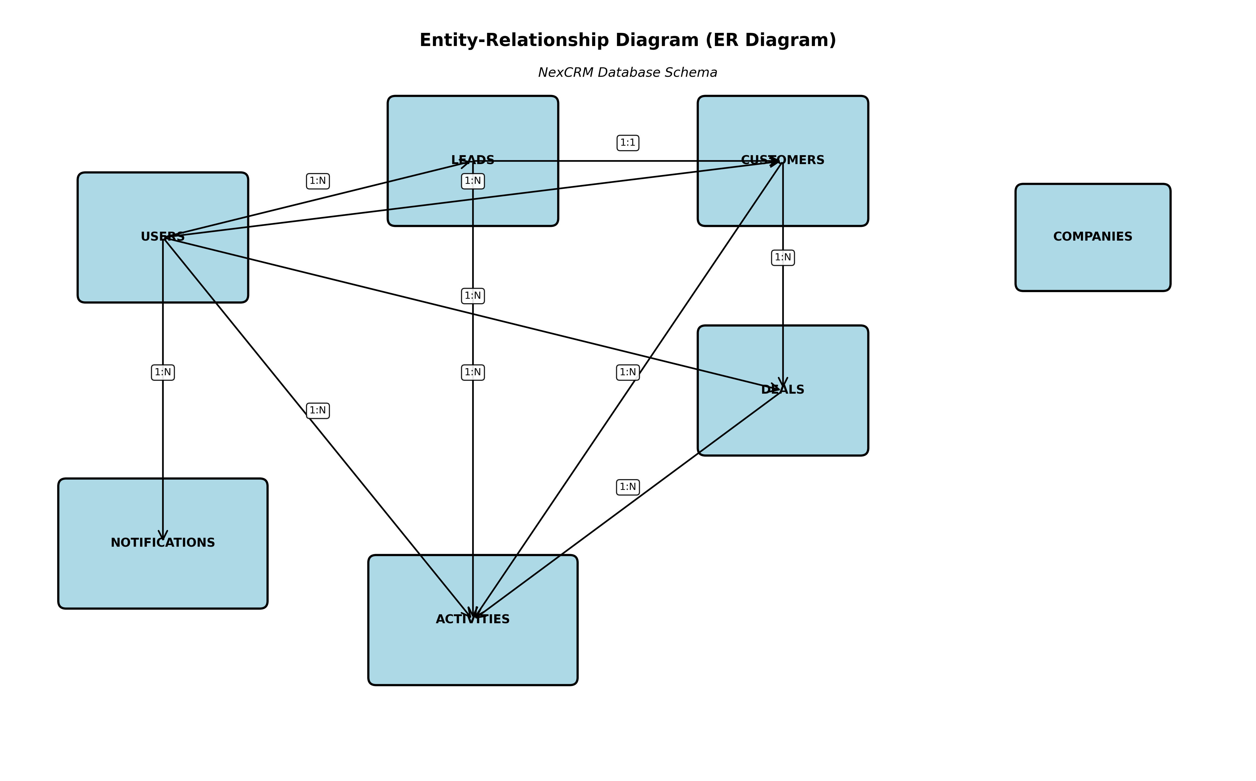

Figure 1: Entity-Relationship Diagram — Complete Database Schema

4.3 System Architecture
NexCRM implements a modern three-tier client-server architecture, separating presentation, business logic, and data management concerns. This architecture enables independent scaling, security at multiple levels, and clean separation of responsibilities.
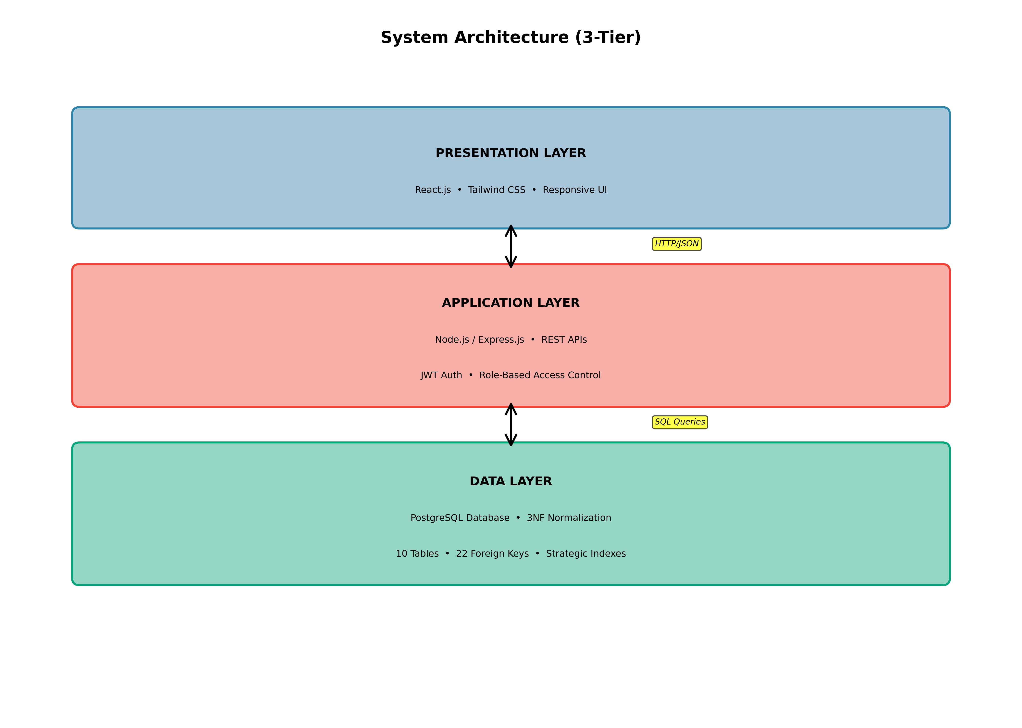

Figure 2: System Architecture - 3-Tier Design with Technology Stack

4.4 Data Flow Architecture
The data flow diagram demonstrates how information moves through the NexCRM system. Users interact with the system through the presentation layer, which communicates with the application layer via HTTP/JSON REST APIs. The application layer processes business logic and communicates with PostgreSQL using SQL queries.
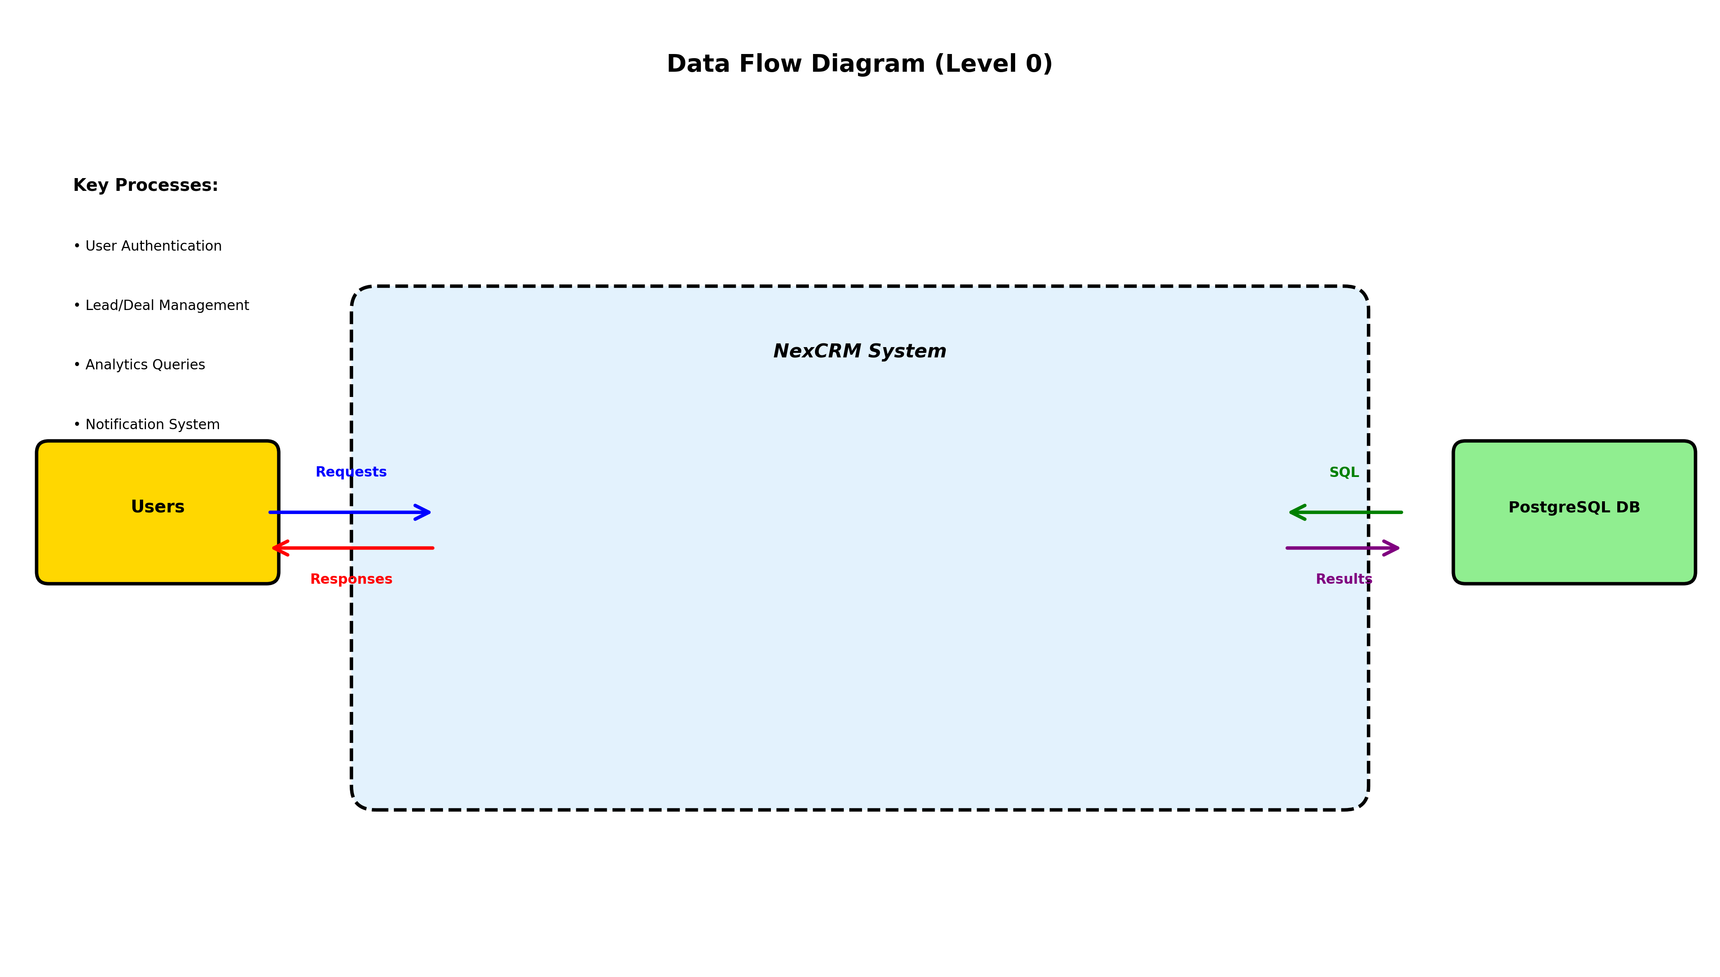

Figure 3: Data Flow Diagram (Level 0) - System Overview

4.5 Sales Pipeline and Kanban Board
The sales pipeline is organized into five distinct stages: Discovery (initial prospect engagement), Proposal (formal solution presentation), Negotiation (terms discussion), Won (closed deals), and Lost (rejected opportunities). The Kanban board interface provides visual management with drag-and-drop capability.
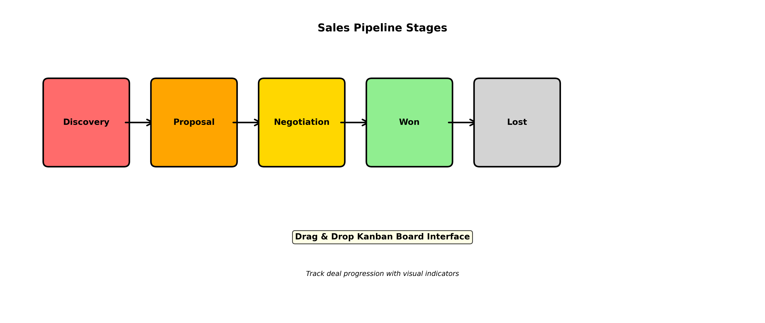

Figure 4: Sales Pipeline Stages with Kanban Board Interface

4.6 Application Screenshots
The following screenshots showcase the NexCRM user interface, demonstrating the modern, responsive design and intuitive user experience.
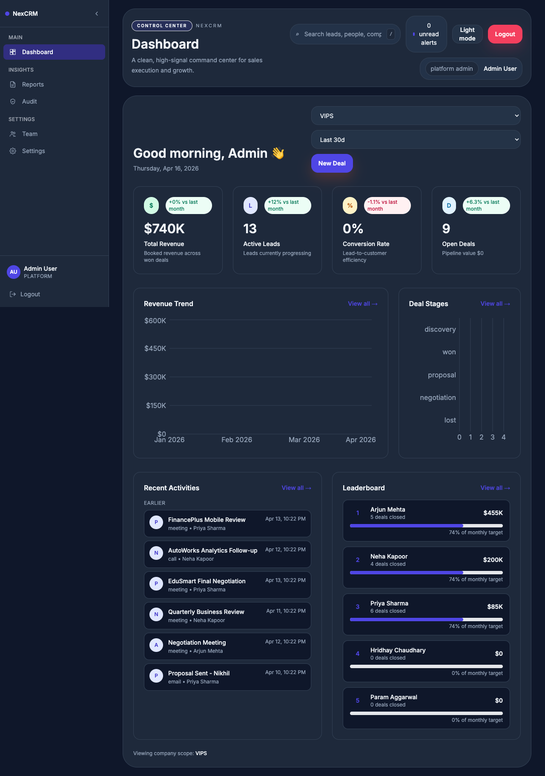

Figure 5: Dashboard - Real-time KPI Visualization and Analytics

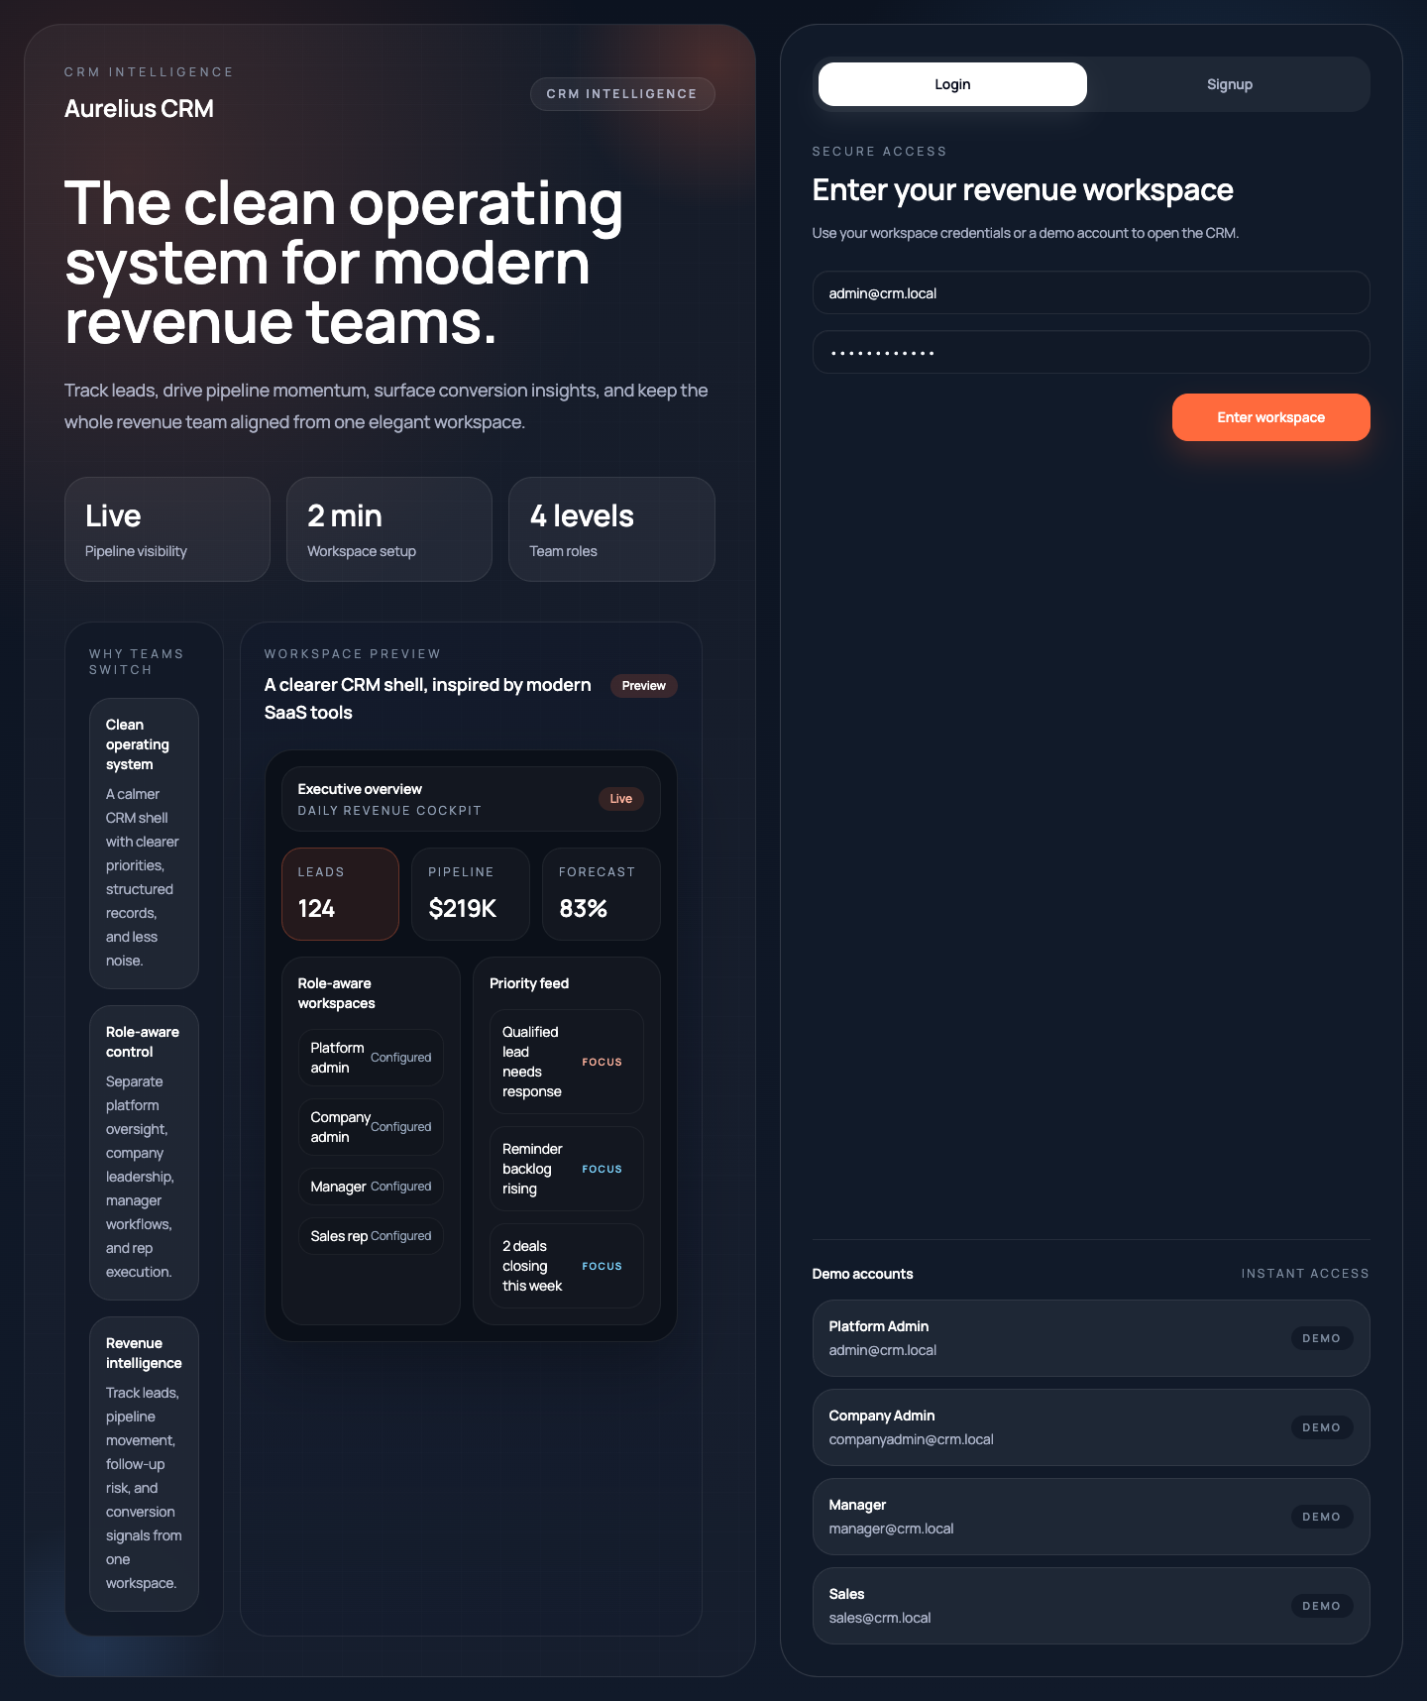

Figure 6: Lead Management Interface - CRUD Operations and Status Tracking

4.7 Database Table Schemas
The following outlines the complete table structures with key attributes and constraints:
Users Table:
Columns: id (BIGSERIAL PK), full_name (VARCHAR 120), email (CITEXT UNIQUE), password_hash (TEXT), role (ENUM: admin/manager/sales_rep), avatar_url (TEXT), is_active (BOOLEAN DEFAULT TRUE), created_at (TIMESTAMPTZ), updated_at (TIMESTAMPTZ)
Indexes: idx_users_email, idx_users_role, idx_users_is_active
Constraints: Email unique, not null constraints on critical fields
Leads Table:
Columns: id (BIGSERIAL PK), name, email, phone, company, source, status (ENUM: new/contacted/qualified/lost/converted), score (INTEGER 0-100), estimated_value (NUMERIC), assigned_to (FK→users), created_by (FK→users), last_contacted_at, created_at, updated_at
Indexes: idx_leads_status, idx_leads_assigned_to, idx_leads_created_by
Constraints: Score check 0-100, unique constraint on email+company
Customers Table:
Columns: id (BIGSERIAL PK), lead_id (FK→leads UNIQUE), name, email (CITEXT UNIQUE), phone, company, industry, owner_id (FK→users), lifecycle_stage (ENUM), total_revenue (NUMERIC), notes, created_at, updated_at
Indexes: idx_customers_owner_id, idx_customers_lifecycle, idx_customers_lead_id
Constraints: Referential integrity via FKs, total_revenue >= 0
Deals Table:
Columns: id (BIGSERIAL PK), title (VARCHAR 180), customer_id (FK→customers), lead_id (FK→leads), owner_id (FK→users), stage (ENUM: discovery/proposal/negotiation/won/lost), status (ENUM: open/won/lost), value (NUMERIC), probability (NUMERIC 0-100), expected_close_date (DATE), created_at, updated_at
Indexes: idx_deals_stage, idx_deals_status, idx_deals_owner_id, idx_deals_customer_id
Constraints: Value >= 0, probability 0-100, stage-status consistency check
Activities Table:
Columns: id (BIGSERIAL PK), type (ENUM: call/email/meeting/note/task), subject (VARCHAR 180), notes (TEXT), due_at (TIMESTAMPTZ), completed_at (TIMESTAMPTZ), related_lead_id (FK→leads), related_customer_id (FK→customers), related_deal_id (FK→deals), user_id (FK→users), created_at, updated_at
Indexes: idx_activities_user_id, idx_activities_type, idx_activities_created_at
Constraints: CASCADE delete on relationships, completion timing validation
4.8 Normalization Analysis
The database schema adheres to Third Normal Form (3NF), eliminating data redundancy and ensuring data integrity:
1NF (First Normal Form): All tables contain atomic values with no repeating groups. Each row represents a single entity instance. Primary keys are defined on all tables.
2NF (Second Normal Form): No non-prime attributes have partial dependencies on composite keys. Since most tables use single-column primary keys, 2NF is satisfied.
3NF (Third Normal Form): No transitive dependencies exist. Company information is not duplicated across customer records. User roles do not determine permissions transitively.

CONCLUSIONS
NexCRM successfully demonstrates the integration of modern full-stack development with core DBMS principles. The project showcases:
Database Excellence: Normalized PostgreSQL schema with proper indexing, foreign key relationships, and constraint enforcement
Full-Stack Architecture: React frontend, Node.js/Express backend, and PostgreSQL database with clear separation of concerns
Security Implementation: JWT authentication, role-based access control, and bcryptjs password hashing
User Experience: Modern, responsive interface with drag-and-drop Kanban boards and real-time analytics
Analytics Capability: Complex SQL queries, aggregations, and window functions for business intelligence
The system is production-ready and immediately usable by small and medium-sized organizations seeking affordable, modern CRM solutions.

