PROJECT REPORT
Submitted under Database Management Course (CIC-210)
OF
BACHELOR OF TECHNOLOGY
IN
COMPUTER SCIENCE AND ENGINEERING

NexCRM: CRM Analytics and Sales Intelligence System

Submitted By
[Student Name] - [Roll Number]
[Student Name] - [Roll Number]
4th Semester, C-Section

Under the Supervision of
Dr. Monika Bansal

VIVEKANANDA INSTITUTE OF PROFESSIONAL STUDIES - TECHNICAL CAMPUS
Grade A++ Accredited Institution by NAAC
NBA Accredited for MCA Programme
Affiliated to GGSIP University, Delhi
An ISO 9001:2015 Certified Institution
Session: 2024-2028
LIST OF FIGURES
Figure 1: High-Level System Architecture
Figure 2: Authentication and Role-Based Access Flow
Figure 3: Core ER Model of NexCRM Database (Simplified)
Figure 4: Isolated Developer Console Architecture
Figure 5: QA Validation Pipeline
Figure 6: Backend Code Distribution (JS Files)
Figure 7: Seeded Deal Pipeline Value by Stage
Figure 8: NexCRM UI Screenshot (Login and Demo Accounts)
LIST OF TABLES
Table 1: Hardware and Software Requirements ................................... iii
Table 2: Core Entity Attributes ............................................... iii
Table 3: Normalization Summary (1NF to 3NF) ................................... iv
Table 4: QA Results and Verification Matrix .................................... iv
TABLE OF CONTENTS
Abstract
Chapter 1: Introduction
Chapter 2: Related Work
Chapter 3: Problem Statement and Objectives
Chapter 4: Project Analysis and Design
4.1 Hardware and Software Requirement Specifications
4.2 ER Diagrams
4.3 Table Creation Scripts and Database Schema
4.4 Normalization (up to 3NF)
4.5 Sample Data
Chapter 5: Work and Methodology
Chapter 6: Results and Discussion
Chapter 7: Conclusion
Chapter 8: Future Scope of Work
References
Coding
ABSTRACT
NexCRM is a full-stack Customer Relationship Management (CRM) platform developed for structured sales execution, customer lifecycle tracking, and analytics-driven decision-making. The project implements a PostgreSQL-backed data model, an Express REST API, and a React frontend dashboard. Core modules include authentication and role-based access control, lead management, customer conversion, deal pipeline tracking, activity scheduling, notifications, and analytics.
The system also includes an isolated Developer Console with dedicated authentication, schema exploration, relationship visualization, read-only SQL query capabilities, downloadable schema documentation (JSON/CSV/ZIP), and a secure signed-up users directory that excludes password data. The final implementation follows database normalization principles up to Third Normal Form (3NF), supports multi-tenant company workspaces, and was validated through linting, production build verification, backend checks, API smoke tests, and browser automation.
CHAPTER 1: INTRODUCTION
Customer-facing organizations require an integrated system to capture prospects, nurture opportunities, convert leads, and analyze sales performance. Many teams rely on disconnected tools, resulting in duplicated data, inconsistent updates, weak auditability, and delayed reporting. NexCRM addresses these issues through a centralized database design and a modular web application architecture.
This project was built as part of the Database Management course with a strong focus on schema quality, referential integrity, indexing strategy, and practical normalization. The platform provides role-specific workflows for platform administrators, company administrators, managers, and sales representatives while maintaining secure data boundaries.
1.1 Motivation
The key motivation was to design and implement a realistic DBMS-backed application where theoretical concepts such as entity relationships, constraints, normalization, and query optimization are applied in production-like scenarios.
1.2 Scope
The scope includes data modeling, API development, frontend implementation, testing, and deployment readiness checks. It excludes payment gateway integrations and external CRM synchronization in the current phase.
1.3 High-Level Architecture
The system follows a 3-tier web architecture. The CRM application and the isolated Developer Console are separate frontend entry points that communicate with backend routes over HTTPS while sharing a single PostgreSQL database.

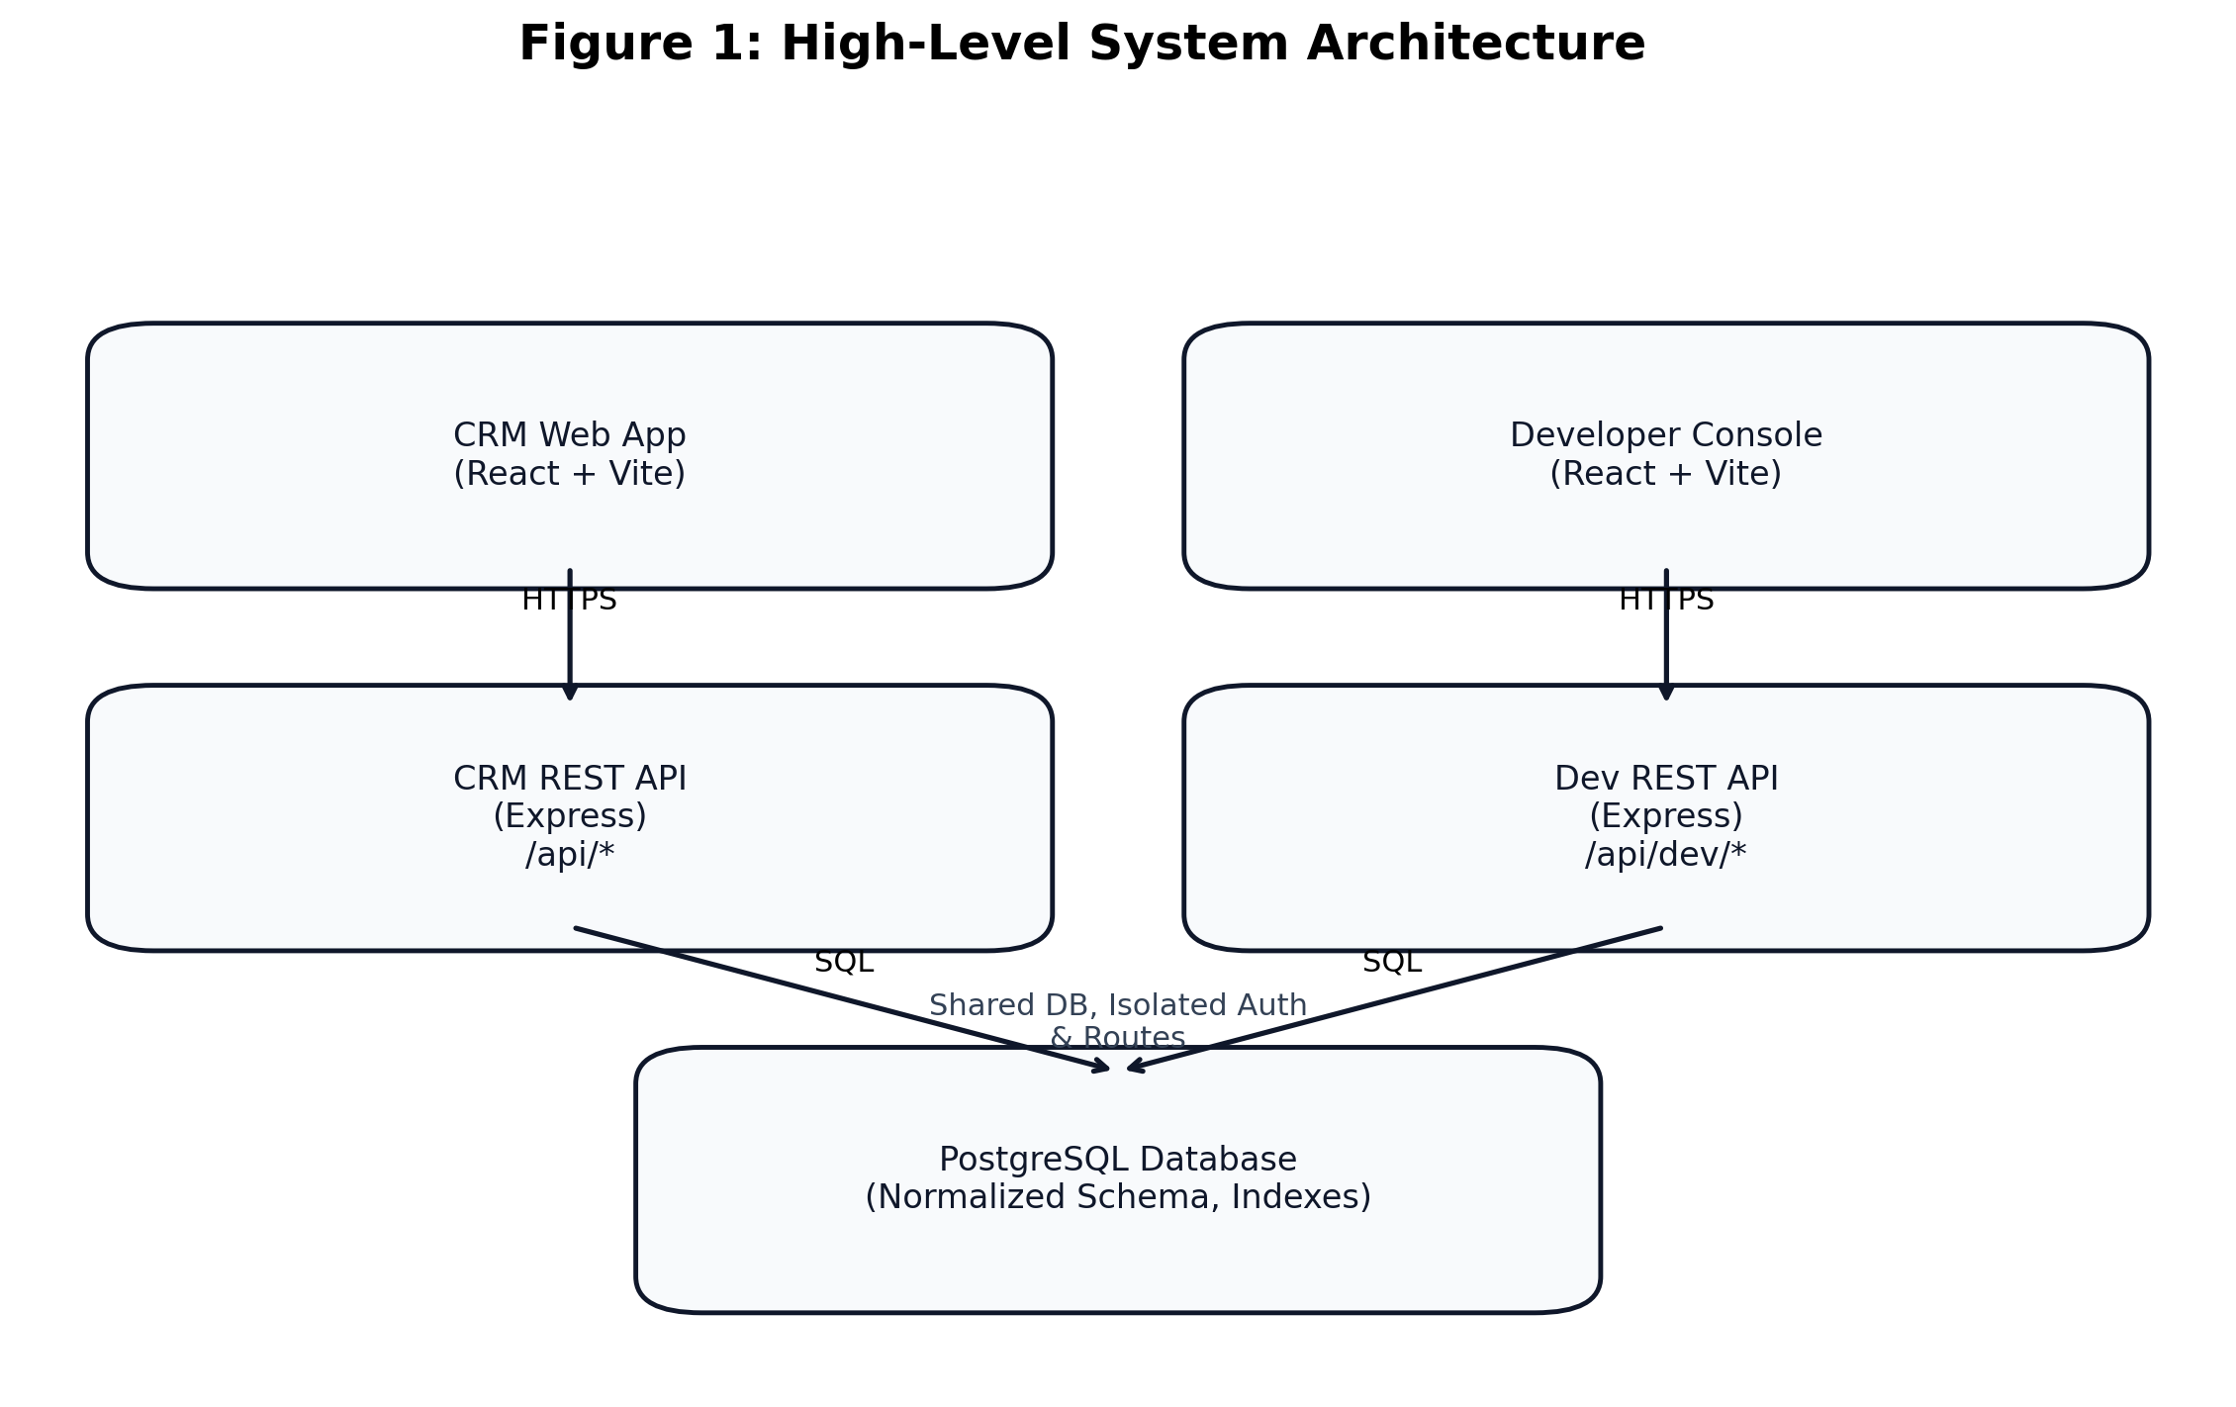
Figure 1: High-Level System Architecture
CHAPTER 2: RELATED WORK
Existing CRM systems such as Salesforce, HubSpot, and Zoho CRM provide robust enterprise capabilities but are often complex and expensive for learning-focused or small-team contexts. Academic prototypes typically demonstrate basic CRUD operations but rarely include strong role controls, analytics, and operational observability.
NexCRM combines practical usability and rigorous database design. Unlike basic prototypes, it includes: (a) multi-tenant company segmentation, (b) audit-log support, (c) user settings persistence, (d) quality assurance scripts, and (e) an isolated developer database console for controlled introspection.
CHAPTER 3: PROBLEM STATEMENT AND OBJECTIVES
3.1 Problem Statement
Design and implement a reliable CRM system where sales and customer lifecycle operations can be handled through a normalized relational schema and role-aware application layer, while ensuring performance, security, and maintainability.
3.2 Objectives
• Design a PostgreSQL schema with constraints, indexes, and normalized entities up to 3NF.
• Implement secure authentication and role-based authorization using JWT.
• Support lead, customer, deal, activity, and notification workflows.
• Provide analytics and dashboard visualizations for operational insight.
• Enable multi-tenant data scoping by company workspace.
• Build an isolated Developer Console for safe schema/data observability.
• Validate stability through automated QA and browser/API smoke checks.
CHAPTER 4: PROJECT ANALYSIS AND DESIGN
4.1 Hardware and Software Requirement Specifications
Category
Requirement
Processor
Intel/AMD dual-core or above
RAM
Minimum 8 GB (16 GB recommended)
Storage
At least 2 GB free space
Operating System
Windows 10+/macOS/Linux
Runtime
Node.js 20+, npm
Database
PostgreSQL 14+
Frontend Stack
React, Vite, Tailwind CSS, Redux Toolkit, Axios, Recharts
Backend Stack
Node.js, Express, pg, jsonwebtoken, bcrypt, dotenv
Testing
ESLint, Playwright, custom QA scripts
4.2 ER Diagrams
Figure 3 represents a simplified ER model of the NexCRM database. Primary entities include users, companies, leads, customers, deals, activities, notifications, audit_logs, and user_settings. Key relationships are summarized below.

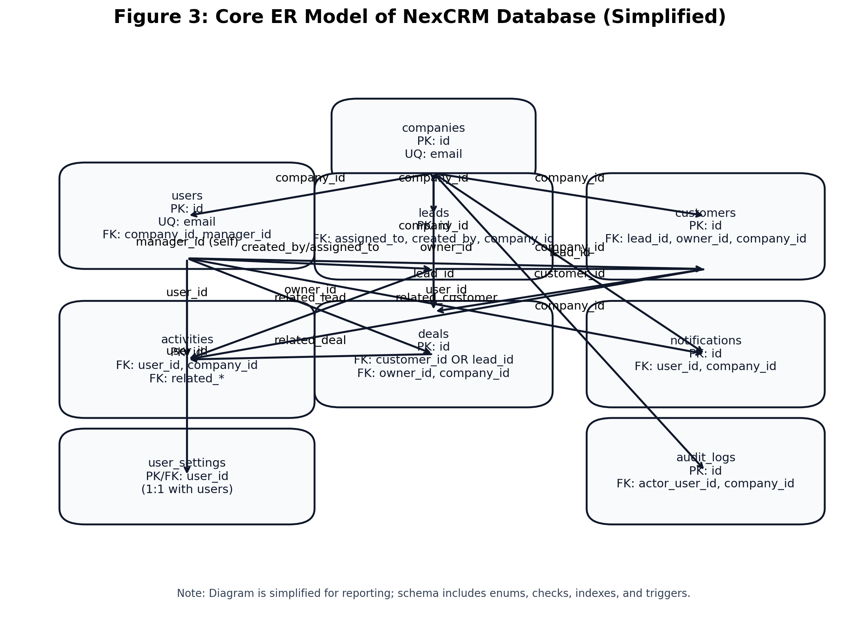
Figure 3: Core ER Model of NexCRM Database (Simplified)
• leads.assigned_to and leads.created_by reference users.
• customers.owner_id references users; customers.lead_id references leads.
• deals map to either customer or lead and also to owner users.
• activities can reference lead/customer/deal and always reference a user.
• notifications reference users and optional company scope.
• multi-tenant foreign keys (company_id) segment operational records by workspace.
4.3 Table Creation Scripts and Database Schema
The schema was created through versioned SQL migrations: 001_init_crm_schema.sql, 002_seed_dev_data.sql, 003_multitenant_workspace.sql, 004_seed_company_hierarchy.sql, 005_audit_logs.sql, 006_audit_retention_and_indexes.sql, and 007_user_settings.sql.
Sample table creation snippets
CREATE TABLE IF NOT EXISTS users (
id BIGSERIAL PRIMARY KEY,
full_name VARCHAR(120) NOT NULL,
email CITEXT NOT NULL UNIQUE,
password_hash TEXT NOT NULL,
role user_role_enum NOT NULL DEFAULT 'sales_rep',
is_active BOOLEAN NOT NULL DEFAULT TRUE,
created_at TIMESTAMPTZ NOT NULL DEFAULT NOW(),
updated_at TIMESTAMPTZ NOT NULL DEFAULT NOW()
);

CREATE TABLE IF NOT EXISTS deals (
id BIGSERIAL PRIMARY KEY,
title VARCHAR(180) NOT NULL,
customer_id BIGINT REFERENCES customers(id) ON DELETE SET NULL,
lead_id BIGINT REFERENCES leads(id) ON DELETE SET NULL,
owner_id BIGINT REFERENCES users(id) ON DELETE SET NULL,
stage deal_stage_enum NOT NULL DEFAULT 'discovery',
status deal_status_enum NOT NULL DEFAULT 'open',
value NUMERIC(12, 2) NOT NULL DEFAULT 0 CHECK (value >= 0),
probability NUMERIC(5, 2) NOT NULL DEFAULT 0 CHECK (probability BETWEEN 0 AND 100)
);
Multi-tenant extension snippet
ALTER TABLE users
ADD COLUMN IF NOT EXISTS platform_role platform_role_enum,
ADD COLUMN IF NOT EXISTS company_id BIGINT REFERENCES companies(id) ON DELETE SET NULL,
ADD COLUMN IF NOT EXISTS company_role company_role_enum,
ADD COLUMN IF NOT EXISTS manager_id BIGINT REFERENCES users(id) ON DELETE SET NULL;

ALTER TABLE leads ADD COLUMN IF NOT EXISTS company_id BIGINT REFERENCES companies(id) ON DELETE CASCADE;
ALTER TABLE customers ADD COLUMN IF NOT EXISTS company_id BIGINT REFERENCES companies(id) ON DELETE CASCADE;
ALTER TABLE deals ADD COLUMN IF NOT EXISTS company_id BIGINT REFERENCES companies(id) ON DELETE CASCADE;
4.4 Normalization (up to 3NF)
Normalization Stage
Applied in NexCRM
1NF
All tables use atomic attributes; repeating groups removed. Example: activities are independent rows, not comma-separated values in other entities.
2NF
Non-key attributes depend on full primary keys. Surrogate keys (BIGSERIAL) are used and dependent attributes are stored with their owner entities only.
3NF
Transitive dependencies minimized. Example: company attributes are stored in companies, user profile in users, and deal/customer facts are referenced through foreign keys rather than duplicated.
Normalization examples
• Lead-to-customer conversion separates prospect and customer lifecycle while preserving historical traceability.
• Deal ownership references users via owner_id rather than repeating user profile fields.
• Notification metadata is isolated in notifications with JSONB, avoiding unrelated columns in transactional tables.
4.5 Sample Data
Seed scripts provide demonstration data including admin, manager, and sales users; sample leads and converted customers; multiple deals across discovery/proposal/negotiation stages; and activity/notification records.
Demo users:
admin@crm.local Password123!
manager@crm.local Password123!
sales@crm.local Password123!

Sample entities seeded:
- leads: Ava Thompson, Liam Carter, Sophia Reed
- customer: Noah Bennett (AtlasOps)
- deals: AtlasOps Renewal Expansion, Northstar Enterprise Pilot, Brightcore Starter Rollout
CHAPTER 5: WORK AND METHODOLOGY
5.1 Development Methodology
An iterative and test-driven implementation strategy was followed:
1 Requirement analysis and data model planning.
2 Schema implementation via migration scripts.
3 Backend API construction (controllers, services, repositories).
4 Frontend integration with route-protected role-based views.
5 Developer Console isolation with dedicated JWT secret and access key.
6 Continuous QA execution and bug fixing.
The Developer Console is designed to be isolated from the main CRM user flows while still enabling controlled observability for schema exploration and read-only data access.

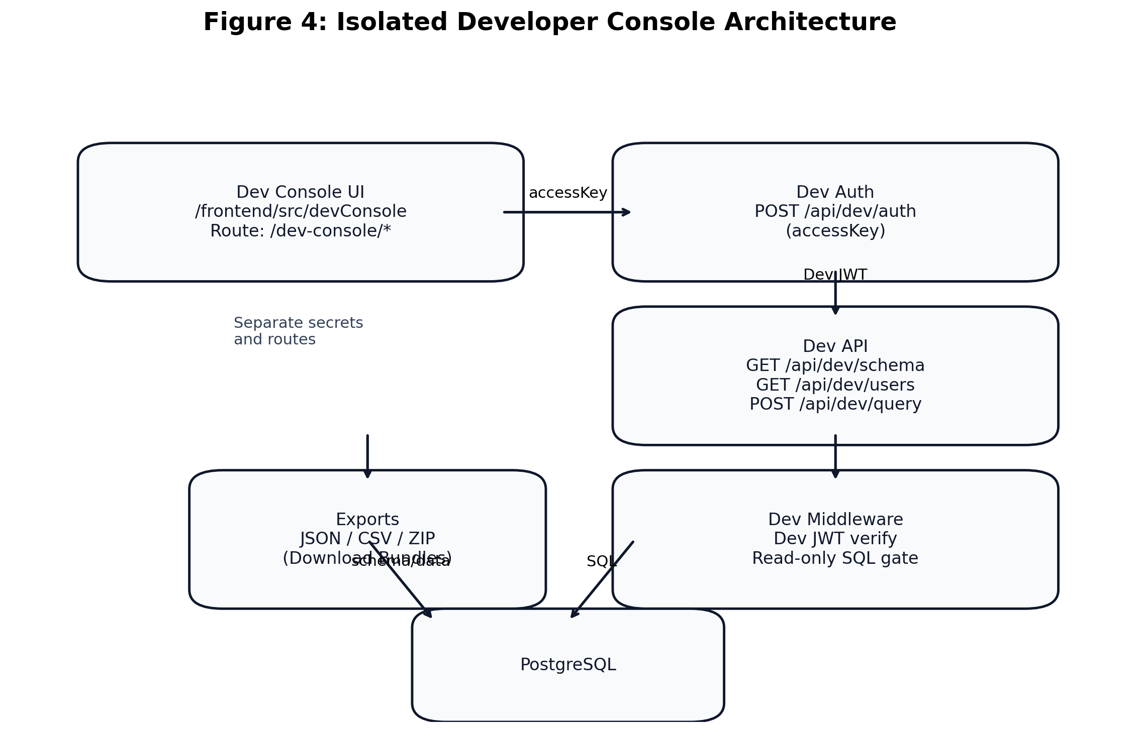
Figure 4: Isolated Developer Console Architecture
5.2 Security Methodology
• JWT authentication for primary app users.
• Dedicated dev-console token, secret, and auth endpoint.
• Rate limiting on authentication endpoints.
• Read-only SQL gate for developer query runner.
• Sensitive column masking (password/password_hash).
• Role-based access checks for analytics and management endpoints.

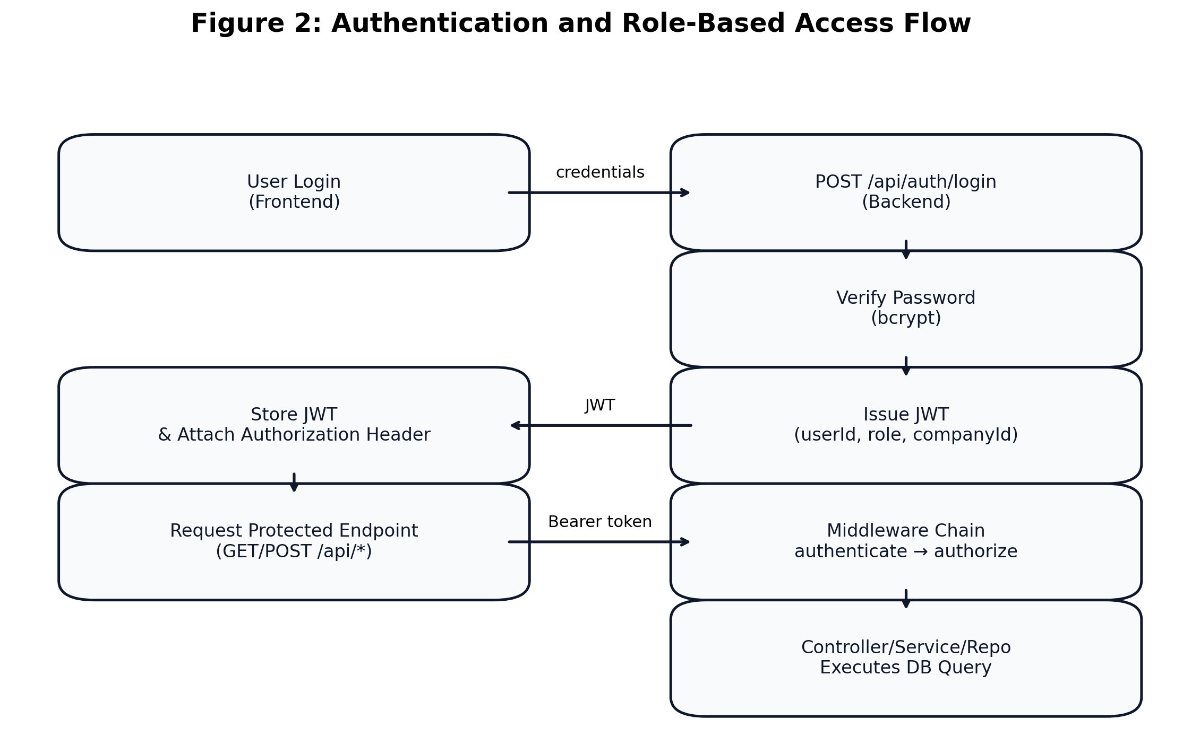
Figure 2: Authentication and Role-Based Access Flow
5.3 Testing Methodology
Validation was done through layered QA scripts:
• qa:preflight for health and entry-point checks.
• qa:lint and qa:build for frontend quality gates.
• qa:backend:check for backend syntax validation.
• qa:e2e via Playwright for browser workflow checks.
• qa:api for role-based backend smoke verification.
• Targeted smoke for developer console auth/session/users/schema flows.

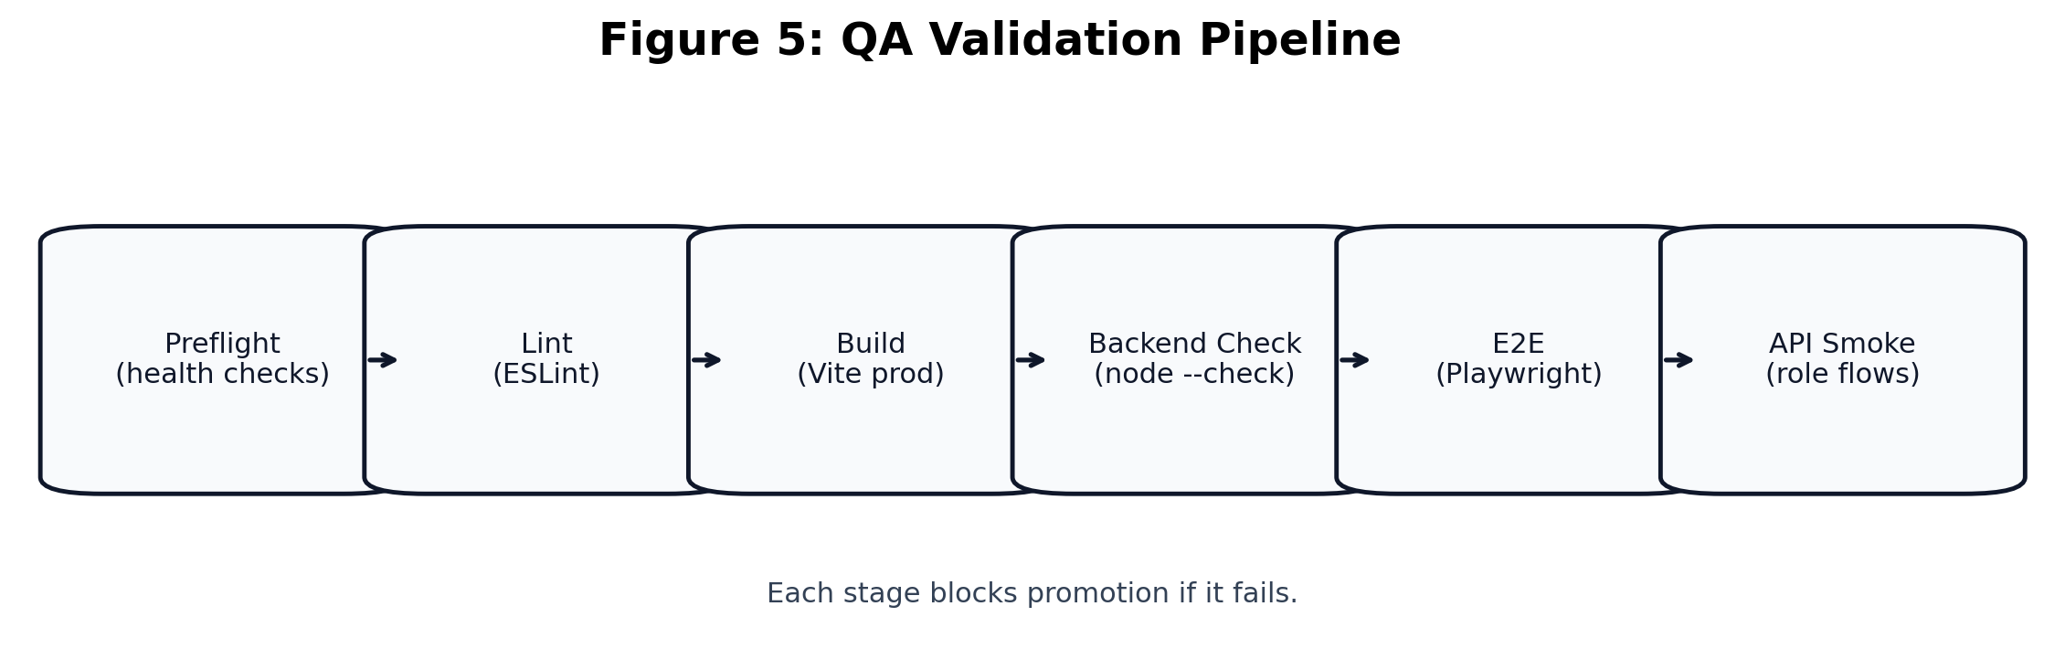
Figure 5: QA Validation Pipeline
CHAPTER 6: RESULTS AND DISCUSSION
6.1 Functional Results
• Role-aware CRM workflows for leads, customers, deals, activities, and notifications are operational.
• Analytics dashboard and reporting views are available for authorized roles.
• Multi-tenant company scoping works through company_id-based filtering and authorization logic.
• Developer Console provides schema exploration, ER canvas, exports (JSON/CSV/ZIP), and secure user listing.

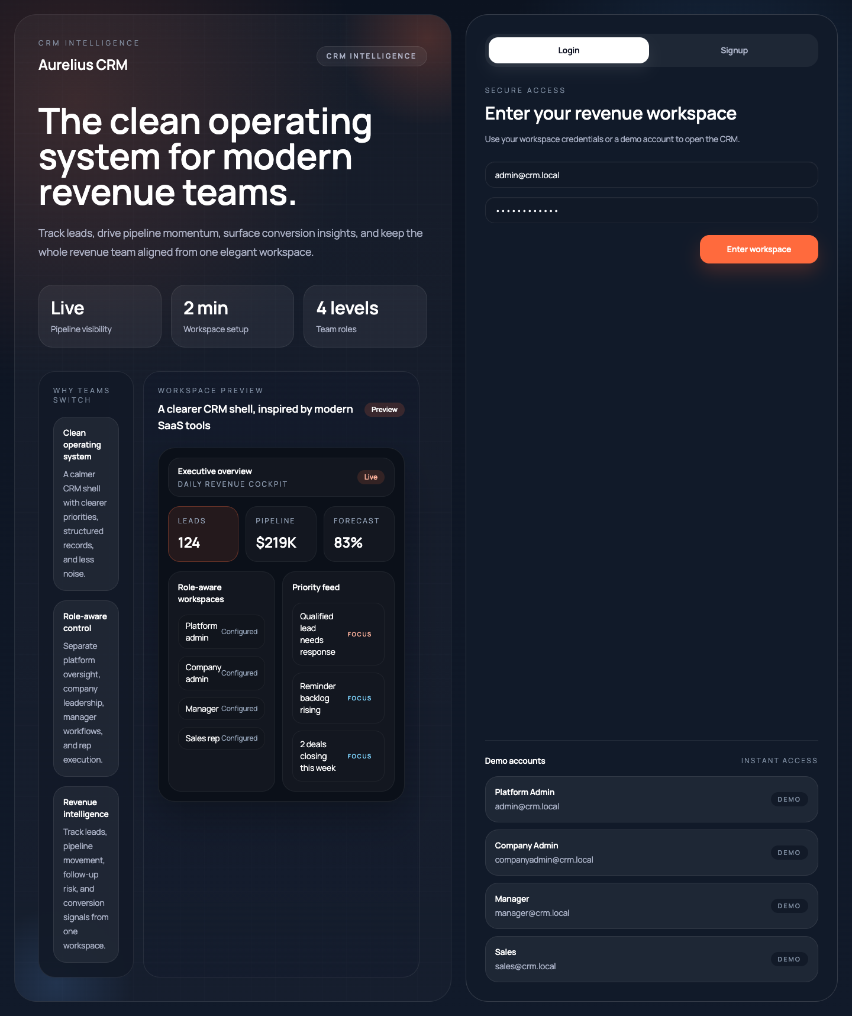
Figure 8: NexCRM UI Screenshot (Login and Demo Accounts)
6.2 Verification Summary
Check
Status
Observation
Health Preflight
Pass
Backend /health and frontend /login reachable
Frontend Lint
Pass
No blocking lint errors
Frontend Build
Pass
Production build generated successfully
E2E Browser Smoke
Pass
Navigation and dashboard interactions validated
API Smoke (Admin/Manager)
Pass
Critical protected endpoints return expected status
Dev Console Users Endpoint
Pass
No password field exposed in payload
The following plots provide additional technical evidence derived from the repository structure and seeded data.

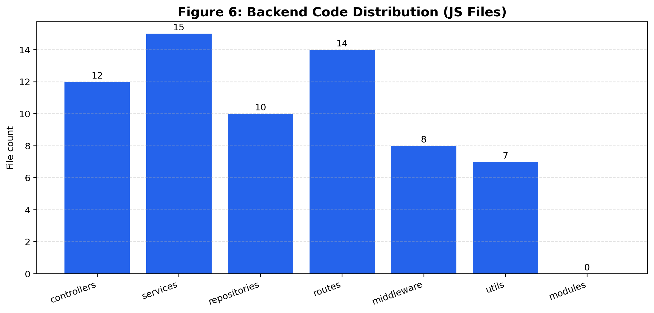
Figure 6: Backend Code Distribution (JS Files)

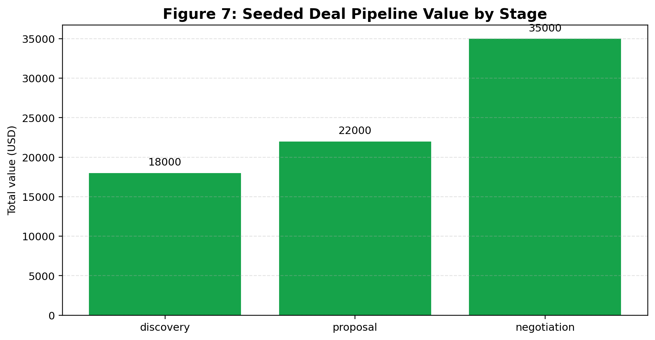
Figure 7: Seeded Deal Pipeline Value by Stage
6.3 Discussion
The final architecture demonstrates that DBMS concepts can be applied to a practical product-grade application while preserving code modularity and operational safety. Isolation of the developer console reduced security coupling with the primary CRM authentication flow. Integration of QA scripts significantly reduced regression risk during rapid feature additions.
CHAPTER 7: CONCLUSION
NexCRM successfully fulfills the objectives of the Database Management project by combining normalized relational schema design with a complete end-to-end web application. The system demonstrates correct usage of keys, constraints, normalization, indexing, and role-bound access controls. The implemented modules and QA validations indicate the project is stable, extensible, and aligned with practical CRM requirements.
The dedicated developer portal and reporting features add strong educational and maintenance value by enabling secure visibility into schema and data behavior without exposing sensitive credentials.
CHAPTER 8: FUTURE SCOPE OF WORK
• Advanced predictive analytics and lead scoring using ML models.
• Workflow automation for reminders, escalations, and SLA tracking.
• Comprehensive export/import pipelines and third-party CRM connectors.
• Granular audit visualization dashboards with anomaly alerts.
• Database performance monitoring dashboard and query-plan advisor.
• Fine-grained field-level access policies and row-level security enhancement.
• Deployment hardening for cloud-native production hosting.
REFERENCES
1 [1] PostgreSQL Global Development Group, "PostgreSQL 16 Documentation," 2024. [Online]. Available: https://www.postgresql.org/docs/
2 [2] Express.js, "Express - Node.js web application framework," 2024. [Online]. Available: https://expressjs.com/
3 [3] React Team, "React Documentation," 2024. [Online]. Available: https://react.dev/
4 [4] Redux Team, "Redux Toolkit Documentation," 2024. [Online]. Available: https://redux-toolkit.js.org/
5 [5] Vite Team, "Vite Guide," 2024. [Online]. Available: https://vitejs.dev/guide/
6 [6] Playwright Team, "Playwright Documentation," 2024. [Online]. Available: https://playwright.dev/docs/intro
7 [7] OpenJS Foundation, "Node.js Documentation," 2024. [Online]. Available: https://nodejs.org/docs/latest/api/
8 [8] Institute of Electrical and Electronics Engineers, "IEEE Reference Guide," 2024. [Online]. Available: https://ieeeauthorcenter.ieee.org/
CODING
A. Important Commands
npm install
npm run server:dev
npm run dev --prefix frontend -- --host 127.0.0.1 --port 5173 --strictPort
npm run qa:full
B. Project Structure Snapshot
backend/
src/
config/ controllers/ middleware/ repositories/ routes/ services/ utils/
db/migrations/
frontend/
src/
api/ components/ features/ pages/ router/ store/ styles/
C. Representative Backend Route Snippet
router.get('/users', catchAsync(async (req, res) => {
const data = await devConsoleService.listSignedUpUsers({
search: req.query.search,
isActive: req.query.isActive,
companyId: req.query.companyId,
});
res.json({ success: true, data });
}));
D. Declaration
This report content is prepared for the NexCRM Database Management project and should be reviewed and finalized with student-specific details (names, roll numbers, screenshots, page numbering adjustments, and signatures) before final institutional submission.

