**TEAM ID :M2023TMID13353**

**COLLEGE NAME:JAYAM COLLEGE OF ENGINEERING**

**AND TECHNOLOGY**

**PROJECT NAME: ADVANED COVID-19 DETECTION FROM LUNG X-RAYS WITH**

**MACHINE LEARNINGS**

***INTRODUCTION:***

***PROJECT OVERVIEW:***

The novel coronavirus disease first appeared in the city of Wuhan, China, in late 2019. While China’s government took a number of precautionary measures, including a lockdown of the city, to limit the spread of COVID-19 , it had, by then, been too late to contain the virus.

By early spring 2020, the virus had been reported in most countries, and by the end of March 2020, the World Health Organization (WHO) officially declared the new virus a pandemic . According to data released by the WHO, by April 30, 2021, more than 157 million people have been affected with the virus and more than 3 million had lost their lives to the disease .

While coronaviruses are not novel, SARS-CoV-2 is not standard . This virus is very probably to have originated from an animal reservoir . Patients with COVID-19 are assessed and cared for using different treatments than those applied for other coronavirus transmissions . But our knowledge of the disease remains limited and is expanding simultaneously with the pandemic . Commonly reported symptoms of COVID-19 include fever, coughing, tiredness, a sore throat and body aches, while numerous accounts of loss of taste or scent have been reported across the globe. In rarer but typically more severe cases, patients can experience difficulty breathing, a high fever, chills, fatigue, muscle or body aches or even death .

The standard COVID-19 test is known as the polymerase chain reaction (PCR) test and is used to detect the existence of infection antibodies. Unfortunately, these tests demand high precision and are time-consuming with a non-negligible possibility of false negatives . It goes without saying that an erroneous conclusion of the absence of the virus can lead to drastic results and is counterintuitive to governments’ efforts to restrict the spread of the virus.

Moreover, many countries lack the adequate resources to implement COVID-19 tests and testing sites on a large scale. To bypass such issues, radiography chest image analysis is considered an alternative method to the PCR test.

Artificial Intelligence (AI) models can be an apt solution . Thanks to its great accuracy, the deep learning approach has been widely welcomed and successful for medical image classification applications. Many recent works based on deep learning technology have promoted the development of intelligent diagnostic systems, which can help human experts make better decisions about patients’ health. Lopez et al. try to raise the problem of skin lesion classification in their paper especially the identification of early melanoma, and propose a deep learning method to solve the problem of image classification and identification of skin lesions whether they are malignant or benign.

A survey from the latest UN Global Pulse assessment of the application of AI to COVID-19-related needs shows that, compared with standard testing, AI has potential for human accuracy and may significantly save radiologists’ time and effort. Thus, the potential for a cheaper and more timely diagnosis cannot be overlooked . Both computed tomography (CT) and X-ray can be used .

Due to considerable sustained achievement in machine learning, especially in statistical learning that integrates big data and the important interest of interpretable AI in medicine , AI and deep learning can improve COVID-19: discovery and identification. The main challenge is to detect COVID-19 with an accurate and low-cost detection methods. Convolutional Neural Networks (CNN) have been demonstrated to be very powerful in including extraction and learning, so they are generally adopted by researchers . The purpose of this work is to establish a fully automated system for the classification of COVID-19 and non-COVID-19 pneumonia. We have trained three popular convolutional networks on the elaborated dataset. These networks (VGG16, ResNet50, and InceptionV3) have achieved compelling results in some tasks in recent years. We fine-tune them for the purpose of the detection of COVID-19. As of today, only a limited set of X-ray images relating to COVID-19 inquiries is available for public use. Thus, we could not train these models from scratch. In this work, we adopt two strategies to solve the COVID-19 image shortage problem:

* we apply data augmentation in order to build a converted version of the COVID-19 image (e.g., flip, small rotation, small distortion, etc.) to triple the set of samples.
* we fine-tuned the last layer of the model; thus, we can use less labeled samples per category for the training process.

***PURPOSE:***

The purpose of this algorithm is to offer an accurate diagnosis for two-class classification (COVID/no-findings) and a multi-class classification (COVID/no-findings/pneumonia). The classification accuracy for the binary classification is 98.08 %, and for the multi-classification is 87.02 %.

**IDEATION&PROPOSED SOLUTIONS:**

**PROBLEM STATEMENT DEFINITION:**

1. VGG19 and VGG16

The Visual Geometry Group is abbreviated as VGG. VGG16 is built using multiple 33 kernel-sized filters sequentially (11 and 5 in the first and second convolutional layers, respectively). VGG’s input is set to a 224 × 244 RGB picture. The VGG-19 convolutional neural network was trained using over a million pictures from the ImageNet database. The network has a depth of 19 layers and is capable of classifying images of multiple classes. The VGG architectures’ primary concept is to keep the convolution size modest and constant while designing an extremely deep network.

InceptionV3

InceptionV3 makes use of label smoothing, factorized 7 × 7 convolutions, and an auxiliary classifier to transmit label information down the network, as well as batch normalization for sidehead layers. It features smaller convolutions for quicker training and lower grid size to overcome computational cost constraints. Numerous optimization methods have been proposed for an InceptionV3 model in order to relax the restrictions and facilitate model adaptability. Factorized convolutions, regularization, dimension reduction, and parallelized calculations are all included in the methods.

ResNet50 and 101

ResNet50’s architecture is divided into 4 stages. The network may accept an input image with a height, width of multiples of 32, and channel width. The network may accept an input image with a height, width of multiples of 32, and channel width Each ResNet architecture conducts initial convolution and max-pooling with a kernel size of 7 × 7 and 3 × 3, respectively. Each 2-layer block is replaced with this 3-layer bottleneck block in the 34-layer net, resulting in a 50-layer ResNet. A 101-layer ResNet is created by adding additional 3-layer blocks.

.

GoogLeNet

GoogLeNet is a deep convolutional neural network with 22 layers and almost 12× fewer parameters compared to Inception architecture. However, by adding more layers, the number of parameters grows, and the network may overfit. The pre-trained network accepts images with a resolution of 224 × 224. In GoogLeNet, global average pooling was utilized instead of a fully linked layer. The architecture makes use of the Activation, AveragePooling2D, and Dense layers.

.

MobileNetV2

MobileNetV2 introduces a new module with an inverted residual structure. With MobileNetV2, state-of-the-art object recognition and semantic segmentation are accomplished. MobileNetV2’s architecture begins with a fully convolutional layer with 32 filters and 19 residual bottleneck layers. Typically, the network requires 300 million multiply-add operations and utilizes 3.4 million parameters. Accuracy is increased by removing ReLU6 from the output of each bottleneck module.

AlexNet

AlexNet is made up of 5 convolutional layers, 3 max-pooling layers, 2 normalization layers, 2 fully connected layers, and 1 softmax layer. Each convolutional layer is composed of convolutional filters and a ReLU nonlinear activation function. Max pooling is accomplished using the pooling layers. Due to the existence of completely linked layers, the input size 224 × 224 × 3 is fixed. If the input picture is grayscale, it is converted to RGB by duplicating the single channel to create a three-channel RGB image. AlexNet’s total parameter count is 60 million, with a batch size of 128.

EfficientNet B7

To enhance performance, a new baseline network was created using the AutoML MNAS framework, which improves both accuracy and efficiency (FLOPS). The resultant architecture is comparable to MobileNetV2 and MnasNet in that it utilizes mobile inverted bottleneck convolution (MBConv), but is somewhat bigger owing to an increased FLOP budget. The basic network is then scaled up to create a family of models called EfficientNets. EfficientNetB7 does not include any pre-trained weights.

.

DenseNet 121

Each layer in a DenseNet design is directly linked to every other layer, resulting in the term Densely Connected Convolutional Network. There are L(L + 1)/2 direct connections between ‘L’ levels. The feature maps from previous layers are not averaged, but concatenated and utilized as inputs in each layer. As a result, DenseNets need fewer parameters than a comparable conventional CNN, which enables feature reuse by discarding duplicate feature maps. Dense Blocks, in which the size of the feature maps stays constant inside a block but the number of filters varies. These layers in between are referred to as Transition Layers and are responsible for downsampling the image by using batch normalization, 1 × 1 convolution, and 2 × 2 pooling layers.

.

NFNet

NFNets is an abbreviation for Normalizer-Free Networks. NFNets are a subclass of modified ResNets that achieve competitive accuracy in the absence of batch normalization. NFNets scales the activations at the start and end of the residual branch using two scalers (α and β). Scaled Weight Standardization is used in NFNets to prevent mean shift. Additionally, Adaptive Gradient Clipping was used to train NFNets with larger batch sizes and learning rates.

Modified MobileNetV2 (Novel Approach)

Modified MobileNetV2 is likewise a design suited for mobile as well as computer vision like MobileNetV2. To assist with computer vision, deep learning techniques are now being utilized in other areas including robotics, the Internet of Things (IoT), and Natural Language Processing. The modified MobileNetV2 model, as well as the CNN layers, are used to predict and categorize diseases in chest X-ray images in this study. The modified MobileNetV2 architecture includes a set of hidden layers based on a bottleneck residual block, as well as a depth-wise separable convolution that significantly lowers the number of parameters and results in a lightweight neural network that differs from typical convolution. The standard convolution is substituted with a depth-wise convolution with a single filter, followed by a depth-wise severable convolution with a pointwise convolution.

3.3. Modified MobileNet V2 Architecture

The modified MobileNetV2 that has been proposed is not only compact in size but also computationally efficient, leading to enhanced performance on both large and small data sets.

Seven convolutional layers formed the bulk of the bottleneck residual block in the modified model. The final two layers that were previously included in the initial generation of MobileNet: a depth-wise convolution filtering the inputs and a 1 × 1 pointwise convolution layer. Though, this layer 1 × 1 role has shifted. The main concept is to use 3 × 3 depth-separable convolution filters followed by 1 × 1 subsequent convolution filters instead of the usual 3 × 3. The new design uses fewer operations and parameters to achieve the same filtering and combining process as traditional convolution. In MobileNetV1, the pointwise convolution had to either double or maintain the number of channels. In MobileNetV2, pointwise convolution has the opposite effect: it decreases the number of available channels. The first new feature was introduced by the expansion layer. The expansion layer is a 1 × 1 convolution. Its function is to increase the number of channels in the image data before proceeding to depth-wise convolution. As a result, since it performs the reverse of the projection layer, this expansion layer always has more output channels than input channels. shows the architecture of modified MobileNetV2

The residual connection described in Algorithm 1 is a novel feature in the model building block. An expansion factor t is applied to the feature channels. For testing, modified MobileNetV2 with an input size of 224 × 224 was utilized. Modify the second convolution layer with kernel size (2, 2). At the first residual block, use stride 0.5 rather than 1. In the fifth residual block, use stride 2 rather than 1. RMSprop optimizer is added in the third convolution layer.

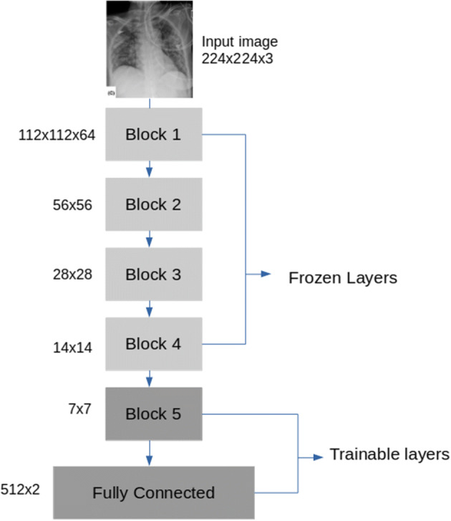

***Fig no:1.011:problem statement definition***

**Empathy map canvas:**

#### Creation

We start by preparing the dataset, as it is the first step to apply deep learning. As COVID-19 addresses the epithelial cells lining our airways, we use a chest X-ray image in order to analyze the health of a patient’s lung.

In this article, we adopt chest X-ray images instead of computer tomography scans to fine-tune the three proposed classification models. Compared with higher radiation exposure, time-consuming CT scans, and expensive, X-rays are a lot cheaper, faster, lower doses for the patient and more available. In addition, portable X-ray machines can be tested in isolation wards, thereby reducing the risk of hospital infections and reducing the number of personal protective equipment used.

Furthermore, chest X-ray image analysis is a practical alternative to the PCR method. They can provide a variety of assistance from the discovery of the disease to the selection of high-risk patients for isolation and prioritization, as well as selective testing to identify false-negative PCR cases, they can provide a variety of help. However, because most cases of viral pneumonia are similar and overlapping, it is hard for radiologists and doctors to distinguish adequate details visually, and it is very time-consuming. Using the deep learning models can be an accurate solution.

In our experiment, we focus on reducing false positives and false negatives by using the transfer learning process with 3 Convolutional Neural Network (CNN) on an augmented dataset by implementing three augmentation strategies on our collected chest X-ray images.

The constructed dataset for this work contains a total of 5000 images:

* 3000 images for normal chest X-ray were selected from different public image databases: Kaggle repositories “Chest X-Ray Images (Pneumonia)” as well as “Covid-19 Radiography Dataset” [].
* 623 chest X-ray COVID-19 images were collected from the GitHub repository , Covid-19 Radiography Data Set. Therefore, we used

image augmentation to expand the size of the total number to 2000 images.

 below presents the content of the prepared dataset, that was divided into two folders namely Normal and COVID-19.

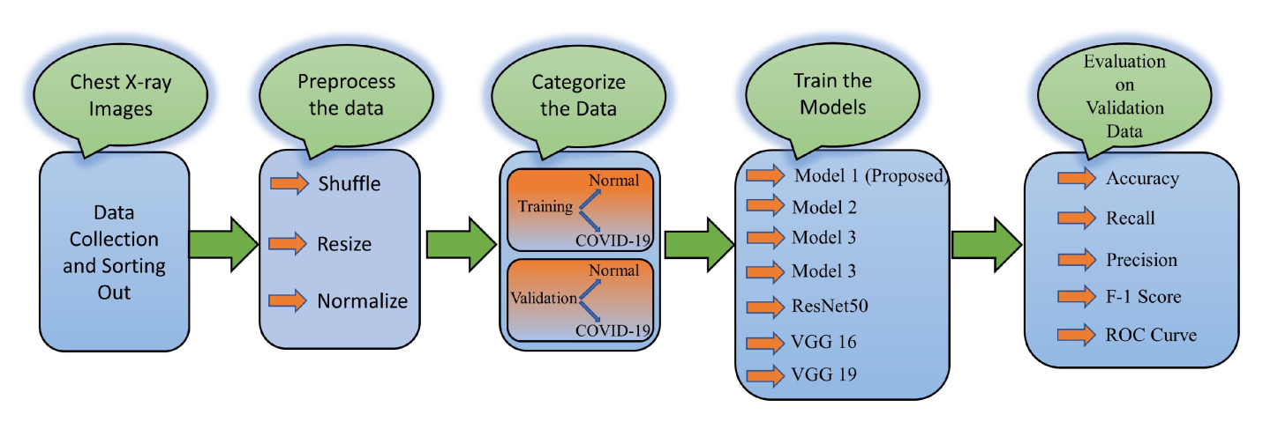

***Fig1.012:EMPATHY MAP CANVAS***

***REQUIREMENT ANALYSIS:***

***FUNCTIONAL REQUIREMENT:***

**The memory aggregation network (MA-Net) is proposed in [**[**14**](https://www.mdpi.com/2079-9292/11/21/3511#B14-electronics-11-03511)**], which improves the model by adding an attention mechanism on the pooling layer based on the residual neural network. The authors also applied the multi-scale attention-guided deep network of soft distance regularization (MAG-SD) to automatically classify COVID-19 case images in lung X-ray images. This method can improve the robustness of the training model, solve the problem of lack of training data, and achieve the effect of enhancing image expression and reducing noise. Ref. [**[**15**](https://www.mdpi.com/2079-9292/11/21/3511#B15-electronics-11-03511)**] constructed deep supervised learning with a self-adaptive auxiliary loss (DSN-SAAL) based on the attention mechanism to identify images of COVID-19 cases. The authors added the attention mechanism module to the convolutional neural network to complete the model design, such as the pooling layer of the convolutional neural network. The attention mechanism is used to strengthen the receptive field area of the image for feature extraction to improve the effect of model feature recognition [**[**16**](https://www.mdpi.com/2079-9292/11/21/3511#B16-electronics-11-03511)**,[17](https://www.mdpi.com/2079-9292/11/21/3511" \l "B17-electronics-11-03511" \o ")].**

**By combining the attention mechanism with the residual network, researchers can calculate the residual value in the residual network through the attention mechanism and obtain high-level features in images to improve the extraction efficiency. Ref. [**[**18**](https://www.mdpi.com/2079-9292/11/21/3511#B18-electronics-11-03511)**] proposed a dual-sampling attention network model based on ResNet34 and adds a dual-sampling strategy to alleviate the imbalance in the dataset. In [**[**19**](https://www.mdpi.com/2079-9292/11/21/3511#B19-electronics-11-03511)**], a deep 3D Multi-instance learning neural network based on attention mechanism was proposed, and the pooling method based on attention mechanism was applied to 3D lung computed tomography (CT) images. Based on the residual neural network, Ref. [**[**20**](https://www.mdpi.com/2079-9292/11/21/3511#B20-electronics-11-03511)**] integrated the attention mechanism and used the attention mechanism to complete the calculation of the residual value in the residual neural network, so as to identify the X-ray images of COVID-19. In the neural network, the residual blocks can capture the advanced features of the image and input them into the attention module. Stacking multiple attention modules between the residual blocks can prevent the model from overfitting. On the basis of image segmentation, the excised lesions were fused with the attention module to complete the detection. In [**[**21**](https://www.mdpi.com/2079-9292/11/21/3511#B21-electronics-11-03511)**], a deep neural network based on focus attention was proposed to identify positive cases of COVID-19 through label data of lung CT images.**

**At present, most of the methods of applying deep learning technology to medical image detection are completed based on a convolutional neural network. The convolutional neural network uses a large number of labeled data sets to train the model to achieve the ideal detection effect. Although the technology of convolutional neural network is mature in image classification, image segmentation, and other problems, it still has the problems of losing feature information and low efficiency. In contrast, the neural network with an attention mechanism can make the model better extract the image’s relevant features to improve the model’s detection accuracy.**

## 3. Materials and Methods

**This section introduces the datasets and methods used to detect and classify lung X-ray medical images. It outlines the datasets, feature processing techniques, feature selection methods, classification methods, experimental environment and evaluation indicators in this study. The detection process of X-ray images of COVID-19**

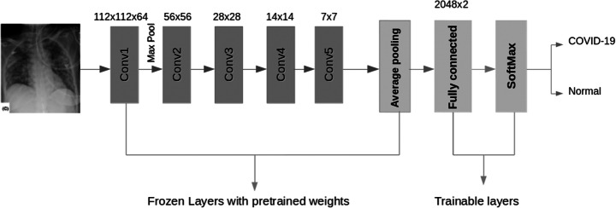

***PROJECT DESIGN:***

***DATA FLOW DIAGRAMS:***

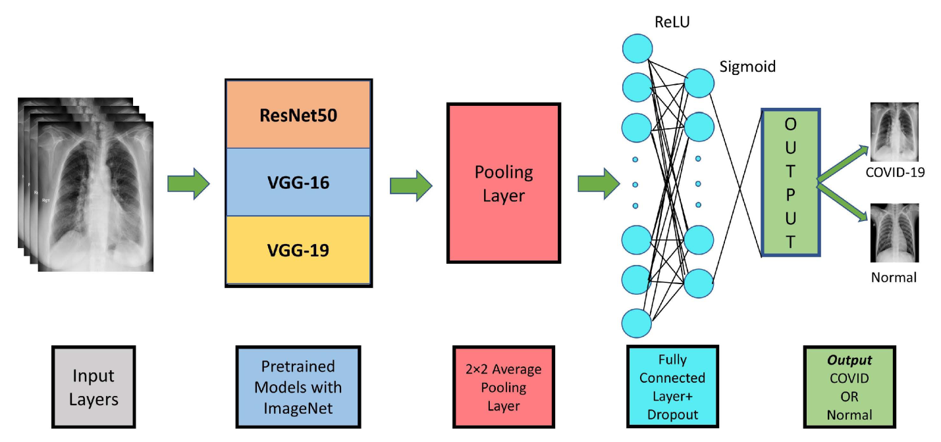

***Fig 1.013: DATA FLOW DIAGRAM***

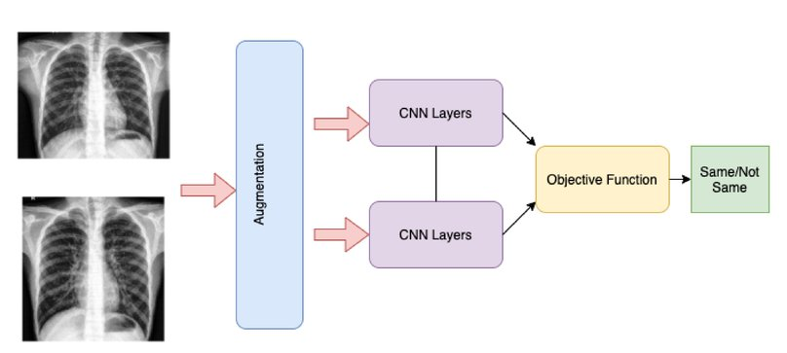

***CODING& SOLUTIONING:***

IMAGE_SIZE = 64

***IMAGE_SIZE=64***

***Def read_image(filepath):***

***return cv2.imread(os.path.join(data_dir,filepath))***

***Def resize_image(image,image_size):***

***Return cv2.resize(image,copy(),image_size,interpolation=cv2.INTER_AREA)***

***X_TRAIN=np.zeros((train.sharp[0],image_size,3))***

***For I,file intqdm(enumerate(train[‘train’]:***

***RESULTS:***

**summarizes the datasets used in the previous studies presented along with test data (i.e., Chest X-rays and C.T. Images, RT-PCR, and Clinical data), types of infected patients, and references. In some articles, public databases such as Kaggle and GitHub repository were utilized, whereas, in other studies, the private data collected from hospitals and universities were investigated. The diagnosis of COVID-19 is crucial as careful investigations and data processing are required using specific medical expertise. It was revealed that in most of the cases, the data from C.T. and X-ray images were studied, whereas a few investigations were conducted using RT-PCR and clinical blood test data to diagnose COVID-19 by using ML/DL techniques.**

**Table 1. Summary of the datasets used in the selected papers.**



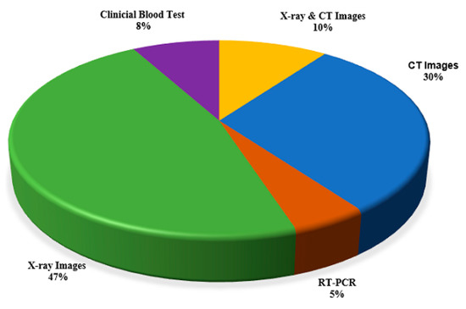

**Figure 5. Percentage utilization of various diagnostic techniques for the detection of COVID-19.**

**Generally, there are two methods of prediction of COVID-19 images, binary classification and multiclass classification. Binary classification is used to detect COVID-19 positive and negative cases. However, this classification method is inaccurate due to the misclassification of COVID-19 images with other types of lung diseases (viral pneumonia, bacterial pneumonia). To solve this issue, researchers have differentiated the images of COVID-19 viral pneumonia, bacterial pneumonia, fungal pneumonia, SARS, MERS, influenza, tuberculosis, and images of healthy people by classifying them using the method of multiclass classification. The accuracy of multiple classifiers is better than binary classifiers in detecting COVID-19 images. The total number of C.T. scans and X-ray images used to categorize the COVID Positive, Normal, Pneumonia, and other Lung patients were reported in the literature and are mentioned in**[**Table 1**](https://www.mdpi.com/2076-3417/11/8/3414#table_body_display_applsci-11-03414-t001)**.**

#### 3.2. Investigation on Classification Performance

[**Table 2**](https://www.mdpi.com/2076-3417/11/8/3414#table_body_display_applsci-11-03414-t002)**summarizes the state-of-art COVID-19 prediction algorithms to test the data (Radiological (chest X-rays and C.T. images), RT-PCR, and Clinical data) along with the highest prediction results of the selected previous studies. Only the best-obtained results of different ML/DL techniques on C.T., X-ray images, RT-PCR, and clinical blood test data were mentioned.**

**Table 2. Summary of state-of-art COVID-19 prediction algorithms.**



**In RT-PCR, samples collected from a person’s body, such as nose or throat, are investigated to detect the presence of the virus. The reliability of RT-PCR is not suitable owing to a high false rate, due to which it cannot give accurate results [**[**73**](https://www.mdpi.com/2076-3417/11/8/3414#B73-applsci-11-03414)**]. The availability of RT-PCR is relatively short around the world. Moreover, it includes a lengthy procedure for detection and is quite expensive. RT-PCR based model revealed with the least accuracy of 80% in recent research [**[**59**](https://www.mdpi.com/2076-3417/11/8/3414#B59-applsci-11-03414)**] and the maximum A.U.C. of 0.84 for another analysis [**[**58**](https://www.mdpi.com/2076-3417/11/8/3414#B58-applsci-11-03414)**]. The clinical blood test-based model was found with the lowest accuracy of 84.24% in the previous study [**[**72**](https://www.mdpi.com/2076-3417/11/8/3414#B72-applsci-11-03414)**] and the highest A.U.C. of 0.97 for another study [**[**66**](https://www.mdpi.com/2076-3417/11/8/3414#B66-applsci-11-03414)**]. Comparatively, the clinical blood test-based model obtained the highest A.U.C. of 0.97 [**[**71**](https://www.mdpi.com/2076-3417/11/8/3414#B71-applsci-11-03414)**] than RT-PCR-based models.**

**In the C.T. scan method, a final chest image is captured by combining the images taken from various angles, while a C.T. scan requires a short time, but it is quite expensive. It can be observed that the C.T. image-based model obtained a minimum A.U.C. of 0.86 in the previous study [**[**60**](https://www.mdpi.com/2076-3417/11/8/3414#B60-applsci-11-03414)**] and maximum accuracy of 99.96% as per the investigation [**[**50**](https://www.mdpi.com/2076-3417/11/8/3414#B50-applsci-11-03414)**].**

**X-rays are used to create images of the chest. An X-ray is economically affordable in most areas. Therefore, most of the medical experts utilized X-ray images instead of C.T. images. An X-ray image-based model was observed with the lowest accuracy of 86.7% in a previous study [**[**40**](https://www.mdpi.com/2076-3417/11/8/3414#B40-applsci-11-03414)**] and the highest accuracy of 99.7% for another study [**[**55**](https://www.mdpi.com/2076-3417/11/8/3414#B55-applsci-11-03414)**].**

**Currently, ML/DL has played a significant role in boosting many CAD systems’ diagnostic efficiency for various medical applications such as diagnosing and detecting different pulmonary diseases. Recent studies have shown that DL techniques have proven to be very efficient for CAD systems in radiography [**[**48**](https://www.mdpi.com/2076-3417/11/8/3414#B48-applsci-11-03414)**]. Hence, C.T. scan and X-ray both are widely used imaging methodologies for detecting various diseases and COVID-19. While X-rays need less data memory, processing time requires a low radiation dose than a C.T. scan [**[**74**](https://www.mdpi.com/2076-3417/11/8/3414#B74-applsci-11-03414)**]. Thus, CAD systems present vital solutions to boost and support radiologist workflow in predicting COVID-19 using low-dose X-ray images and overcoming limitations.**

**The literature has investigated that some researchers employed C.T. and X-ray image-based combined models, which were observed with the lowest accuracy of 96.61% in a previous study [**[**62**](https://www.mdpi.com/2076-3417/11/8/3414#B62-applsci-11-03414)**] and the highest accuracy of 98% for another study [**[**35**](https://www.mdpi.com/2076-3417/11/8/3414#B35-applsci-11-03414)**]. It can be stated that radiological X-ray image-based models worked better than the C.T. image-based models by examining**[**Table 2**](https://www.mdpi.com/2076-3417/11/8/3414#table_body_display_applsci-11-03414-t002)**because the highest accuracy of X-ray-based models is 99.7% by using D.C.N.N. [**[**55**](https://www.mdpi.com/2076-3417/11/8/3414#B55-applsci-11-03414)**] to classify COVID-19. Thus, the C.T. and X-ray images are optimal for detecting coronavirus, but medical experts are required for the RT-PCR test, C.T. scan, and X-ray techniques.**

**It was observed that CNN and D.N.N. were the most considerable classification techniques for detecting COVID-19, followed by SVM, Random Forest followed by K-NN, and L.S.T.M. Moreover, compared to other ML/DL techniques, CNN was the most widely utilized classifier for the diagnosis of COVID-19. D.C.N.N. was the most accurate for the detection of COVID-19, but its usage was relatively short. Hence it needs to be explored further in future research for the detection and diagnosis of COVID-19. The study revealed that ML/DL-based approaches can significantly promote intelligent diagnosis systems, which are promising for healthcare professionals to make fast and reliable detection of the virus. It will also eliminate the manual flaws during the diagnosis by physicians and radiologists. Moreover, it will be a step towards time-efficient and accurate diagnoses to facilitate both hospitals and the patients**

***CONCLUSION:***

***The chest X-ray images (COVID-19, healthy) were mostly applied to analyze lung problems. The study attempts to understand the specific strengths and weaknesses of common deep learning models in order to identify COVID-19 with acceptable accuracy. This is critical for a doctor’s decision-making, since each has benefits and drawbacks. Furthermore, when time, resources, and the patient’s condition are restricted, the doctor may be forced to make a choice based on only one modality. In this work, deep learning techniques were used for automatic COVID-19 detection from chest X-ray images. For this, twelve different models were implemented. Among them, eleven models are existing CNN models while the last one is modified MobileNetV2, a novel approach suggested in the study for more accurate classification with the least compilation time. In this study, authors have shown that the existing methods, when trained and tested on a large dataset, are outperformance by the proposed modified model in COVID-19 detection. The classification accuracy of the modified MobileNetV2 model is 98% in 2 h 50 min 21 s. The precision, recall, sensitivity, and F1 score of the model are 97%, 98%, 97% and 97%, respectively. Compared to the proposed model, the highest performance achieved by the existing models is from MobileNetV2. The existing MobileNetV2 model has an accuracy of 97% in classifying COVID-19 and healthy chest X-rays in 5 h 42 min 34 s. The precision, recall, sensitivity, and F1 score of this model are 96%, 97%, 96% and 96%, respectively. Furthermore, the Wilcoxon signed-rank test done in the study confirms the validity of the findings. These findings will assist doctors in choosing suitable models for various image analysis methods, which will be important when time and resources are limited in a pandemic scenario like the present COVID-19. As future work, the proposed method could be implemented on a dataset with more classes of pulmonary diseases such as asthma, chronic obstructive pulmonary disease, pulmonary fibrosis, pneumonia, lung cancer and COVID-19. Additionally, from the literature review, it was observed that there is a lack of proper feature extraction processes from image data. Therefore, a feature extraction technique will also be included in future work***.