Data analytics with Cognos

Covid vaccines analysis

Phase 2: Innovation

consider exploring advanced machine learning techniques like clustering or time series forecasting to uncover hidden patterns in vaccine distribution and adverse effects data.

Introduction

Analyzing COVID-19 vaccine data is a critical task in understanding the effectiveness, distribution, and impact of vaccination efforts during the ongoing pandemic.

DEFINITION OF MACHINE LEARNING :

Machine learning is a subfield of artificial intelligence (AI) that focuses on the development of algorithms and models that enable computers to learn and make predictions or decisions without being explicitly programmed.

Machine learning systems use data and statistical techniques to improve their performance on a specific task over time.

The primary goal of machine learning is to develop algorithms that can generalize from data, allowing them to make accurate predictions or decisions on new, unseen data.

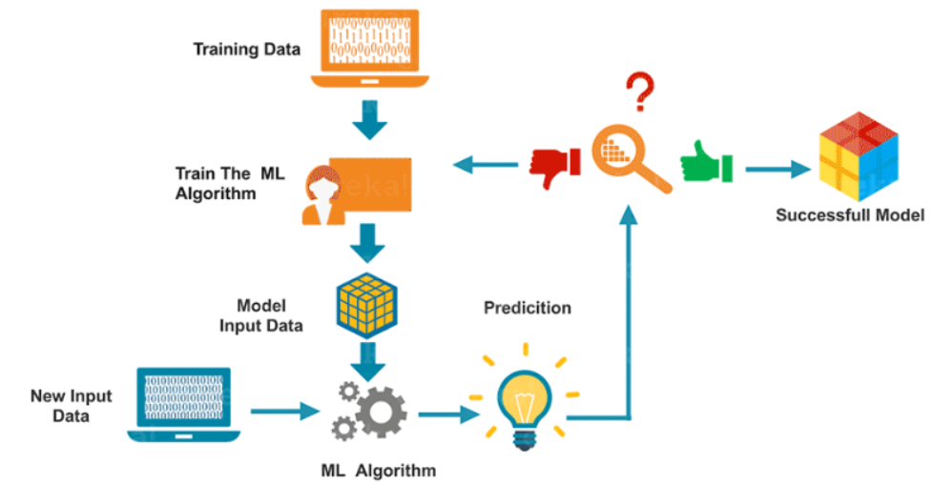

Machine learning Algorithms

* + - Decision trees
    - Random forest
    - Support vector machine
    - Naïve bayes
    - K-means clustering

Decision trees

Decision Trees are a popular machine learning algorithm used for both classification and regression tasks. They work by recursively splitting the dataset into subsets based on the most significant attribute(s) at each node of the tree.

How decision trees work:

* + - Root node
    - Splitting
    - Recursive splitting
    - Leaf nodes

Random forest

Random Forest is an ensemble learning method based on decision tree classifiers. Ensemble methods combine multiple models to create a more accurate and robust predictive model. In the case of Random Forest, it builds a forest of decision trees and merges their predictions.

How Random Forest Works:

* + - Bootstrapped sampling
    - Feature randomness
    - Voting or averaging

Support vector machine

Support Vector Machine (SVM) is a powerful supervised machine learning algorithm used for both classification and regression tasks. SVM works by finding the optimal hyperplane that best divides a dataset into classes or predicts a continuous outcome.

How SVM works

* + - Linear separation
    - Non-linear separation
    - Regularization

Navie bayes

Naive Bayes is a popular probabilistic machine learning algorithm based on Bayes' theorem. It is primarily used for classification tasks, although it can be adapted for regression as well. Naive Bayes is particularly useful for text classification problems, such as spam email detection and sentiment analysis. Despite its simplicity, Naive Bayes often performs surprisingly well in practice, especially for tasks involving natural language processing.

How naïve bayes works

* + Bayes’ theorem
  + Naïve assumption
  + Classification

K-means clustering

K-means clustering is a popular unsupervised machine learning algorithm used for partitioning a dataset into K distinct, non-overlapping subsets (clusters). Each data point belongs to the cluster with the nearest mean value, serving as a prototype of the cluster. The algorithm aims to minimize the within-cluster variance, meaning it tries to make data points within each cluster as similar as possible.

How K-means clustering works

*Initialization:*

Step 1: Choose the number of clusters (K) that you want to create.

Step 2: Randomly initialize K cluster centroids. These centroids are the initial mean values for each cluster.

*Assign Data Points to Clusters:*

Step 3: For each data point, calculate the distance (usually Euclidean distance) to each cluster centroid.

Step 4: Assign the data point to the cluster whose centroid is the closest.

*Update Cluster Centroids:*

Step 5: Recalculate the mean of all data points within each cluster. This becomes the new cluster centroid.

*Repeat:*

Step 6: Repeat steps 3-5 until the cluster assignments do not change significantly, or a maximum number of iterations is reached.

*Result:*

The algorithm converges when the cluster assignments stabilize. At this point, the final cluster centroids represent the center of the clusters, and each data point is associated with a specific cluster.

Key Concepts:

* Centroid: Representative point at the center of each cluster.
* Assignment Step: Data points are assigned to the nearest centroid.
* Update Step: Centroids are recalculated based on data point means.
* Convergence: Algorithm stops when centroids don't change significantly.

Applications:

* Customer segmentation.
* Image compression.
* Anomaly detection.
* Document clustering.
* Recommendation systems.

Pros:

* Simple and interpretable.
* Scalable for large datasets.
* Works well when clusters are relatively spherical.
* K-means is a versatile clustering algorithm used for various tasks.

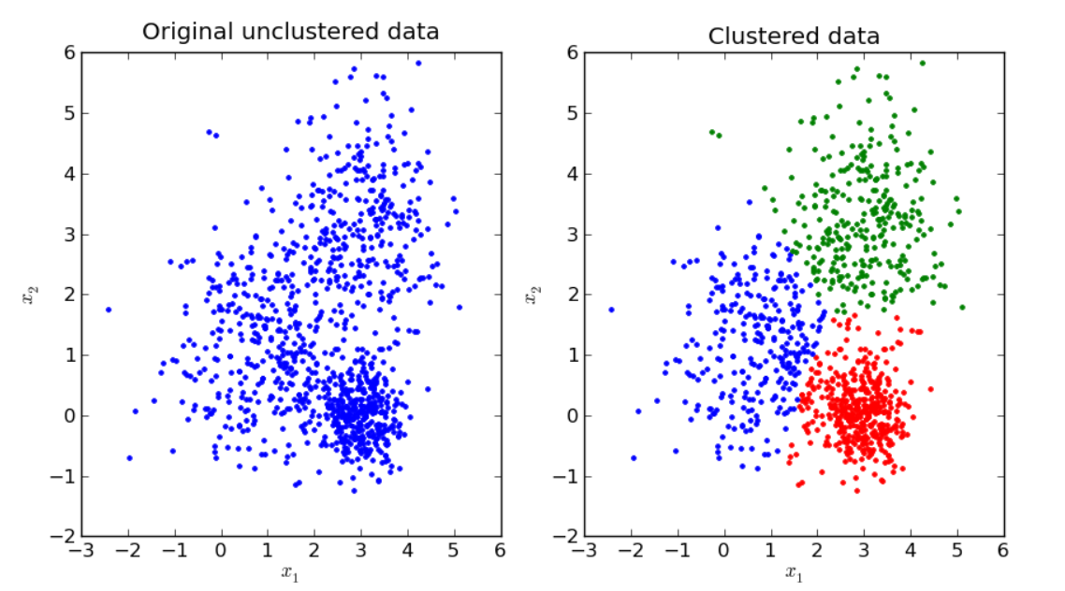

Covid vaccine analysis

1. Vaccine Development and Design:

* *Epitope Prediction:* Machine learning models can predict potential epitopes on the virus, aiding in vaccine design.
* *Antibody-Antigen Interaction:* ML algorithms analyze interactions between antibodies and antigens to identify effective vaccine candidates.
* *Vaccine Adjuvant Selection:* Algorithms help in choosing the right adjuvants that enhance the body's immune response.

2. Vaccine Distribution and Supply Chain Optimization:

* *Demand Forecasting:* Machine learning models, especially time series forecasting, predict vaccine demand in specific regions, aiding in supply chain management.
* *Supply Chain Optimization:* ML algorithms optimize the supply chain, ensuring vaccines reach the right places at the right time, minimizing

3. Vaccine Efficacy and Impact Analysis:

* *Real-world Effectiveness Studies:* Machine learning techniques analyze real-world data to assess vaccine effectiveness against different variants and populations.
* *Outcome Prediction:* Models predict COVID-19 outcomes based on vaccination status and demographic information, helping identify high-risk populations.

4. Adverse Effects Monitoring and Analysis:

* *Adverse Event Prediction:* Machine learning algorithms analyze large datasets to identify patterns and predict adverse events following vaccination.
* *Sentiment Analysis:* Natural Language Processing (NLP) techniques gauge public sentiment regarding vaccines, aiding public health messaging.

5. Vaccine Hesitancy and Public Engagement:

* *Vaccine Hesitancy Prediction:* ML models predict regions or demographics with higher vaccine hesitancy, enabling targeted awareness campaigns.
* *Social Media Analysis:* Natural language processing and sentiment analysis on social media platforms help gauge public sentiments and concerns about vaccines.

6. Clinical Trials and Drug Discovery:

* *Patient Recruitment:* Machine learning algorithms match suitable candidates to clinical trials, accelerating the trial process.
* *Drug Repurposing:* ML models identify existing drugs that could be repurposed for COVID-19 treatment, potentially accelerating the discovery process.

7. Virus Mutation Prediction:

* *Mutation Analysis:* Machine learning models analyze viral genetic data to predict potential mutations, aiding in vaccine adaptation and development of booster shots.

8. Vaccine Passport and Contact Tracing:

* *Digital Health Passports:* Machine learning ensures secure and accurate verification processes for digital vaccine passports.
* *Contact Tracing:* ML algorithms analyze movement patterns and exposure risks, aiding efficient contact tracing efforts.

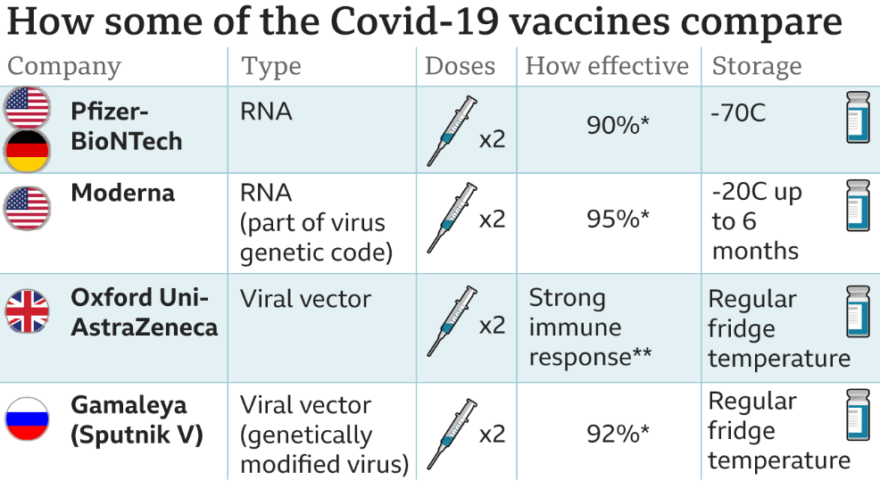

Conclusion

"In conclusion, our analysis of COVID-19 vaccine distribution and effectiveness has shed light on the complexities of global vaccination efforts. While our findings provide valuable insights into the current state of affairs, they also underscore the challenges that lie ahead. As we navigate this unprecedented crisis, it is evident that collaborative efforts, innovative solutions, and continued research are paramount. By addressing the limitations of our current strategies and embracing new avenues of exploration, we can pave the way for a safer, healthier future. Let us remain steadfast in our commitment to science, compassion, and solidarity, for it is through these unwavering efforts that we will triumph over this pandemic and build a more resilient world for generations to come."

TEAMMATES

K.S.SRINITHI

S.LEENA

C.ELAKKIYA

N.LOGESWARI

P.ANUCIYA